Capsule Stain
The main purpose of capsule stain is to distinguish capsular material from the bacterial cell. A capsule is a gelatinous outer layer secreted by bacterial cell and that surrounds and adheres to the cell wall.
Most capsules are composed of polysaccharides, but some are composed of polypeptides. The capsule differs from the slime layer that most bacterial cells produce in that it is a thick, detectable, discrete layer outside the cell wall. The capsule stain employs an acidic stain and a basic stain to detect capsule production.
Principle:
In capsule staining, a smear of bacteria is made at the center of a slide. It is not heat-fixed, as the cell shrinkage caused by heating may create a clear zone around the cell, which may be mistaken as capsule.
Moreover, as the capsular material is water-soluble and may be washed away with vigorous washing, only two reagents are used in staining without any in-between water-washing.
One of the two reagents is the primary stain, crystal violet. It imparts dark purple-blue color to both, the cell as well as the capsule.
However, it is ‘absorbed’ into the cell due to the ionic nature of the cellular components, whereas it simply ‘adheres’ to the capsule, because of the non-ionic nature of the capsular material. To prevent of the dislodging of the capsular material, the smear is not water-washed.
The second reagent, copper sulphate acts both as a decolorizing agent and a counter-stain. It decolorizes by removing excess crystal violet from around the cells as well as the crystal violet adhering to the capsule. It also counter- stains the capsule and imparts a light blue color to it. The capsule now appears light blue, whereas the cell appears deep purple-blue.

Procedure:
- Place a small drop of a negative stain (India Ink, Congo Red, Nigrosin, or Eosin) on the slide.
- Using sterile technique, add a loopful of bacterial culture to slide, smearing it in the dye.
- Use the other slide to drag the ink-cell mixture into a thin film along the first slide and let stand for 5-7 minutes.
- Allow to air dry (do not heat fix).
- Flood the smear with crystal violet stain (this will stain the cells but not the capsules) for about 1 minutes. Drain the crystal violet by tilting the slide at a 45 degree angle and let stain run off until it air dries .
- Examine the smear microscopically (100X) for the presence of encapsulated cells as indicated by clear zones surrounding the cells.
1. Colour of the area surrounding the cells:
Light blue: Capsule present (capsulated bacteria)
Dark purple-blue: Capsule absent (non-capsulated bacteria)
2. Colour of the cells:
Dark purple-blue
3. If capsulated, size of the capsules:
Small, moderate or large.

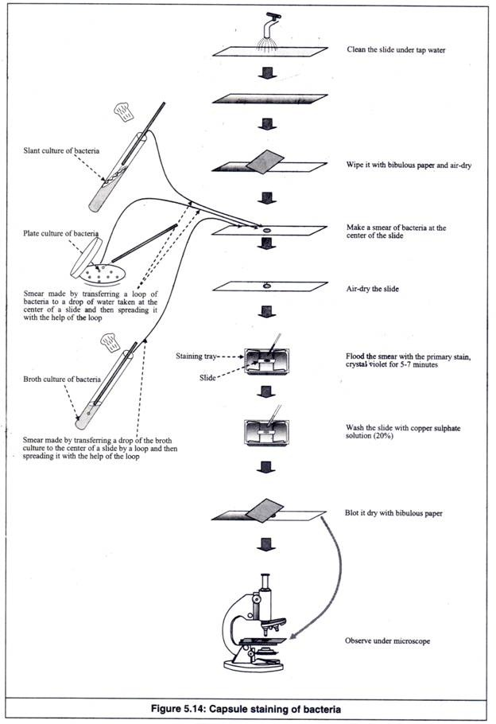
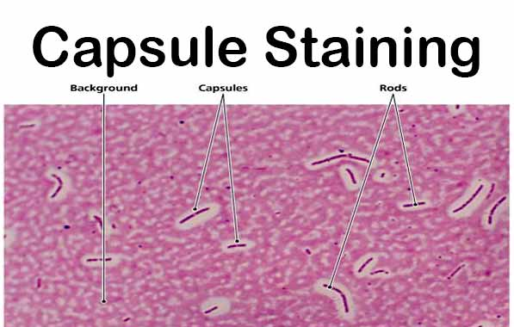
Capsule: Clear halos zone against dark background

