Simple Staining
\The simple stain can be used as a quick and easy way to determine cell shape, size and arrangements of bacteria., the simple stain is a very simple staining procedure involving single solution of stain. Any basic dye such as methylene blue, safranin, or crystal violet can be used to color the bacterial cells.
These stains will readily give up a hydroxide ion or accept a hydrogen ion, which leaves the stain positively charged. Since the surface of most bacterial cells and cytoplasm is negatively charged, these positively charged stains adhere readily to the cell surface.
\Simple Staining Procedure

- Using a sterilized inoculating loop, transfer loopful of liquid suspension containing bacteria to a slide or transfer an isolated colony from a culture plate to a slide with a water drop.
- Disperse the bacteria on the loop in the drop of water on the slide and spread the drop over an area the size of a dime. It should be a thin, even smear.
- Allow the smear to dry thoroughly.
- Heat-fix the smear cautiously by passing the underside of the slide through the burner flame two or three times. It fixes the cell in the slide. Do not overheat the slide as it will distort the bacterial cells.

Staining
- Cover the smear with methylene blue and allow the dye to remain in the smear for approximately one minute somewhere between 30 seconds to 2 minutes .
- Using distilled water wash bottle, gently wash off the excess methylene blue from the slide by directing a gentle stream of water over the surface of the slide.
- Wash off any stain that got on the bottom of the slide as well.
- Saturate the smear again but this time with Iodine. Iodine will set the stain
- Wash of any excess iodine with gently running tap water. Rinse thoroughly.
- Wipe the back of the slide and blot the stained surface with bibulous paper or with a paper towel.
- Place the stained smear on the microscope stage smear side up and focus the smear using the 10X objective.
- focus the smear under oil with the 100X objective.
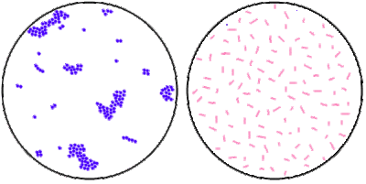Left: Cocci in Cluster; Right: Bacilli (Image source: microrao.com)
Results
The bacterial cells usually stain uniformly and the color of the cell depends on the type of dye used. If methyene blue is used, some granules in the interior of the cells of some bacteria may appear more deeply stained than the rest of the cell, which is due to presence of different chemical substances.

