Academic Curriculum Vitae

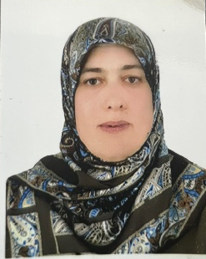
Personal Information:
Full Name:Esraa Awni Haydier
Academic Title: Lecturer
Email: esraa.haydier@su.edu.krd
Mobile: 009647504942027

Education:
- 2004-2005: (BSc. in Statistics). Department of Statistic, College of Administration and Economic, University of Salahaddin – Erbil.
- 2011: (MSc. in Statistics). Department of Statistic, College of Administration and Economic, University of Salahaddin – Erbil: Title Thesis().
Employment :
2005-2008: Teaching assistant in statistic department, College of Administration and Economic, University of Salahaddin – Erbil.
2013-2019: Assistant Lecturer in statistic department, College of Administration and Economic, University of Salahaddin – Erbil.
2019-2023: Lecturer in statistic department, College of Administration and Economic, University of Salahaddin – Erbil.
Qualifications
- IT qualifications: Microsoft Word, Excel, PowerPoint, and SPSS,Matlab.

- Languages qualifications: Kurdish- Reading, writing and speaking
Arabic- Reading, writing and speaking
English- Reading and Speaking and get Pre-Intermediate level in Language center / Salahaddin University

Teaching experience:
- Teaching the subject Principle of Statistic 2014-2015 in Administration department, College of Administration and Economic, University of Salahaddin – Erbil.

- Teaching the subject Decision Theory 2016 in statistics department, College of Administration and Economic, University of Salahaddin – Erbil.

- Teaching the subject Principle of Statistic 2018 in Finance and banking department, College of Administration and Economic, University of Salahaddin – Erbil.

- Teaching the subject Principle of Statistic 2019 in Accounting department, College of Administration and Economic, University of Salahaddin – Erbil.

- Teaching the subject Matlab programm 2020 until now in Statistic department, College of Administration and Economic, University of Salahaddin – Erbil.

Research and publications

Esraa Awni Haydier, Fatema Othman Hamarasul, Forecasting World gold Prices Using ARIMA Model
Zanco Journal of Humanity Science, (2019), Vol. (23), NO. (2)..

Fatema Othman Hamarasoul, Esraa Awni Hidar, Use of the modified and standard deviation plates to control the quality property of amoxicillin and predict the control residue of the time series model, Zanco Journal of Humanity Science, (2019), Vol. (23), NO. (1).

Professional Social Network Accounts:

https://scholar.google.co.uk/citations?view_op=new_articles&hl=ar&imq=drakhshan+jalal+hassan#

