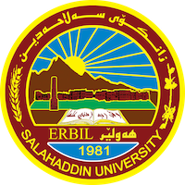
Academic Curriculum Vitae

Personal Information:
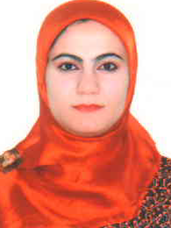
Full Name: Ivan Dler Ali
Academic Title: Lecturer
Email: (university email): evan.ali1@su.edu.krd
Mobile: 07504943295

Education:
Degrees | Department | College | University | Country | Date of Completion
BSc | Mathematics | Education | Salahaddin | Kurdistan Region/ Iraq | 2008
MSc | Mathematics | Education | Salahaddin | Kurdistan Region/ Iraq | 2014

Employment:
Year | Department | Collage | University | Scientific title
2009-2012 | Mathematics | Education | Salahaddin University | Assist researcher
2012-2014 | Mathematics | Education | Salahaddin University | Master student
2015-2020 | Mathematics | Education | Salahaddin University | Assist Lecturer
2020 - until now | Mathematics | Education | Salahaddin University | Lecturer

Qualifications
- Teaching qualifications
- IT qualifications
- Language qualifications such as TOEFL, IELTS or any equivalent
- Any professional qualification
- You could put any professional courses you have attended

Teaching experience:
Department | Course Teaching | No.
Mathematics | Calculus
Mathematics | Graph Theory
Mathematics | Liner Algebra
Mathematics | Advanced Calculus

Research and publications
No | Research Title
 | Ivan Dler Ali and Herish Omer Abdullah (2017). Restricted Detour Polynomial of Edge- Identification of Two Wheel Graphs. AIP Conference Proceeding.
 | Herish Abdullah and Ivan Ali (2020). The Restricted Detour Polynomial of the Theta Graph. Raf. J. of Comp. & Math’s. 1 (14):13-20.
 | Sanhan Muhammad Salih Khasraw, Ivan Dler Ali and Rashad Rashid Haji (2020). On the Non-Commuting Graph of Dihedral Group. Electronic Journal of Graph Theory and Applications. 8(2):233-239.
 | Herish Abdullah and Ivan Ali (2021). The restricted detour polynomials of a prism and some wheel related graphs. Journal of Information and Optimization Sciences 42(6):1-12.

Conferences and courses attended
3rd International Conference of Mathematics and its Applications (TICA-2022). 29-31 August 2022.
International conferences Scientific translation, simplification of science and improvement of research skills. 3-4 July, 2022
4th International Virtual Conference of Nanotechnology Science Under the Theme (Nanotechnology and Our Daily Life. 30th July 2022.

Funding and academic awards
- List any bursaries, scholarships, travel grants or other sources of funding that you were awarded for research projects or to attend meetings or conferences.

Professional Social Network Accounts:

- List your profile links of ReserchGate, LinkedIn, etc.

Profile link | Social Account | No.
https://scholar.google.com/citations?user=IZWpCG8AAAAJ&hl=en | Google Scholar
https://www.researchgate.net/profile/Ivan-Ali | ReserchGate
https://orcid.org/0009-0008-9866-488X | Orcid

