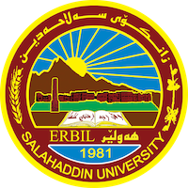
Academic Curriculum Vitae
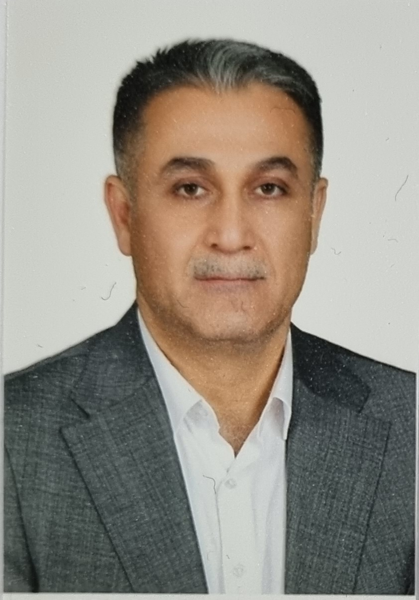
Personal Information:
Full Name: Evan Oghstin Slaiwa
Academic Title: Lecturer
Email: (evan.slaiwa@su.edu.krd)
Mobile: 07504496042

Education:
- Ainkawa Secondary School [1989 – 1992], Erbil, Iraq Degree obtained: High School certificate
- University of Salahaddin/ Erbil, College of Engineering – Civil Dept. [1992 - 1996]. Degree obtained: B.Sc Civil Engineering
- University of Salahaddin/ Erbil, College of Engineering – Civil Dept. [2000 - 2002]. Degree obtained: M.Sc in Water and Hydraulic Civil Engineer
Employment:
- Ministry of Municipality and Tourism, Erbil, Directory of Planning and Following, from 12/1996 to 12/1997
- University of Salahaddin/ Erbil, Civil Engineering Dept., from 12/1997 to 02/2000
- University of Salahaddin/ Erbil, Civil Engineering Dept., preparing M.Sc degree from 2/2002 to 05/2002
- University of Salahaddin/ Erbil, Directorate of Building construction, from [06/2002] till [04/2004]
- University of Salahaddin/ College of Engineering / Civil Dept. / Lecturer /from [05/2004] till now
Qualifications
- Civil Engineer 1996
- Assistant lecturer 2004
- Lecturer 2019

Teaching experience:
- 1st Year Students, Building material.
- 2nd Year Students, Fluid Mechanics.
- 3rd year students: Eng. Hydrology.
- 4th year students: Hydraulic Structures, Engineering Project.
Research and publications
- State all researches, publication you made.

Conferences and courses attended
- Effect of Alton Kopri Wastewater on Lesser-Zab Raw Water, Tikrit Journal of Engineering Sciences, ISSN: 1813-162X (Print) ; 2312-7589 (Online), available online at: http://www.tj-es.com
- Evaluation of Water Quality for Lesser-Zab River for Various Applications, Kirkuk University Journal /Scientific Studies (KUJSS) Volume 12, Issue 4, September 2017 ISSN 1992 – 0849

Professional memberships
- Member of Teaching Staff Civil Engineering Department/ College of Engineering/ University of Salahaddin Erbil, Iraq since 1997.
- Member (Licentiate) of Kurdistan Engineers Syndicate since 1996

Professional Social Network Accounts:

- https://www.researchgate.net/profile/Evan_Slaiwa
- https://orcid.org/0009-0007-0845-0371
- https://scholar.google.com/citations?view_op=search_authors&hl=en&mauthors=label:water_and_hydraulic_civil_engineering
- https://scholar.google.com/citations?view_op=search_authors&hl=en&mauthors=label:water_and_hydraulic_civil_engineering

