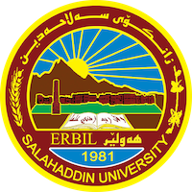
Academic Curriculum Vitae

Personal Information:
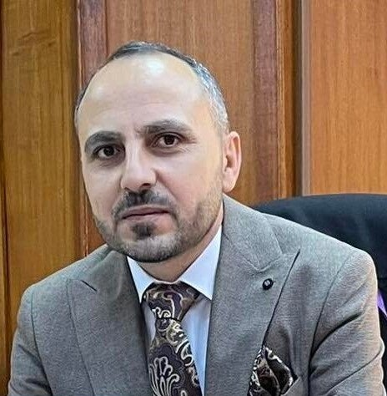
Full Name: Fahmy Mohamad Ali Abdullah
Academic Title: Lecturer
Email: fahmy.abdullah@su.edu.krd
Mobile: 009647504773318

Education:
2002 – 2006 B.Sc degree in Economics, Salahaddin University.
2009 – 2011 M.Sc degree in Economics, Salahaddin University.
2016 – 2022 PhD in Economics (Fiscal Policy), Salahaddin University.

Employment:
2006 – 2008 Teaching staff member in high school.
2008 – 2009 Assistant researcher in the Economic Department, College of Administration & Economics, Salahaddin University.
2011 – 2022 Assistant Lecturer, in the Finance and Banking Department, College of Administration & Economics, Salahaddin University.
2022 – Present Lecturer, in the Finance and Banking Department, College of Administration & Economics, Salahaddin University.

Qualifications:
Since 2008 I thought different theoretical lectures to undergraduate students in each Economics as well as Banking and Finance Departments in Administration and Economics College.
IT qualifications such as Word Microsoft, Excel, Access, PowerPoint, SPSS, and EViews.
Language qualifications such as IELTS, language center- Salahuddin University certificate.

Teaching experience:
I taught different theoretical lectures such as financial mathematics, labor economy, microeconomics, academic skills, and computer skills.

Research and publications:
- کاریگەری هۆکارە ئابوورییەکان لەسەر کێشەی ناوجە کوردستانییەکانی دەرەوەی هەرێمی کوردستان – عێراق، گۆڤاری زانکۆ بۆ زانستە مرۆاڤایەتییەکان )پەسەندی بڵاوکردنەوە).
- دور إتقان اللغات في إيجاد فرص العمل في مدينة أربيل في عام 2022: قطاع الفنادق أنموذجاً، المجلة العراقية للعلوم الاقتصادية (قبول نشر).

Conferences and courses attended:
I attended Salahaddin University Language Center course.

Funding and academic awards:
- List any bursaries, scholarships, travel grants, or other sources of funding that you were awarded for research projects or to attend meetings or conferences.

Professional memberships:
Kurdistan Teachers Union
Kurdistan Economist Syndicate2011

Professional Social Network Accounts:
Google Scholar
Facebook

