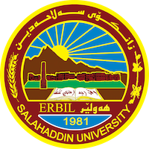

Academic Curriculum Vitae

Personal Information: 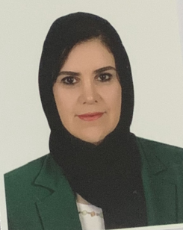
Full Name: Fairooz Khano Saleem
Academic Title: Assistant lecturer
Email: fairooz.saleem@su.edu.krd
Mobile:09647504943898

Education:
- Soran University, Iraq, Master 2016 in Arabic Language
- Salahaddin University, College of Language, Arabic Department 2011 bachelor
Assistant lecturer / Arabic language 2020
- Technical Institute 2007
Employment:
- The ministry of justice 2005
- The ministry of higher education and scientific research 2007

Qualifications
- English language course 2012-2020
- Computer course 2013
- Turkish language course 2017

Teaching experience:
- College of Education- Makhmour 2017 - 2019
- Arabic Teacher Creating visual aids, and all course materials in improving teaching techniques. Moreover, Promoting language development skills through reading, conducted skill evaluations and made recommendations to each student.
- College of Languages, Salahaddin University, Arabic Department 2019 - Present Library Employee Idenitifying the necessary resource. Furthermore, developing new or revised systems, procedures, and work flow.
- Arabic Lecturer in Arabic department/ College of Education/Shaqlawa
- Measurement and Evaluation/ Teaching methods in Biology Department/College of Education/Shaqlawa
Research and publications
- State all researches, publication you made.

Conferences and courses attended
- 5th- Conference on Student Research Project and Academic Posters Competition

Professional Social Network Accounts:

- List your profile links of ReserchGate, LinkedIn, etc.

It is also recommended to create an academic cover letter for your CV, for further information about the cover letter, please visit below link:
https://career-advice.jobs.ac.uk/cv-and-cover-letter-advice/academic-cover-letter/

