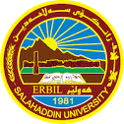
Academic Curriculum Vitae
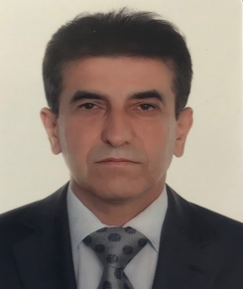
Personal Information
Full Name: Farhad Omar Issa
Academic Title: Lecturer
Email: ( farhad.issa@su.edu.krd )
Mobile: 009647507416669
Education:
- Bachelor in Political Sociology- College of Human Science, Shahed university of Tehran .
- MA in International relations - College of Law and Political Science- University of Karaj.
Employment:
Lecturer Salahaddin University - Erbil

Qualifications:
- I have experience teaching in several contemporary academic ways. I participated in many academic courses in this field , especially in guiding students towards developing their scientific level.

Teaching experience:
(International political economy)

Research and publication-
Researches:
-فرهاد عمر عيسى ، "رؤلى بانكى جيهانى لة طةشةكردنى ولاتانى باشوور" ، طوظارى ياسا و راميارى . سالى ضواردةهةم، ذمارة 20 ، كانوونى يةكةمى 2016 .
-فرهاد عمر عيسى، " كاريطةرى وولاتانى بريكس لةسةر ئاسايشى نةتةوةيى ئيَران لة سالى 2009 تاكو 2017 " ، طوظارى ياسا و راميارى . سالى ثانزدةهةم ، ذمارة 22 ، كانوونى يةكةمى 2017 .
Conferences and courses attended
Funding and academic awards
Professional memberships
Professional Social Network Accounts
https://scholar.google.com/citations?hl=en&user=qd2LNogAAAAJ&view_op=list_works&gmla=AJsN-F6UMcKq19poFK8EDG4Lwpkc-ooLnQIScrssjVHPTLlDvbe02SaZcBq-46XNQJwnUHCtO0p2WhAWXBr5wY-vhXo1IT2X3_yrwAhAKTkSdiOYOauAFm4

