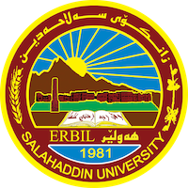
Academic Curriculum Vitae
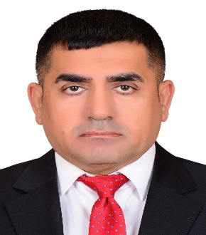
Personal Information:
Full Name: FARHAD KHALID MUSTAFA
Email: farhad.mustafa1@su.edu.krd
Mobile:07518079118
Academic Title: Head of the Department
Education: Master's
- Graduated from the Institute of Teachers Preparation 1988 -1989
- Bachelor’s: 2008 – 2009
- Master’s: 2014
Employment:
- Teacher at the Ministry of Education for 11 years (from 1994 to 2009).
- Teaching Assistant from 2009 to 2014.
- Lecturer at Salahuddin University - Erbil since 2014 until now.
- Head of the Department of Social Sciences - evening study since 2016
Qualifications
- Teaching qualifications
- I am very good at WORD & POWERPOINT & EXCIL programs.
- I speak Kurdish and Arabic very well, and Turkish and English are moderately fluent
- He holds a training certificate from the Arab Trainers Union- TOT
- has been awarded this certifies in training of trainers international (TOT) for academy of scientific research & training
Teaching experience:
11 years in the Ministry of Education
9 years old at Salahuddin University - Erbil
Lecturer at raparin University for two years
Participation in preparation courses for university graduates as teachers in the Ministry of Education
Research and publications
- https://scholar.google.com/citations?user=TNVZz3QAAAAJ&hl=ar
Conferences and courses attended
- A teaching preparation course for pluralistic education at Norn University, Germany, in 2017 And presenting a joint lecture with Dr. Bahar Zayer on pluralism in the curricula in the Kurdistan Region.
- Participation in the second session of the Iraqi Scientific Society for Manuscripts- 2022
- Participation in the Sixth Periodic Scientific Conference of the Second Rusafa Directorate of Education \ Division of Research and Studies under the title Scientific Research and Contemporary Challenges jointly with Salahuddin University- ERBIL and Tikrit University – 2023
- Participation in a workshop entitled Reconsideration of the Curricula of Basic Education Faculties at Rabin University - 2023 within the plan of the Ministry of Higher Education in the Kurdistan Region.

Funding and academic awards
- Nothing.

Professional memberships
- Member of the Kurdistan Teachers Union
- Member of the International Genocide Writers Union
- Member of the Kurdistan Organization without genocide

Professional Social Network Accounts:

- List your profile links of Research Gate, LinkedIn, etc.

- https://www.linkedin.com/feed/
https://www.researchgate.net/signup.SignUpPublications.html

