Question Bank (GIS)
- Define GIS?
- What is a Geographic Information System?
- What are the components of a GIS?
- GIS software tools?
- How does a GIS answer special questions?
- What types of questions can be answered by a GIS?
- What types of data are used in a GIS?
- How is spatial data represented in a GIS?
- What are the applications of GIS?
- What is a geographic data?
- How are geographic data represented?
- Problems with representing geographic data?
- Differentiate between discrete objects and fields?
- Purposes of GIS data structure?
- GIS attribute table information?
- Define vectorization?
- What types of data are used in a GIS?
- Draw types of spatial relationships?
- Differentiate between vector data models and raster data models?
- What is TIN and what is used for?
- Types of spatial relationships?
- Types of spatial operations?
- Primary sources of GIS data collections?
- Data collection workflow?
- Examples of human errors in digitizing?
- Secondary sources of GIS to collections?
- Explain image classification?
- What are the necessary of image classification?
- Image interpretation strategies?
- Types of image classification?
- Differentiate between visual interpretation and digital interpretation?
- Elements of image interpretation?
- Advantages and disadvantages of visual interpretation?
- Types of digital interpretation?
- Supervised image classification?
- unsupervised image classification?
- Differences between supervised and unsupervised image classifications?
- Explain ground truthing and ground checking?
- Uses of ground truth data?
- Explain test sites?
- What we mean by spectral signature?
- Steps of verification of accuracy of image classification?
- Advantages and disadvantages of digital image classification?
- Define spatial analysis in GIS?
- Types of spatial analysis in GIS?
- Explain Query in GIS?
- Define reclassification?
- Proximity analysis and neighborhood function?
- Explain data integration?
- Mapmatics in GIS?
Have a look at the image below and then answer the question?
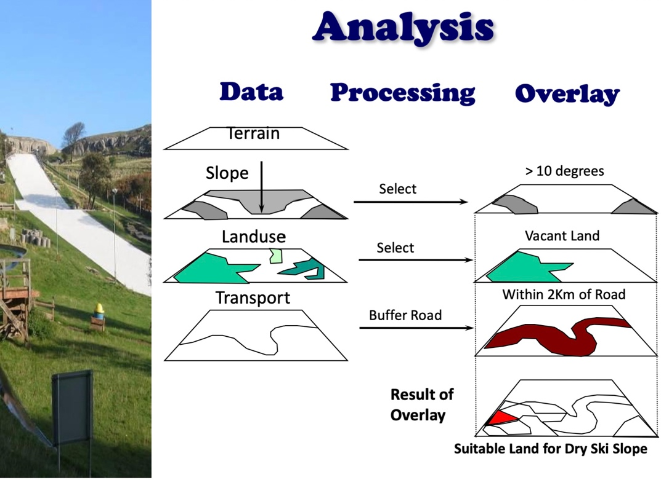

- Which is the longest ski piste in Happy Valley?
- What is the total area of forestry in the valley?
- How many luxury hotels are there in the valley?
- Where are the hotels with less than 20 bedrooms?
- Which hotels are within 200m of a main road?
- In which land use types are the meteorological stations located?
- Which roads should I use for a scenic forest drive?
- Where could a new ski piste be located?
- What is the predicted snowfall for the new piste?
- From where will the new piste be visible?

