Academic Curriculum Vitae
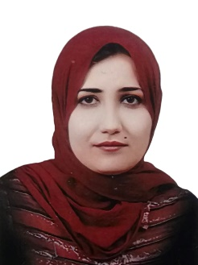

Personal Information:
Full Name: Fatimah Othman hamarasool
Academic Title: Lecturer
Email: fatimah.hamarasool@su.edu.krd
Mobile: 009647504646530

Education:
- 2001-2002: (BSc. in Statistics). Department of Statistic, College of Administration and Economic, University of Salahaddin – Erbil.
- 2009-2010: (MSc. in Statistics). Department of Statistic, College of Administration and Economic, University of Salahaddin – Erbil.
Employment:
2003-2007: Teaching assistant in statistic department, College of Administration and Economic, University of Salahaddin – Erbil.
2010-2019 : Assistant Lecturer in statistic department, College of Administration and Economic, University of Salahaddin – Erbil.
2019-2023: Lecturer in statistic department, College of Administration and Economic, University of Salahaddin – Erbil.
Qualifications
- IT qualifications: Microsoft Word, Excel, PowerPoint, stat graph, and SPSS.

- Languages qualifications: Kurdish- Reading, writing and speaking
Arabic- Reading, writing and speaking
English- Reading and Speaking
Teaching experience:
- Teaching the subject Principle of Statistic 2010-2018 in Economics department, College of Administration and Economic, University of Salahaddin – Erbil.

- Teaching the subject Principle of Statistic 2010-2012 in STATISTICS department, College of Administration and Economic, University of Salahaddin – Erbil.

- Teaching the subject statistical tourism of Statistic 2010-2015 in Tourism Administration department, College of Administration and Economic, University of Salahaddin – Erbil.

- Teaching the subject SPSS 2015-2019 in Economics department, College of Administration and Economic, University of Salahaddin – Erbil.

- Teaching the subject SPSS 2018 until now in Statistic department, College of Administration and Economic, University of Salahaddin – Erbil.

- Teaching the subject , in Accounting department, College Qalla University.

Research and publications

Fatema Othman Hamarasoul, Esraa Awni Hidar, Use of the modified and standard deviation plates to control the quality property of amoxicillin and predict the control residue of the time series model, Zanco Journal of Humanity Science, (2019), Vol. (23), NO. (1).

Esraa Awni Haydier, Fatema Othman Hamarasul, Forecasting World gold Prices Using ARIMA Model
- Zanco Journal of Humanity Science, (2019), Vol. (23), NO. (2)..

Professional Social Network Accounts:

https://scholar.google.com/citations?user=EWIj934AAAAJ&hl=en

