Final Examination in Invertebrate Zoology 2nd Class Students Name:
Biology Department / Science College Time:45min.
----------------------------------------------------------------------------------------------------------------------------------------
Q. (1) / Give the example (scientific name) for the following?
1- Molluscan have pyramid shell.
2- Molluscan have tubular shell, without gill.
3-Arthropods that called Millipedes.
4-Molluscan that called Cuttlefish.

Q. (2) / A-Identify the given sample?
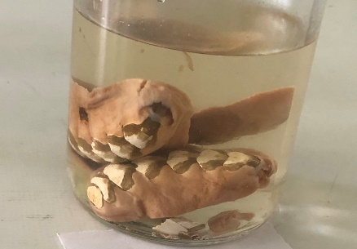
B- Write the class name of A?

Q. (3) /A- Identify the given sample?
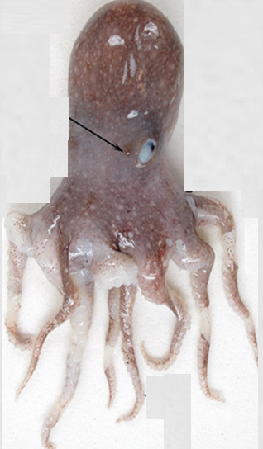
B-Write family name of A?

Q. (4) / A-Identify the given sample and write the class name?
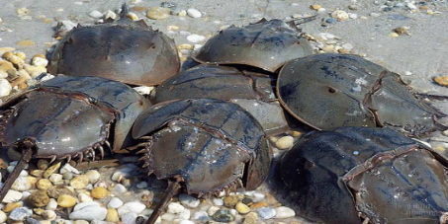
B- Count Cnidarian class?
Q. (5) / Complete the missing Taxonomic ranks for Pecten sp.?
Phylum:
Class:
Order:
genus:
Q. (6) / 1- Which of the following invertebrate belong to class Chilopoda?
A- Anodonota sp. B- Loligo sp. C- Buthus sp. D- Scolopendra sp.
2- Tusk shell is the common name of ………………. .
A- Acropora spp. B- Fungia spp. C- Murex sp. D- No one of them.

Q. (7) / Draw and label the medium type of water canal system in sponges?

Q. (8) / Write the common name of the following?
1-Aurelia sp.
2-Corallium sp.
3-Euospongia sp.
4- Lumbricus terrestris

Q. (9)/ A-Identify the sample?
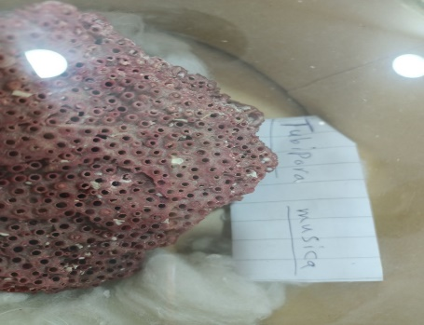
B- Write the sub-order of A?

Q. (10)/ Identify the slid?
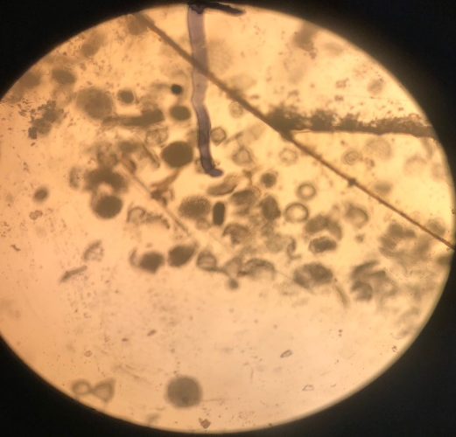
B-Write phylum name of A?

Good Luck
Lecture: Fenik Sh. Hussen

