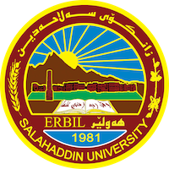
Academic Curriculum Vitae

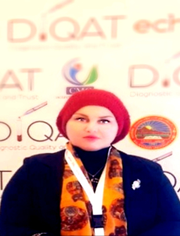
Personal Information:
Name: Fenk Amjed Hasan
Academic Title: DR. Assist prof.
Date of birth: 1976 – Erbil/ Iraq
Gender: Female
Status: Married
Address: Erbil, iraq
Mobile: 009647504918878
E-mail: fenk.hasan1@su.edu.krd Fenk_hasan@yahoo.com
Linkedin:
Education:
- Doctorate of Psychology-University of Salahaddin-Collage of Education(2009).
- Master of Personal Psychology-University of Salahaddin-Collage of Education
- Bachelor of Education & psychology, University of Salahaddin-Collage of Education

Employment:
- Member at sintific research center/Salahaddin University 2022-present.
- Assistant Professor-General psychology/Salahaddin University, Collage of Art 2013-2022.
- Lecturer-General Psychology/Salahaddin University, Collage of Art-Psychology 2012-2013
- Lecturer-General Psychology/Salahaddin University, Collage of Art-Sociology Department 2010-2012
- Lecturer-General Psychology/Salahaddin University, Collage of Basic Education 2009-2010
- Assistant Lecturer-General Psychology/Salahaddin University, Collage of Basic Education 2004-2009

Qualifications
Good, using different programs in microsoft office.
Languages Speaking Reading&Writting:
  - Kurdish mother tongue
  - Arabic Excellent Excellent
  - English Good Good

Research and publications
Publications In Arabic Languge
1- Books
2- Researches In Arabic Languge
التسامح والسعادة دراسة عبر حضارية بين مصر والعراق

Conferences and courses attended
- Modern Instructors Training Course/Jordan/
- Participation in the Cairo University Conference
- Participation in the ART course/Qandil Org
- Member of the Judging Committee (The CV Program)/Rudaw
- Presented a Seminar in Child Protection Organization in Kurdistan
- Assistant lecturer in salhaddin university of education
5 years
- Lecturer in Salahaddin University of Education 3 years
- Assistant Professor in salahaddin university 2012.
- Essay published about Women rights in newspapers.
- Accepted in the examination of English Level for Master.
- Master research in introvert and extrovert personality and its relation to Education
- Doctorate research about the dominant personality traits of Kurdish society according to enneagram program.

Presenting public seminars at (SU) about:

Professional Social Network Accounts:

Linkedin: https://www.linkedin.com/in/heve-hassan-6063a512b/
Researchgate: https://www.researchgate.net/profile/Heve_Hassan/contributions
Google website: https://sites.google.com/a/su.edu.krd/dr-heve-a-hassan/

