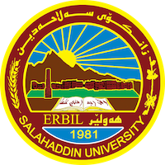
Academic Curriculum Vitae

Personal Information: 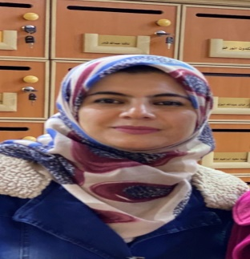
Full Name: Fenk Jaafer Hussein
Academic Title: Lecturer
Email: fenk.hussein@su.edu.krd
Mobile: 07828220509

Education:
- Bachelor degree in law at Salahaddin University- College of Law and Political Science in 2006-2007.
- Master degree in law (Public Law) at Salahaddin University- College of Law and Political Science in 2014.
- Ph.D degree in law (Public Law) at Salahaddin University- College of Law in 2021.

Employment:
Place | Date | Employment title
Salahaddin University | 2009 | Legal assistant
Salahaddin University | 2014 | Assistant lecturer
Salahaddin University | 2021 | Lecturer

Qualifications
- Teaching method in 2014.
- IT qualifications(Word, Excel, Power point, Network)
- Language qualifications such as, IELTS in 2017, participation of Education Course English language in 2009.

Teaching experience:
Subject | Stage
Computer | First stage in 2014
Public Financial law | Second stage in 2015
Public Financial law | Second stage in 2016
General English | Second stage in 2017
General English | First stage in 2018
Legal Terminology | First stage in 2019
Administrative law | Second stage in 2020
General Penal law | Second stage in 2021

Research and publications
1- جريمة الإتجار بالبشر ودور الشرطة الجنائية الدولية في مكافحته, مجلة ياساو رامياري, قبول بالنشر.
2- الفارّين من وجه العدالة ودور الشرطة الجنائية الدولية في ملاحقتها, مجلة ياساو رامياري, قبول بالنشر.

Conferences and courses attended
- Attending the join symposium between Salahaddin University and private Technical Institutes of (Aynda, Rwanduz, Akre) entitled ( The Current Crises of Kurdistan Region; Cause and Solution) in 2018 as a guest.
- Attending the conference entitled (The role of university in building the thought of internal and societal peace) held by Salahaddin University in 2018 as a guest.
- Attending the conference entitled the (Bleeding Iraqi money and ways to stop it) held by Salahaddin University and Elders of Iraqi for Transitional Justice in 2018 a guest .
- Attending the Forum of (Death Penalty in Kurdistan Region) which organized by Independent Human Rights Commission in Kurdistan Region-Iraq in 2022.
- Attending the National Academic symposium of Islamic Medicine (NASIM), held by Salahaddin University in 2022.

Funding and academic awards
- List any bursaries, scholarships, travel grants or other sources of funding that you were awarded for research projects or to attend meetings or conferences.

Professional memberships
- I was a member at Bar Association of Kurdistan Region in 2007.
- I was a member at Jurists Syndicate of Kurdistan Region in 2008.
- I am a member at Teachers Union .

Professional Social Network Accounts:

-https://www.researchgate.net/profile/Fenk-Hussen
-https://scholar.google.com/citations?user=zQZjoTYAAAAJ&hl=en
https://facebook.com/rtttiopkjh/23590=9.

