10: L
10
2022 :

2.5 -3.5’
1.5 - 2.5
J2.5 - 1.5 II IN - 12.5

'..:.. ";'\

' animal physiology ,prac
animal physiology ,pi-ac
animal physiology ,prac
| 4iq

human physiology ,prac
human physiology ,prac
human physiology ,prac |: , U.

I reseech project

(2)

( 1 )
”“’ ““

““"
’‹* ›“’
( l )

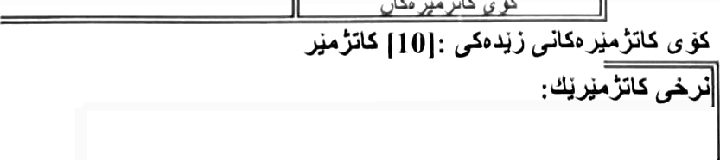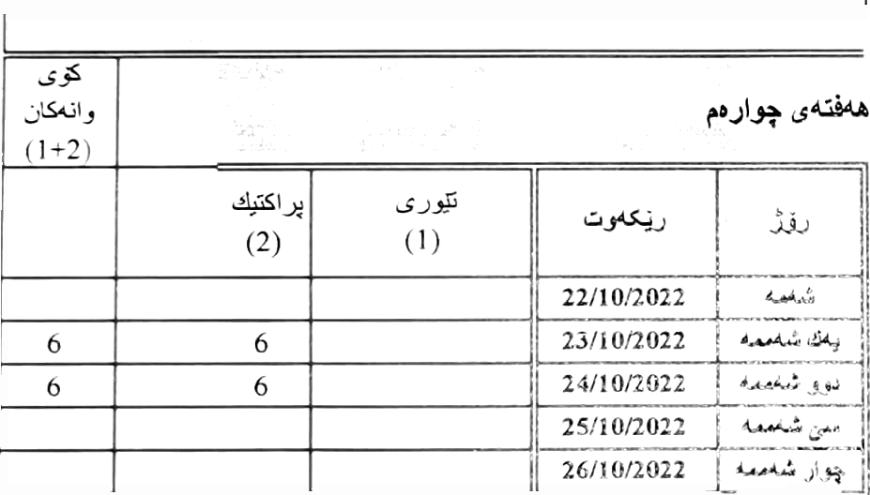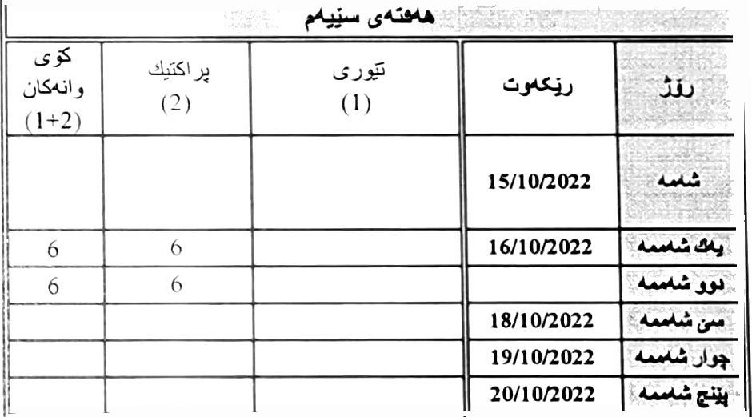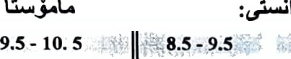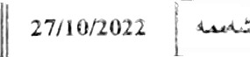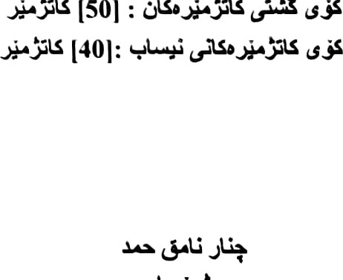

2
 |  |  | (I +2) | ”
 |  |  |  |  |  | 01/t0/2022 | .’ | ....
08/10/2022 |  |  | 6 |  |  | 02/10f2022 | :. | W '
09/t0/2022 | W |  |  |  |  | 03/10/2022 | '. | W
I 0/10/2022 | a> |  |  |  |  | 04/10/2022 | -. | iii•
I I /10/2022 |  |  |  |  |  | 05/10/2022 | : | 3@
I 2/10/2022 | u |  |  |  |  | 06/10/2022 | .:'
13/10/2022 |  |  | 2 | 2

14.0 8.0

I 7/T 0/2022

Ii

14.0

5500

