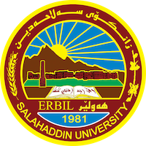
Academic Curriculum Vitae

Personal Information: 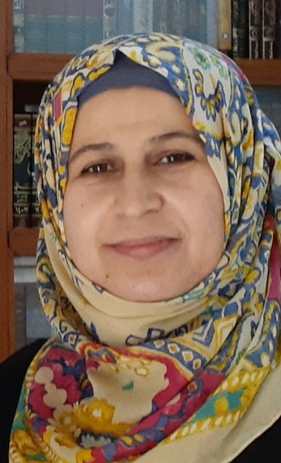
Full Name: Frishta Hama Ahmed
Academic Title: Assistant lecturer
Email: (university email) frishta.ahmed@su.edu.krd
Mobile: 07507342404

Education:
- Bachelor's degree in Arabic language from Salah Al-Din University / / College of Languages / Department of Arabic Language.2006-
- MA in Arabic Language - Semantics from Salah Al-Din University / College of Education / Department of Arabic Language.2015-
Employment:
- Salahaddin university- language collage- 2007

Qualifications
Teaching Methods Course - 2015.
- IELTS Test - 2018
- English language course at the Language Center / Salah Al-Din University - 2019.
- English language course for academic purposes, three levels - 2017
- Personal strategic planning course - 2017.
Computer training course - 2009.
Teaching experience:
- Lecturer at Hali Kar International language Institute - 2018, 2019.
- Lecturer at the College of Education - Makhmour - 2018, 2019.
- Teaching staff - College of Basic Education - Department of Arabic Language - 2021- until now.
Research and publications
- State all researches, publication you made.

Conferences and courses attended
- Attendance at the media conference in the era of artificial intelligence technology. In the hall of the College of Science - Salahaddin University - Erbil on: 19-1-2023.
- Attendance at the sixth scientific conference for holders of postgraduate degrees, tagged with (scientific research and contemporary challenges), on: 1-3-2023.
- الحضور في ( - كۆنفرانسی پرسی ئینتما و گرفته‌كانی نیشتمانسازی له‌ هه‌رێمی كوردستان ، 1-2/3/2023، كۆنفرانسی زانستی نێوده‌وله‌تی یه‌كه‌م، كۆلێژی ئاداب ، زانكۆی سه‌لاحه‌دین)
- الحضور في (كؤنفرانسي باشترين تويزينةوةى دةرجون و بؤستةرى قوتابيان بؤ سالي 2022-2023).

-
Funding and academic awards
- List any bursaries, scholarships, travel grants or other sources of funding that you were awarded for research projects or to attend meetings or conferences.

Professional memberships
- List any membership you hold of any professional body or learned society relevant to your research or other life activities.

Professional Social Network Accounts:

- https://scholar.google.com/citations?hl=en&user=lhhYsdYAAAAJ
- https://www.researchgate.net/
- https://www.facebook.com/baxshndabaziany
- https://orcid.org/my-orcid?orcid=0009-0005-4880-0159

