Geographical Information Systems (GIS)
What is GIS?

- Geographic Information System GIS?
- Geographic Information Science GISc?
- A system that provides the ability to work with information that is referenced to the surface of the earth.
- Is a paper map a GIS?

What is a GIS
- GIS: a particular form of information system applied to geographical data; It was developed from the need to handle and manipulate geographically referenced data.
- A system: a group of connected entities and activities that interact for a common purpose;
- An information system: a set of processes, executed on raw data, to produce information that will be useful for decision making;
- Geographical data: spatial geo-referenced data with one type of coordinate systems.
- Geographic: refers to the Earth’s surface and near-surface
- Spatial (locational): refers to any space;
- A GIS contains at least:
  - A Computer
  - A Software Application (ArcGIS, ArcView,)
  - Some Spatial Data
  - A User
- And works together to perform some geospatial function
  - What does “geospatial” mean?

What can GIS do?
- Make a map
- Find directions to known location
- Find local a Star Bucks
- Determine cost of roads, developments
- Predict the extent of an invasive species
- Map ancient civilizations
- Help manage natural resources!

Change detection
- Changes in a particular area or feature over time can be measured. For example, land use change can be monitored using remote sensing technology to identify increases and decreases in vegetation cover, waterways and urban areas over 10, 20, 30 etc years.
Production of interactive maps with a customisable timeline make it easy visualise the changes over different periods.
Flood risk mapping
- A local government needing to map flood risk areas can use a combination of historical flooding data and modelling techniques to produce a map showing all waterways and the potential flooding levels in the surrounding area.
- By making real-time updates to the model during a flood event, the public can be kept up to date with if and when their homes will be affected.
Site selection
- GIS for selecting a site to place a new feature in the landscape can be highly useful.
- For example, a local council wanting to find the best location to site a new hospital can use geospatial analysis to identify current hospital locations, examine suburb population sizes, calculate distances/drive times to existing hospitals from different suburbs, and study the demographics of areas to see where has the greatest need for a new hospital.
Weed and pest management
- Invasive weeds and pests can lead to massive economic costs.
- GIS is used to determine the areas infested by mapping in the field (recording perimeters of infested areas or recording individual points/sightings) or using satellite imagery/remote sensing.
- This helps in the development of weed/pest management plans and means that changes over time can be measured to identify how effective the management is.

Who uses GIS? Everyone! GIS is used globally of all sizes and in all sectors.
- The following is a list of some industries and sectors that benefit from GIS:
- Local government, National government, Fleet managers, Marketers, Emergency response, Transport, Military defence, Healthcare, Oil and gas, Agriculture, Forestry, Telecommunications.
Steps in GIS
- Acquiring data
- Preparing data
- Assembling data (making electronic maps)
- Analysis
- Preparing final documents (inc. Cartography)
- Publication / Distribution

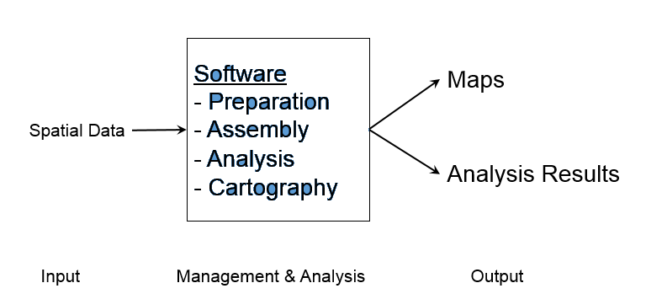

Current GIS
- Acquire: Maps, GPS, Aerial & Satellites, Internet!
- Preparation, Assembly, Analysis, Cartography: ArcGIS and other software
- Distribution: Printing, Publication, the Internet!

Acquire Data
- Existing Maps: USGS Topographic Map Series (1:24k)
- Geographic Positioning System (GPS)
- Aerial Photography
  - Digital Orthographic Quarter Quads
- Satellite Photography
  - LandSat
  - MODIS
  - QuickBird

Preparation
- Decompression (unzip)
- File Format Conversion
- Projection and Datum Conversion
- Data Organization
Assembly
- Adding Layers in ArcGIS
- Checking goereferencing
- Editing?

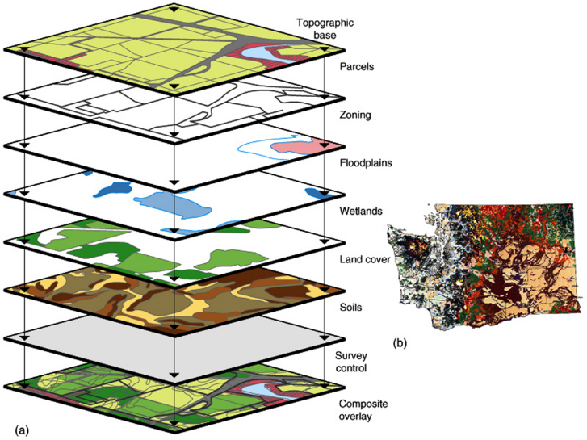

Analysis
- Vector operations: union, intersection
- Vector measurements: Distance, area
- Raster calculations
- Raster transformations
- Raster measurements: histograms

Preparation (inc. Cartography)
- Cartography:
  - Colors and symbols
  - Labels
  - Legends
  - North arrows, scale bars
  - Titles and credits
  - Regional Maps
- Preparing Reports
- Posters
- Journal Articles

