GIS Subsystems
A GIS has four main functional subsystems. These are:
- a data input subsystem;
- a data storage and retrieval subsystem;
- a data manipulation and analysissubsystem; and
- a data output and display subsystem.

Data Input
A data input subsystem allows the user to capture, collect, and transform spatial and thematic data into digital form. The data inputs are usually derived from a combination of hard copy maps, aerial photographs, remotely sensed images, reports, survey documents, etc.
Data Storage and Retrieval
The datastorage and retrieval subsystem organizes the data, spatial and attribute, in a form which permits it to be quickly retrieved by the user for analysis, and permits rapid and accurate updates to be made to the database. This component usually involves use of a database management system (DBMS) for maintaining attribute data. Spatialdata is usually encoded and maintained in a proprietary file format.
Data Manipulation and Analysis
The data manipulation andanalysis subsystem allows the user to define and execute spatial and attribute procedures to generate derivedinformation. This subsystem is commonly thought of as the heart of a GIS.
Data Output
The data output subsystem allows the user to generate graphic displays, normally maps, and tabular reports representing derived information products.

Components of GIS
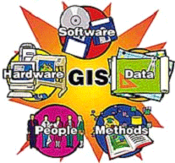
An operational GIS also has a series of components that combine to make the system work. These components are critical to a successful GIS.
A working GIS integrates five key components: Hardware, Software, Data, People, and Methods.
- Hardware
Hardware is the computer system on which a GIS operates. Today, GIS software runs on a wide range of hardware types, from centralized computer servers to desktop computers used in stand-alone or networked configurations.
- Software
GIS software provides the functions and tools needed to store, analyze, and display geographic information.
- Data
Data is perhaps the most important component of a GIS is the data. Geographic data and related tabular data can be collected in-house, compiled to custom specifications and requirements, or occasionally purchased from a commercial data provider. A GIS can integrate spatial data with other existing data resources, often stored in a corporate DBMS. The integration of spatial data and tabular data stored in a DBMS is a key functionality afforded by GIS.
- People
GIS technology is of limited value without the people who manage the system and develop plans for applying it to real world problems.
- Methods
A successful GIS operates according to a well-designed implementation plan and business rules, which are the models and operating practices unique to each organization.

Gis Data Models
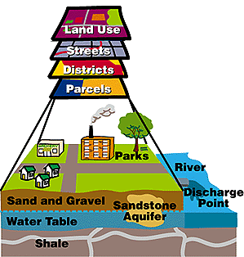
- A GIS stores information about the world as a collection of thematic layers that can be linked together by geography.
- The thematic layer approach allows us to organize the complexity of the real world into a simple representation to help facilitate our understanding of natural relationships.

Spatial (Geographic) Data Models
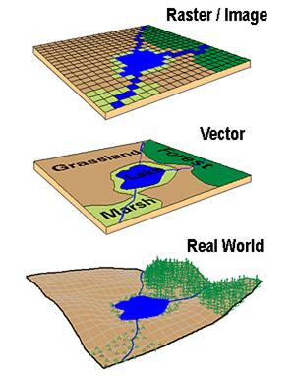
Traditionally spatial data has been stored and presented in the form of a map. Three basic types of spatial data models have evolved for storing geographic data digitally. These are referred to as:
- Raster
- Vector
- Image

The following diagram reflects the two primary spatial data encoding techniques. These are vector and raster. Image data utilizes techniques very similar to raster data, however typically lacks the internal formats required for analysis and modeling of the data. Images reflect pictures or photographs of the landscape.

      - Raster data are digital images represented by a grid of valued pixels, or cells. Raster data structures characterize continuous data (such as imagery). Raster data provide data as a pixel grid or a cell.
      - Vector is A coordinate-based data model that represents geographic features as points, lines, and polygons. Each point feature is represented as a single coordinate pair, while line and polygon features are represented as ordered lists of vertices.
Attributes are associated with each vector feature, as opposed to a raster data model, which associates attributes with grid cells. Vector data structures characterize discrete data (such as roads, pipelines and topographic features). Features are represented as geometric shapes defined through single or grouped coordinates on a set grid.
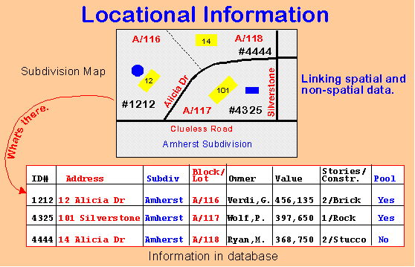
Attribute Data Models
A separate data model is used to store and maintain attribute data for GIS software. These data models may exist internally within the GIS software, or may be reflected in external commercial Database Management Software (DBMS). A variety of different data models exist for the storage and management of attribute data.

