Coordinate Systems

Geodesy is the science that studies the shape and size of the Earth.

Sphere
- Earth’s true shape is a slightly oblate spheroid shape. It is flattened at the Polar Regions. There is a bulging at the equatorial regions, which is caused by Earth’s rotation (spinning on its axis).
- Polar diameter is 12,714 km, Equatorial diameter is 12,756 km, and the Polar Circumference is 40,008 km.
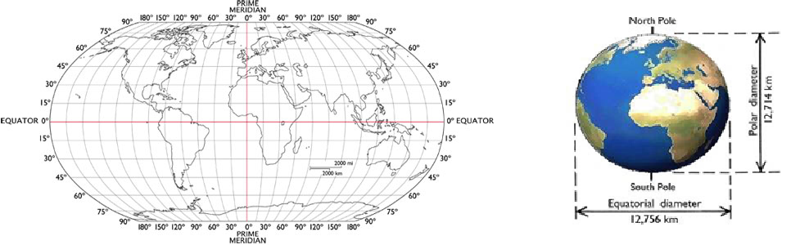

Greatcircle:If a plane passing through the center of the earth, the line defined by the intersection of the plane with the earth’s surface is called a greatcircle. Thus, a great circle divides the globe into two equal halves.

Meridians (lineofLongitude): each half of the great circle that passes through the poles is defined as a longitude. Meridian is used to specify locations in the east-west direction.
Prime meridian: the meridian passing through the British Royal Observatory at Greenwich, England, is selected as zero degree longitude line (Long 0), is call prime meridian.

Equator: the greatcircle that is located midway between the two poles.

Parallels or Latitude:
When a plane parallel to thee quator and passing through the earth, the line defined by the intersection of the plane and the earth’s surface.

Small circles: all parallels other than the equator are called small circles.

Graticule (Spherical grid or geographic grid): the network of parallels and meridians on the earth’s surface.
What is a coordinate system?

Coordinate Systems are ways of splitting up the world in order to form transferable units (numbers) that relate to points on a map. They are very useful, as a set of coordinate values can be given to almost anyone in the world and they can relate the coordinate values to a real life place. Different coordinate systems have different methods of splitting up the earth. A coordinate system enables every location on the earth to be specified by a set of coordinates of known location on a grid.
There are two major global coordinate systems, know as the “Geographic Coordinate System” (i.e. latitude and longitude) and the “Universal Transverse Mercator System” (i.e. UTM coordinates).

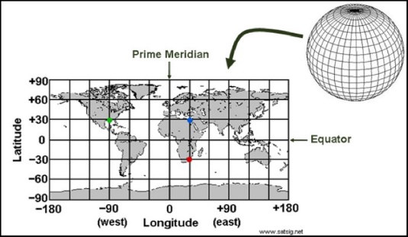
- The most well known coordinate system is the Geographic Coordinate System (GCS), which uses measures of latitude and longitude to determine your location. Lines of latitude run North and South parallel to the equator, with positive numbers representing the northern hemisphere, negative numbers representing the southern hemisphere, and the equator representing 0 degrees latitude.
- Lines of longitude run East and West parallel to the prime meridian, with positive numbers representing the eastern hemisphere and negative numbers representing the western hemisphere, with the prime meridian representing 0 degrees longitude.

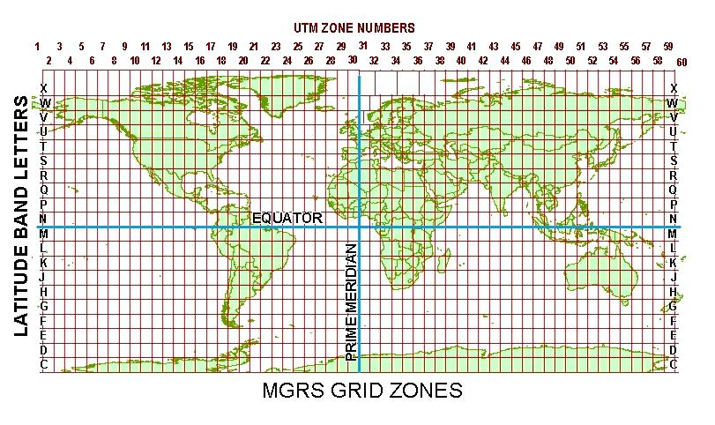
- The Universal Transverse Mercator (or UTM) coordinate system, this system divides the Earth into 60 zones vertically, and 20 sections horizontally. They are reported numerically as ‘eastings” and “northings” (e.g. 630084m east, 4833438m north).

Coordinate Formats and Notation

Latitude and longitude units for the Geographic Coordinate System are represented in Degrees, Minutes, and Seconds where 1 Degree=111.1 km ; 1 Minute=1.85 km; and 1 Second=30.86 meter.
If a location is given in Decimal Degrees, the coordinate is a whole number that will have 2 numbers before the decimal point, 5 or more after the decimal point and may be followed by the degrees symbol (i.e. 43.92741°). In other formats, the numbers are split up and the decimal and the degree symbol will appear inside the number. For example, Degree Decimal‐Minutes has a number followed by the degree symbol and then another number with a decimal in it (i.e. 64°68.445 latitude, 92° 42.367 longitude). Degree, Minutes and Seconds, has a number followed by the degree symbol, a second number followed by an accent symbol (‘) and then another number with a decimal in it (i.e. 44° 40' 16.75 latitude, 93° 37' 10.05 longitude).
Common practice reports the latitude value first, then the longitude value, separated by a comma. For the latitude coordinate, you may also see an indication of the direction from the equator, using either the “‐“ symbols or S (degrees South); and for the longitude, the direction from the prime meridian, using the minus symbols or W (degrees West). For example, the blue point in the Figure 1 above has the latitude & longitude coordinates of “30,30”, but can also be written as “30,30W” or “30, ‐30”. If you find the system of writing coordinates confusing it may just be simplest to write ‘latitude’ and ‘longitude’ with their corresponding values.

What Is A “Datum”
Datums are known geographic shapes of the Earth, which we can apply to maps so coordinate systems can still work perfectly. Datums can be classified into two broad categories: local referencing datums and global referencing datums. A local referencing datum is a datum that has been developed for a set local area often on a national level. A global‐referencing datum best approximates the size and shape of the Earth as a whole (on an international level) but is not good at predicting accurate coordinates on a national scale.and the shape and size of the Earth.

