Remote Sensing (RS)
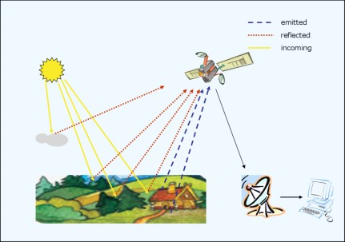
Course objectives:
The aim of the course is to introduce you to the ways in which remote sensing systems are used to acquire data, how these data may be analyzed and how the information is used in studies of the natural and human environments. At the end of the course, you should have a good knowledge of the different types of remote sensing imagery that are available and the analysis procedures used for studying specific environmental problems. You should also be capable of undertaking basic computer-assisted image analysis and producing thematic images.

Remote Sensing-An Introduction
What is Remote Sensing?
- Remotesensing is the science and art of obtaining information about an object, area,or phenomenon through the analysis of data acquired by an device that is not in contact with the object, area, or phenomenon under investigation (Lillesand and Kiefer, 2000).
- Remote Sensing includes all methods and techniques used to gain qualitative and quantitative information about distant objects without coming into direct contact with these objects.

Characteristics and Components of a Remote Sensing System
- Measurements or observations are taken without making direct physical contact with the object.
- TheElectroMagneticRadiation (EMR)istheenergythatcarriesinformationthroughthe atmosphere from the Earth's surface to the sensingdevice.
- The remote sensing instrument used to record the EMR signals are often to be referred to asensor: camera, scanner, altimeters, etc;
- Remote: at a distance from the object or area of interest. Remote sensing platforms: aircraft, satellite, and space shuttles.
- Telemetrycommunication: A network of satellite receivingstations
- Analysis and interpretation: visual and/or digital image processing techniques.

Types of RemoteSensing
- Passive vs Active Remote Sensing
- Passive methods: recording naturally occurring EMR radiation coming from sun that is reflected or emitted from theterrain -target .
- Activesystems,microwave(radar),solar,laser sensors supply theirown energy to illuminate the scene, and then record the amountof radiantflux scattered back toward the sensor system.
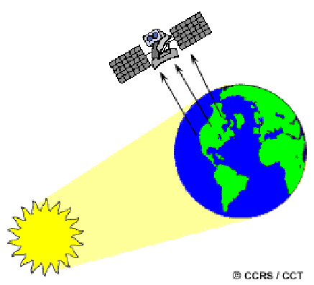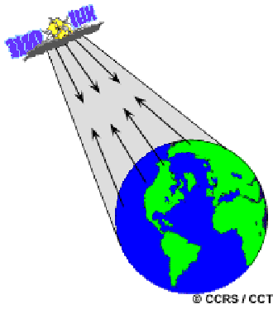
Passive R S Active R S
- Air borne Remote sensing VSSpace borne Remote Sensing
Airborne-based RS
- High-spatial,high-spectral resolution aerial photographs offer detailedview of the Earth’s surface;
- Ground coverageis relativelysmall, and expensive to acquire;
- Severe geometric distortion may occurdue to atmosphericturbulenceand difficult to correct.
- On less regular temporal basis.

Satellite-based RS (Space borne)
- Satellite photographs and images provide synoptic, less detailed view;
- Ground coverageis large, and relativelycheap;
- On regular and consistent temporal basis;
- Stableorbit, and bettergeometricintegrity;

Remote Sensing Process

The process involvesaninteraction between incident radiation and the targets of interest.The remote sensing process contains 7elements:
- Energy Source or Illumination (A) - the first requirement for remote sensing is to have an energy source which provides EM energy to the target of interest.
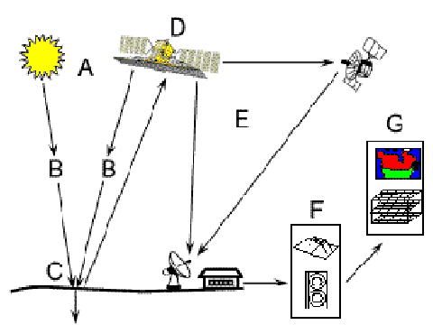
- Radiation and the Atmosphere (B) - as the energy travels from its source to the target, it will come in contact with and interact with the atmosphere it passes through. This interaction may happen a second time as the energy travels from the target to the sensor.
- Interaction with the Target (C) - once the energy makes its way to the target through the atmosphere, it interacts with the target depending on the properties of both the target and the radiation.
- Recording of Energy by the Sensor (D) - after the energy has been scattered by, or emitted from the target, we require a sensor (remote - not in contact with the target) to collect and record the electromagnetic radiation.
- Transmission, Reception, and Processing (E) - the energy recorded by the sensor has to be transmitted digitally to a receiving and processing station where the data are processed into an image (hardcopy and/or digital).
- Interpretation and Analysis (F) - the processed image is visually interpretedto extract information about the target which was illuminated.
- Applications (G) - the final element of the remote sensing process is achieved when we apply the information we have been able to extract from the imagery about the target in order to better understand it, reveal some new information, or assist in solving a particular problem.

Information extracted from Remote Sensing
• The images are interpreted to extract both metric and the matic information about earth’s surface and near-surface for various applications.
• Thematicinformation:Derivebio-physicalvariables,vegetationabundance,water quality parameters,orsoilmoisture,the types of minerals present at the earth's surface.
• Metricinformation:Determination of the precise x,y location and heightzofan object, stereoscopic aerial photography.
• Satellite remote sensing has brought anewdimensionofunder standing of the processes that govern our earth atmosphere system and also the impacts of human activities.

Applications Areas
• Land use/land cover mappingand changedetection
• Agricultural lands assessment and monitoring
• Coastal and marine resource management
• Oil & gas exploration
• Forest resource management
• Urban planningand changedetection
• Geologyand topographic mapping

