Electromagnetic Radiation (EMR)
Principles

Remote Sensing and Electromagnetic Radiation “EMR”
• The first requirement for remote sensing is to have an energy source to illuminate the target. This energy is in the form of EMR.
• Remote sensing is concerned with the measurement of EMR returned by the Earth's natural and man-made features that first receive energy from the sun or an artificial source such as a radar transmitter.
• Different objects return different types and amounts of EMR.
• Differences in reflected EMR make it possible to identify and assess a broad range of surface features and their conditions

ElectroMagnetic Energy
• Electromagnetic energy (radiation) is one of many forms of energy.
• All natural and synthetic substances above absolute zero (0 Kelvin, -273°C) emit a range of electromagnetic energy.

ElectroMagnetic Radiation EMR
• In the absence of matter (vacuum condition), EMR moves at the speed of light (3x10⁸m/s);
•In matter the traveling speed becomes slower. The dense matter, the slower speed.

Electromagnetic Radiation(EMR)
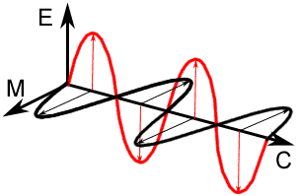
- ElectroMagnetic Radiation "EMR" consists of an Electrical field (E) and a Magnetic field (M) oriented at right angles to the electrical field. Both of them travel at the speed of light (c).

- Two characteristics of electromagnetic radiation are particularly important for understanding remote sensing. These are the:
- Wavelength and
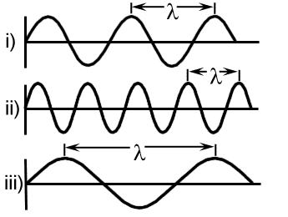
- Frequency.

Wavelength
- The wavelength is the length of one wave cycle, which can be measured as the distance between successive wave crests.
- Wavelength is usually represented by the Greek letter lambda (λ).
- Wavelength is measured in meters (m) or nanometers (nm, 10⁻⁹meters), micrometers (μm, 10⁻⁶meters) or centimeters (cm, 10⁻²meters).

Frequency:
- Refers to the number of cycles of a wave passing a fixed point per unit of time.
- Frequency is measured in hertz (Hz), equivalent to one cycle per second.
- Wavelength and frequency are related by the following formula:
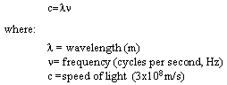
- Wavelength and frequency are inversely related to each other.
- The shorter the wavelength, the higher the frequency.

The Electromagnetic Spectrum (EMS)
- EMS ranges from the shorter wavelengths (including gamma and x-rays) to the longer wavelengths (including microwaves and broadcast radio waves).

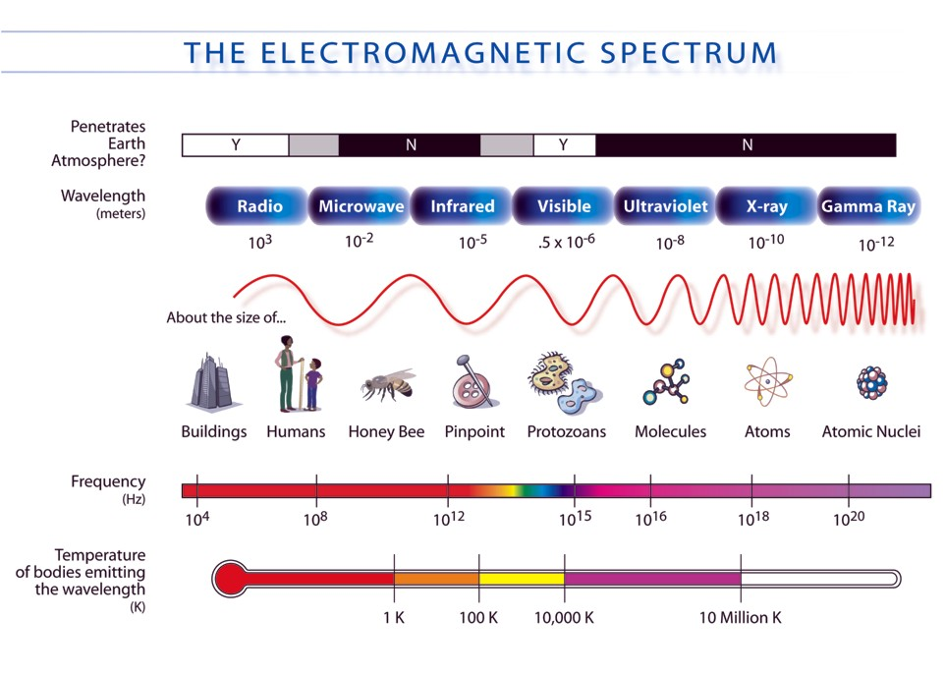
- The light which our eyes can detect is part of the visible spectrum.
- The invisible spectrum can not see it by our eyes, but can be detected by other remote sensing instruments and used to our advantage.

Visible wavelengths: cover a range from 0.4 to 0.7 μm. The longest visible wavelength is red and the shortest is violet.

Primary Colors: Blue, Green, and Red are the primary colors or wavelengths of the visible spectrum.

Visible
• Small portion of the EMS that humans are sensitive to, includes: 1) Blue (0.4-0.5 µm), 2) Green (0.5-0.6 µm), and 3) Red (0.6-0.73 µm)

Infrared (IR) wavelength:
- It covers the wavelength range from 0.7 µm to 1 mm.
- The infrared region can be divided into two categories based on their radiation properties; the reflected IR, and the emitted or thermal IR.

Microwave region: The portion of the spectrum of more recent interest to remote sensing is the microwave region from about 1 mm to 1 m.

Polarized EMR
- The electric and magnetic vibrations associated with a quantum can be in any orientation at right angles to the direction of propagation.
- If the fields for all quanta are lined up in one direction by some means, the radiation becomes polarized plane, horizontal or vertical polarization.

Blackbody Model
• Blackbody is a hypothetical, ideal radiator that totally absorbs and re-emits all energy incident upon it, namely, perfect absorber and emitter of radiation.
• Emittance is a function only of temperature.

Sources of EMR
- All matter in the universe that is warmer than 0K (-273C) emit continuously electromagnetic radiation.
- All objects in every day life emit EMR.
- The amount and type of the emitted energy depends on the temperature of object.
- The hotter objects emit more energy with shorter wavelengths.

