Energy-Matter Interaction

Radiation-matter interactions
• EMR that impinges upon matter is called incident radiation.
• When the EMR encounters the atmosphere, land surface, or ocean surface, one of 3 reactions occurs:reflected off the object, absorbed bythe object, or transmitted through the object.
• Proportion of energythat is transmitted, reflected or absorbed depends upon:
1) composition and physical properties of medium;
2) wavelength or frequencyof incident radiation;
3) angle at which incident radiation strikes a surface.
• In remote sensing, they are largely concerned with reflected radiation of the sun.Reflected radiation causes our eyes to see colors.

Transmission (Transsmitted Energy)
• Incident radiation passes through matter; Radiation penetrates into certain surface media, such as water.
• Refraction occurs when the media are of different densities and the speed of EMR is different in each.

Reflection (Reflected Energy)
There are two types of reflection, while there is no changein velocity or wavelength in those two types:
- Specular Reflection
• Caused by smooth surfaces; The angle of reflection is equal to the angle of incidence. No changein velocityor wavelength.
- Scattering (Diffuse Reflection)
• Occurs when surfaces rough, such as white paper or powders; No changein velocityor wavelength.

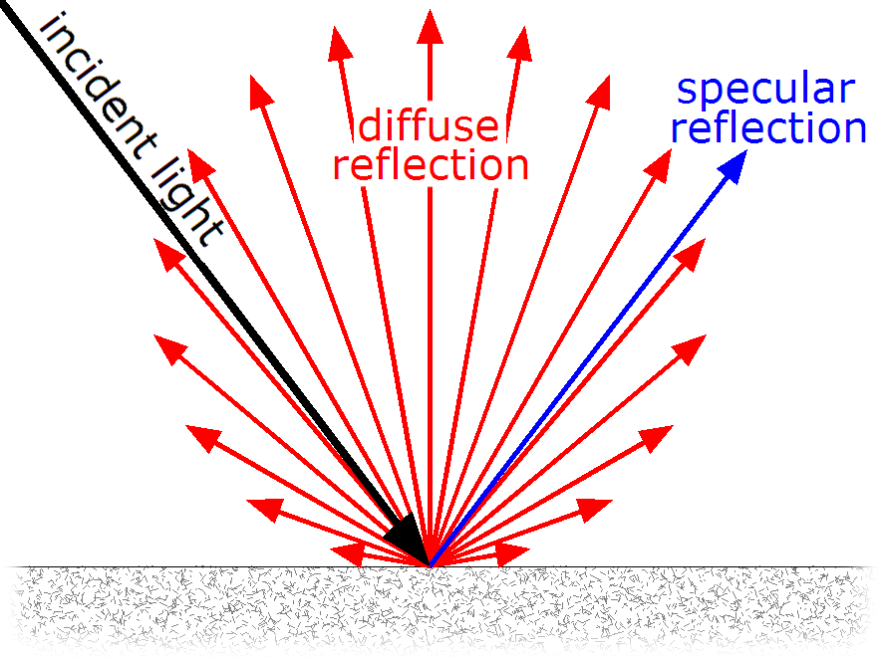

Absorption (Absorped Energy)
Incident radiation is taken in by the medium through electron or molecular reactions within the medium encountered.
EMR-Atmosphere Interactions
EMR travels through vacuum space without modification;Atmospheric windows(transmission bands): areas of EMS where specific wavelengths pass relatively unimpeded through the atmosphere. Important atmospheric windows exploited in remote sensing: Visible, Infrared, and Microwave.
Atmospheric Scattering
- Scattering process disperses radiation in all directions. Important scattering agents include; gaseous molecules, suspended particulates (aerosols), and clouds.
- Three types of atmospheric scattering are important in remote sensing.
- They are 1- Rayleigh (molecular) Scattering, 2- Mie (nonmolecular) Scattering, and 3- non-selective scattering.

- Rayleigh (Molecular) Scattering
• Primarily caused by oxygen and nitrogen molecules (diameters at least 0.1times smaller than affected wavelengths); Most influential at altitudes above 4.5km;
• Bluesky-clearsky appears bluein daylight; blue wavelengths reach our eyes;
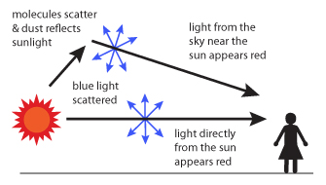
- Mie (nonmolecular) Scattering
• Occurs when there are sufficient particles in atmosphere with mean diameter 0.1 to 10 times larger than wavelength under consideration; Most pronounced in lower 4.5km of atmosphere;
• Caused bywater vapor, tinyparticles of smoke, dust, volcanic smoke, salt crystals released from evaporation of sea spray;

- Nonselective scattering
• Occurs when lower atmosphere contains sufficient number of suspended aerosols(diameters 10 times larger than wavelengths under consideration);
• Water droplets and ice crystals that compose clouds and fogs;Clouds appear brilliant white because colorless water droplet and ice crystals scatter all wavelengths equallywell.
EMR - Surface Interactions
• Natural and man-made (cultural)features of Earth's surface interactwith solar radiation differently. On average, 50% of incident shortwave radiation on top of atmosphere reaches and interacts with Earth's surface features:
50% incident at surface = 4% reflected directly+ 46% absorbed.

Albedo (Spectral Reflectance): it is the ratio between the reflected radiation to incident radiation.
R(λ)=ER(λ)×100
EI(λ)
• Albedo of Earth's: Earth made visible from space only by its albedo.
• Earth's brightest features - clouds, snow and ice surfaces; darkest - water bodies.
• Objects with high albedo are good reflectors but poor absorbers. Objects with low albedo are poor reflectors but good absorbers.

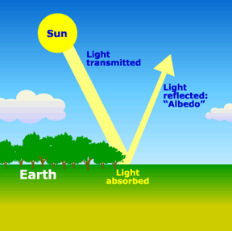
Energy Conservation Principle
• Radiation Budget Equation:
EI(λ)=ER(λ)+EA(λ)+ET(λ)
EI(λ): incident radiation that strikes an object, ER(λ): reflected radiation, EA (λ): absorbed radiation, ET(λ): transmitted radiation
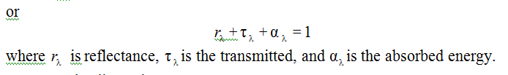
- Transparent materials have little or no absorption and scattering.
- Clear glass - high transmission, low reflection and absorption.
- Fresh snow - high reflectance, low transmission and absorption.

