Academic Curriculum Vitae
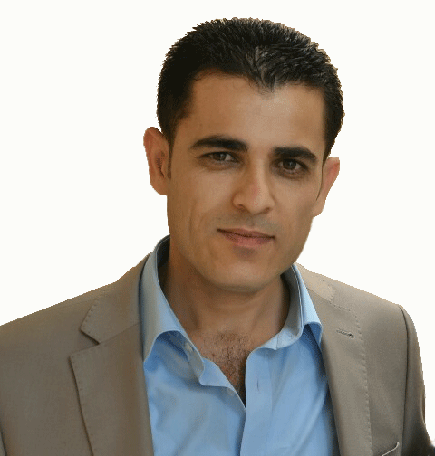
Personal Information:
Full Name: Fuad Wahid Khdhr
Academic Title: Lecturer
Email (university email): fuad.khdhr@su.edu.krd
Mobile: 009647504493156

Education:
- PhD. Applied Mathematics May 2021
Department of Mathematics, College of Sciences, Salahaddin University-Erbil
”New multi-step iterative methods for nonlinear problems with some applications”
Dissertation Supervisors:
Prof. Dr. Rostam K. Saeed (Salahaddin University-Erbil)
Prof. Dr. Fazlollah Soleymani ( Institute for Advanced Studies in Basic Sciences (IASBS), Zanjan, Iran)
- M.Sc. Applied Mathematics Sept 2008 - July 2010
Department of Mathematics, College of Sciences, Salahaddin University-Erbil
”Some Iterative Methods for Solving Non-Linear Equations”
Dissertation Supervisor: Assistant Prof. Dr. Rostam K. Saeed
- B.Sc. Mathematics Sept 2001 - July 2005
Department of Mathematics, College of Sciences, Salahaddin University-ErbilProfessor 2019 at Salahaddin University-Erbil. College of Science, Department of Mathematics

Employment:
- Lecturer May 2021 - Present
Department of Mathematics, College of Science, Salahaddin University-Erbil, Kurdistan, Iraq
- Assistant Lecturer Jan 2011 - April 2021.

Department of Mathematics, College of Science, Salahaddin University-Erbil, Kurdistan, Iraq
- Teaching Assistant Sept 2005 - Sept 2008
Department of Mathematics, College of Science, Salahaddin University-Erbil, Kurdistan, Iraq
Qualifications

Teaching experience:
- Lecturer, Salahaddin University-Erbil
Calculus 2012,2013
Mathematical Package (Maple) 2015
Numerical Analysis 2016,2017
Computational Mathematics with MatLab 2018,2019
Numerical Analysis 2020,2021
Numerical Analysis 2022,2023
- Teaching Assistant, Salahaddin University-Erbil
Calculas Lecturer Dr Ibrahim Othman 2007-2008
Advanced Calculas Lecturer Dr Herish Omer 2006-2007
Visual Basic Programming(Lab) Lecturer Dr Kawa Mustafa 2007-2008
- Visiting Assistant Lecturer, Raparin University
Ordinary Differential Equations 2013
Numerical Analysis 2014
- Visiting Assistant Lecturer, Institute of Shaqlawa
Visual Basic Programing 2012
Mathematics 2013
Research and publications
- Fazlollah Soleymani, Fuad W. Khdhr, Rostam K. Saeed and J Golzarpoor, A family of high order iterations for calculating the sign of a matrix , Mathematical Methods in the Applied Sciences, 43 (14), 8192-8203, (2020).
- Fuad W. Khdhr, Rostam K. Saeed and Fazlollah Soleymani, Improving the Computational Efficiency of a Variant of Steffensen’s Method for Nonlinear Equations , Mathematics, 7(3), 306, (2019).
- Fuad W. Khdhr, Fazlollah Soleymani, Rostam K. Saeed and Ali Akg¨ul, An optimized Steffensentype iterative method with memory associated with annuity calculation, The European Physical Journal Plus, 134(4), (2019).
- R.K. Saeed, and Fuad W. Khdhr, New Third-order Iterative Method for Solving Nonlinear
Equations, Journal of Applied Sciences Research 7(6), 916-921 (2011).
- R.K. Saeed, and Fuad W. Khdhr, Three New Iterative Methods for Solving Nonlinear Equations, Australian Journal of Basic and Applied Sciences 4(6), 1022-1030 (2010).

Conferences and courses attended
- Third International Conference of Mathematics and its Applications (TICMA-2022),
Salahaddin University-Erbil, Erbil, Iraq, August 29-31, 2022.
- The Second International Conference of Mathematics in University of Sulaimani (FICMUOS2020),University of Sulaimani, Sulaimani, Iraq, 24-25 September 2020.
- First International Conference of Mathematics (SICME2019), Salahaddin University-Erbil,Erbil, Iraq, 3th-5th Feb 2019.
- Iraqi-French Mathematics Conference, Erbil-Iraq, 14th–18th Nov, 2009.

RESEARCH INTERESTS
- Numerical Analysis
- High-Order Iterative Methods
- Applied Mathematics

COMPUTER SKILLS
- Windows Operating system.
- Microsoft Office Applications.
- Adobe Illustrator and PhotoShop.
- Database.
- LATEX, Maple, Matlab, Mathematica (Mathematical Programming).
- Visual Studio programming C# and more.
- Web design and development (ReactJS).

LANGUAGES
- Kurdish, Mother Language.
- Arabic, Medium.
- English, Medium.

RESEARCH AREA
My research lies in the area of applied mathematics, in particular, matrix sign function, iterative methods for nonlinear problems and their applications in real life such as in finance. In the financial point of view, it is useful to examine the movement of money through time, which is sometimes known as time-value of money. This is important since a payment on any past or future date can be equivalent to an investment or disinvestment today, where the terms of the credit markets apply for the difference in time. The dynamic behavior of iterative methods in the complex plane for different polynomial test equations. Several nonlinear equations may arise in the process of simulating physical phenomenon such as the N-body problem or the numerical solution o nonlinear partial differential equations (PDEs) of parabolic or elliptic types. In some of such phenomena, computation of the derivatives of a function of several variables is costly and there would be a demand for schemes at which there is no need for computing the derivatives. Computing matrix functions have several interest algorithms to determine problem solving theory and applica8 tions. Control engineers and some applied mathematics have since attracted the attention of the matrix sign function.

