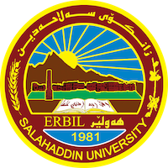
Academic Curriculum Vitae
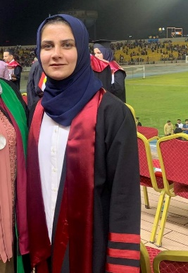
Personal Information:
Full Name: Gashaw Fattah Agha
Academic Title: Assist. Lecture
Email: gashaw.agha@su.edu.krd
Mobile:07507794077

Education:
2007-2011 Bachelor in Science (B.Sc.) Agriculture College, Animal Resource
Dept. University of Salah al-din Erbil-Iraq.
2014-2017 Master of Science (M.Sc.) (Fish Taxonomy)
University of Salah al-din Erbil-Iraq.
Employment:
- Ministry of higher education and scientific research, Salahaddin university, college of Scientific Engineering Agriculture Iraq Erbil 2011-2017 (employer)
- Ministry of higher education and scientific research, Salahaddin university, college of Scientific Engineering Agriculture Iraq Erbil. 2019- up to a day (Assistant Lecture)
- Ministry of higher education and scientific research, Salahaddin university, college of Scientific Engineering Agriculture Iraq Erbil. Library Manager of collage
Qualifications
- Native Kurdish language speaker, English, and Arabic good
- Advanced user of Microsoft Office (Word, Excel, PowerPoint, and Outlook)

Teaching experience:
- Fish Taxonomy
- Ichthyology
- Fish Disease
- Fish Parasites
- Elective

Research and publications
- Agha F. G.; Ibrahim R. I. and S. M.A. Abdullah (2021). DNA Barcoding Of The Cyprinidae From Greater Zab River_Gwer In Kurdistan Region, Iraq. Plant Archives Vol. 21, No. 2, 2021 pp. 639-644
- Jawad, L. A., Agha, G.F., Abdullah, S. M. A., Aguilar, G., & Qasim, A. M.(2022). Morphology and morphometry of pharyngeal bone and teeth in cyprinid species from the Kurdistan Region, Iraq. The Anatomical Record, 1–11. https://doi.org/10.1002/ar.2490
- Agha F. G.; Bilal, S. J. and Abdullah, S. M. A (2023).DNA barcoding of some species of the genus Capoeta Valenciennes, 1842 from Kurdistan Region, Iraq. ZANCO Journal of Pure and Applied Sciences.
Conferences and courses attended
- “1st ICAS 2019, 1st International Conference Agri. Sciences” held on November 6-7,2019 at college of Agriculture, Salahaddin University, Erbil- Kurdistan Region –Iraq.

Professional Social Network Accounts:

- <a href="https://www.researchgate.net/profile/Gashaw-Agha">Gashaw Agha on ResearchGate</a>
- linkedin.com/in/gashaw-f-agha-3513a0124/

