What is fish disease?
Signs of fish disease include abnormalities and symptoms such as a fish not feeding, ulcers on the body, or cloudy eyes. The most common indicators of disease are fish coming to the surface and gasping for oxygen, or higher than usual levels of sickness or death in an aquaculture system.
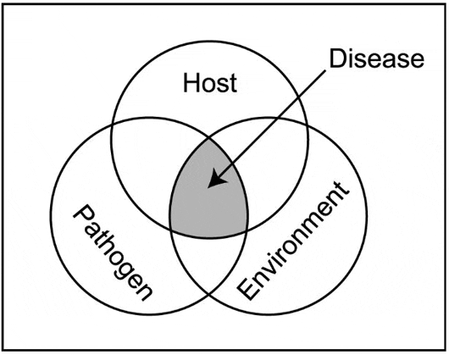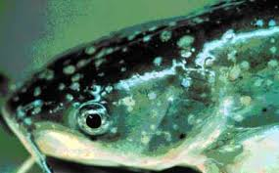
The disease rarely results from simple contact between the fish and a potential pathogen. Environmental problems, such as poor water quality, or other stressors often contribute to the outbreak of disease.
Types of fish diseases
There are two broad categories of disease that affect fish
- Infectious (Infectious diseases are caused by pathogenic organisms present in the environment or carried by other fish).
- Parasitic disease
- Bacterial disease
- Viral disease
- Fungal disease
- Non-infectious (are caused by environmental problems, nutritional deficiencies, or genetic anomalies; they are not contagious)
- Environmental diseases
- Nutritional diseases
- Genetic abnormalities

What are the causes of fish disease?
- Bad water quality
- Inappropriate diet
- Temperature (too high or too low)
- Stress
- Bullying
- Viral diseases
- Fungal infections
- Bacterial infections

Symptoms of Disease: Common symptoms of the disease are the following:
- Isolation from group, differences in behavior and swimming.
- Abnormal position, stop feeding or reject food intake.
- Changes in body physique, shape, colour i.e., discoloration of body.
- Edges of fins become whitish, reddish, removal of scales.
- Accumulation of water or reddish fluid in the body and roots of fins.
- Stomach swollen, necrosis of gills, secretion more mucous.
- Body swelling followed by spots, abrasions, furunculous, ulcer or wound with fungal infection.
- Sudden movement and jumping off the water, rubbing the body against a rough surface, pond dykes, aquatic plants etc., improper respiration and movement.
- Movement on own axis, backward or forward, tail down or head down, oblong, vertical or horizontal, imbalanced body.
- Exopthalmous or endopthalmous with swelling or bulging eyes, improper vision.

Controlling Fish Diseases
- General Principles of Prevention
- Providing water sources free of pathogens
- Protection from the transfer of pathogens
- Disinfection of ponds, fish culture units and equipment; winter freezing and summer drying of ponds
- Optimalization of environmental conditions
- Regular control of health condition and preventive treatment of fish

- General Principles of Therapy
- application of therapeutic substances and preparations to the aquatic environment (therapeutic baths for fish and eggs)
- administration of therapeutic substances in feed
- administration of therapeutic substances via a probe
- administration of therapeutic substances by means of injections

