Types of Parasites, Parasitic Life Cycles, and Hosts

Types of hosts

1) Definitive host: The definitive host is the one in which a parasite reaches sexual maturity and undergoes sexual reproduction.
2) Intermediate host: The host in which asexual development of the parasite occurs is referred as intermediate host.
3) Paratenic host: Also known as Transport host or Carrier host or Transfer host. Sometime the parasite enters a host in which it does not undergo any development but remains alive till it gains entry in the Definitive or Intermediate host. Such a host termed as paratenic host. They are believed to bridge the ecological gap between the Definitive and Intermediate host.
4) Reservoir host: Also known as Temporary host. In the absence of regular hosts, some parasites survive in the reservoir hosts. Reservoir host become the source of infection to regular hosts.
5) Vector host: It is the host in which a part of life cycle of a parasite takes place and is also instrumental in the transmission of the parasite from main host to other.

Type of Parasites
- On the basis of Generation
1) Monogenetic Parasite- These require hosts of only one species to complete their life spoon. e.g.-Ancylostoma duodenale, Diplozoon paradoxum
2) Digenetic Parasite- These require hosts of two different species to complete their life spoon. e.g.-Leishmania donovani and Fasciola hepatica
- On the basis of Pathogencity
1) Pathogenic Parasite- Those parasites which are caused disease and act as a pathogen called pathogenic parasite. e.g.-Taenia solium (caused taeniasis in Man)
2) Nonpathogenic Parasite- They are not cause any disease in the host. e.g.-Taenia hominis (habiting in the intestine of Man without causing harm or disease)
3) Intermittent Parasite- They are not constantly associated with the host. They obtain nourishment from host at time to time. e.g.-Bed bugs (Suck the blood meal from Man)
- On the basis of Localization
1) Ecto Parasite- Those parasite which are live on the host or Outside of the host are called ectoparasite. e.g.- Bed bugs (Mostaly Arthropods Parasites)
2) Endo Parasite- Those parasite which are live in the host or Inside of the host are called endoparasite. e.g.- (Generally Protozoans, Helminthis & Neamtods Parasites)

On the basis of Dependency
1) Facultative Parasite- this parasite which can live in hosts if it is available, but capable of living independently if its host is not available, are known as facultative parasite. e.g.- Mycobacterium tuberculosis (cause tuberculosis in man is a facultative parasite)
2) Obligate Parasite- Those parasite which depend upon the specific host throughout life are called obligate parasite. e.g.- Taenia solium
- Depending on size:
1) Macroparasites: parasites which are visible to the naked eye, such as helminths, tick, mosquitos etc.
2) Microparasites: Parasite which are typically smaller or microscopic in size, such as protozoa.

The life cycle: All parasites have a life cycle that involves a period of time spent in a host organism and that can be divided into phases of growth, reproduction, and transmission. Life cycles of parasites can be further divided into two categories: direct and indirect.

Types of life cycle
- Direct life cycle: Parasites with direct life cycles have only a single host. For example, most adult monogeneans are found on fish, whereas their larvae are free-living.
- Indirect life cycle Parasites with indirect life cycles have several hosts. Adult digeneans, for instance, are found in various vertebrates and their larvae infect at least one and often several hosts.
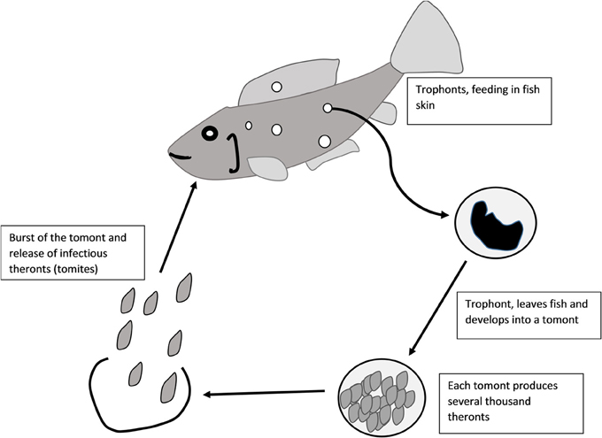
Direct life cycle

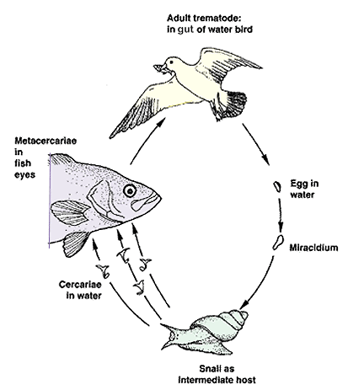
Indirect life cycle
Symptoms of diseases and parasites in fishes
How do you recognize that a fish might be ill?
- Colour may fade out / change
- Body shape, condition and / or behavior will be abnormal
- The fish may refuse to feed or overfeed and trailing faces appear at vent.
- Condition of the fins and gills will deteriorate. Fins may be clamped close to body.
- The fish may not keep its swimming position.
- There may be signs of growth or abnormalities in injuries.

Importance of studying fish parasitology
- For identification parasite
- For identification of diseases

Classification of different parasites
1- Protozoa
a. Ciliata
b. Flagellata
c. Sporozoa
d. Sarcodina
2- Metazoa (helminthes)
a. Nemathelminthes (roundworms)
b. Platyhelminthes (flatworms)
i. Trematoda (flukes)
ii. Cestoda (tapeworms)
- Some arthropods
- Leeches
- Crustacea

