Exercises:
Q1: Find all cycles in the graph shown below:
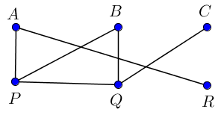
Q2: Consider The graph shown in figure, find all paths from vertex $A$ to vertex $R$. Also, indicate their lengths.
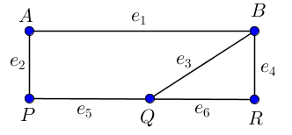

Q3: In each of the following graphs, find paths of length 9 and 11, and cycle of length 5, 6, 8 and p if possible.
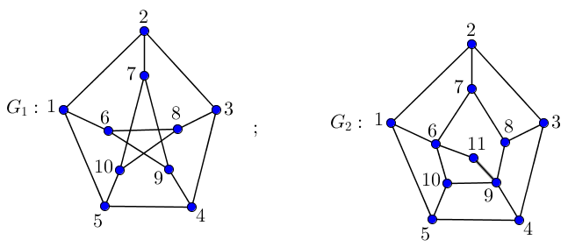
Q4: The terminal vertices of a path are of degree ……………………….. .

Exercises:
Q1: Determine the cut vertices and bridges of the following graph:
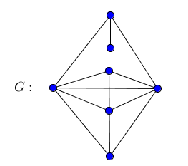
Q2: Construct two non-isomorphic trees having exactly 4 pendant vertices on 6 vertices.
Q3: Find minimal spanning tree of the following graph $G$, where
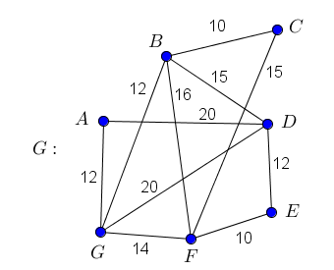

Exercise:

Q1: Find the connectivity and edge connectivity of the following graphs:

Q2: Consider the graph $G$ shown below. Determine
- All vertex- disjoint $x-y$ paths joining the vertices $x$ and $y$.
- All edge-disjoint $x-y$ paths joining the vertices $x$ and $y$.
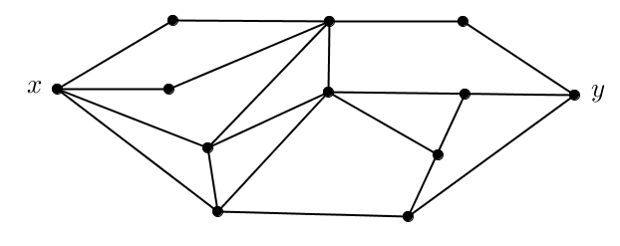

Q3: Among all graphs with $p$ vertices and $q$ edges, the maximum connectivity $κ(G)$ is zero when $q<p-1$ and is $\left\lfloor \frac{2q}{p}\right\rfloor$ when $q≥p-1$.

Excercies:
Q1: Are the following graphs Eulerian? Does there exists an Eulerian open trail?
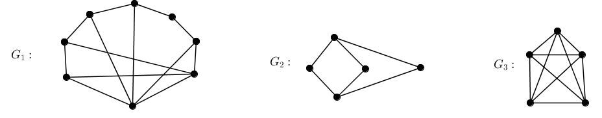

Q2: Determine if each statements is true or false. If true, provide a brief proof. If false, find a counter example.
- Any graph in which all vertices have even degree contains an Eulerian trail.
- A closed walk contains a cycle.

Q3: Which of the following graphs are Hamiltonian?
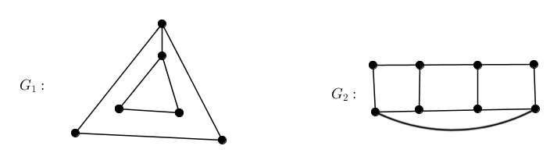

Q4: For what integers $m$ and $n$ is $K_{m,n}$ Hamiltonian.

