ENDOPTERYGOTA
1- Neuroptera- Aphidlions
2- Mecoptera - Scorpionflies.
3-Lepidoptera - Butterflies and moths.
4-Trichoptera - Caddisfly.
5- Diptera - True fly.
6-Siphonaptera - Fleas.
7- Hymenoptera - Bees, wasps, ants.
8- Coleoptera - Beetles and weevils.
9- Strepsiptera – Stylopids

1-Order: Neuroptera: Antlions- lacewings(Aphidlion)
Neuroptera includes 600 species of lacewings and antlions. They have large, membranous wings which with heavy venation. Nearly all insects in this order are terrestrial, live in vegetation and feed on soft-bodied prey such as aphids, scale insects and mites. Species that are not predatory visit flowers and eat pollen and nectar.
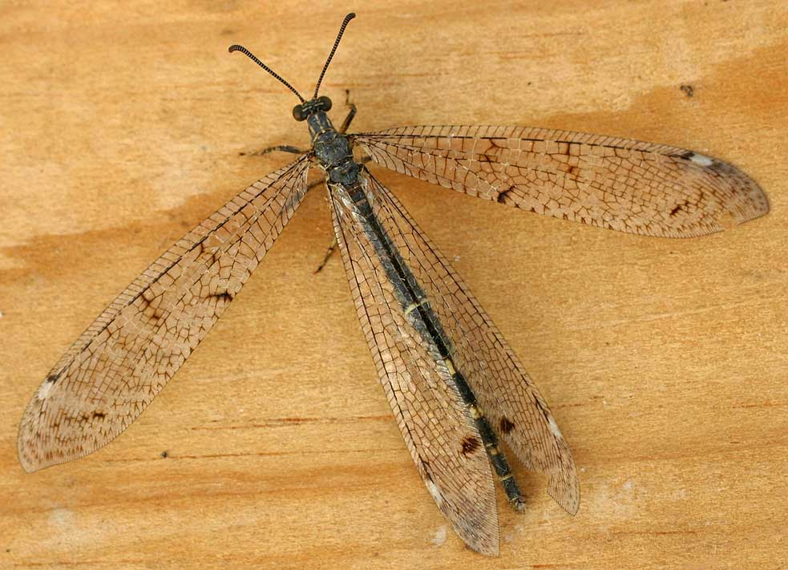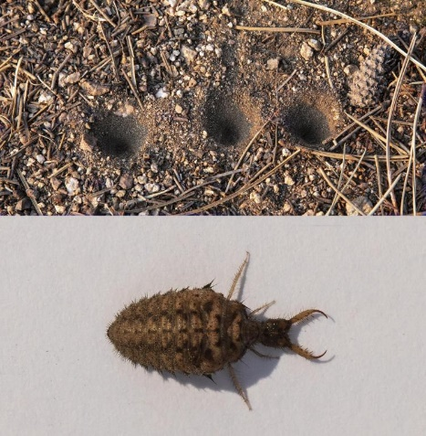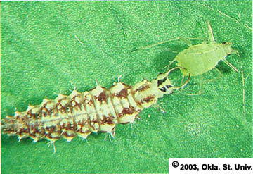

Characters
1-Antennae filiform, multi segments.
2-Chewing mouthparts.
3-Front and hind wing membranous, similar in size. with heavy venation
4-Larvae campodeiform, carnivorous, Aquatic forms have thread-like. gills on most abdominal segments.
5-Pupae exarate.
6-Adults usually predaceous.

Major Families:
A-Suborder: Megaloptera -- aquatic predatory larvae1
1-Family:Corydalidae
2-Family:Sialidae
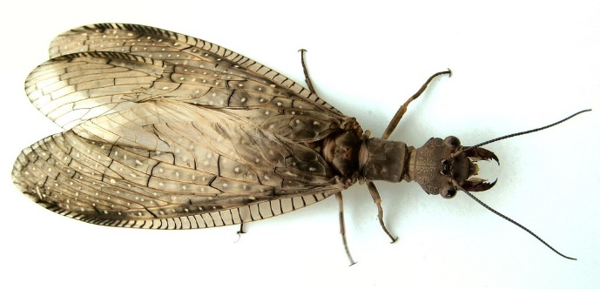

B-Suborder: Raphidioptera -- terrestrial predatory larvae –
Family: Raphidiidae (Snakeflies) –
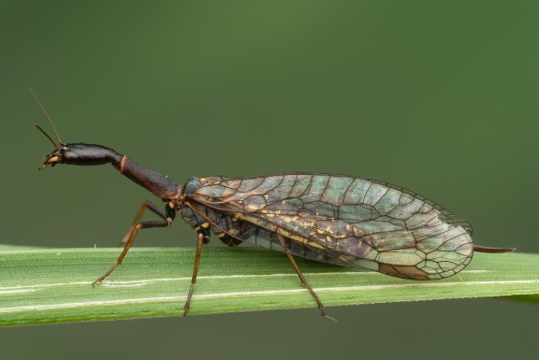
C- Suborder: Planipennia -mostly terrestrial predatory larvae
1-Family:Chrysopidae (Greeen lacewings) –
aphid predators Chrysoperla carnea
. 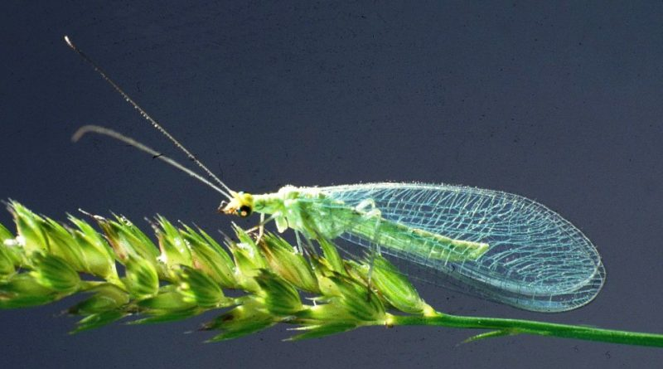
2-Family:Hemerobiidae (Brown lacewings) -- aphid and mite predator
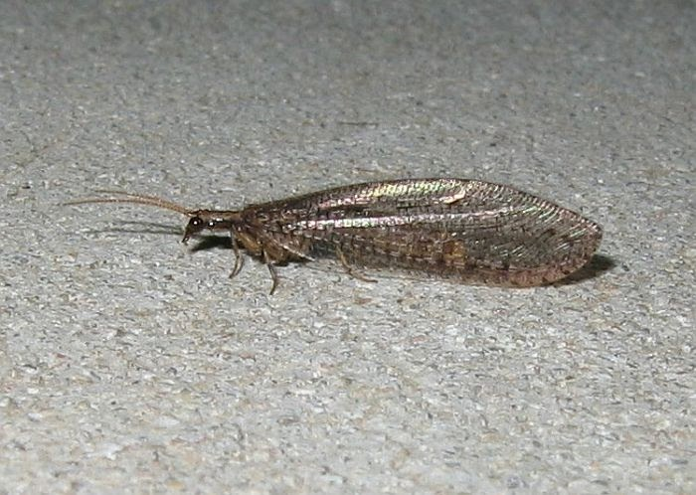
3-Family: Mantispidae ( mantisfly)

2-Order: Mecoptera - Scorpionflies.
Mecoptera, or scorpionflies, are perhaps less universally known than other more popular or speciose orders. Scorpionflies are so-named because males of many species have enlarged genitals that look somewhat like a scorpion’s stinger. Most of the 600 known species have ranges restricted to tropical regions. Are mostly scavengers of decaying plant matter or dead, soft-bodied insects.
Characters
1-Chewing mouthparts
2-Two pairs of wings •
3-Complete metamorphosis
4- Head often elongated
5-Have enlarged genitals that look somewhat like a scorpion’s stinger.

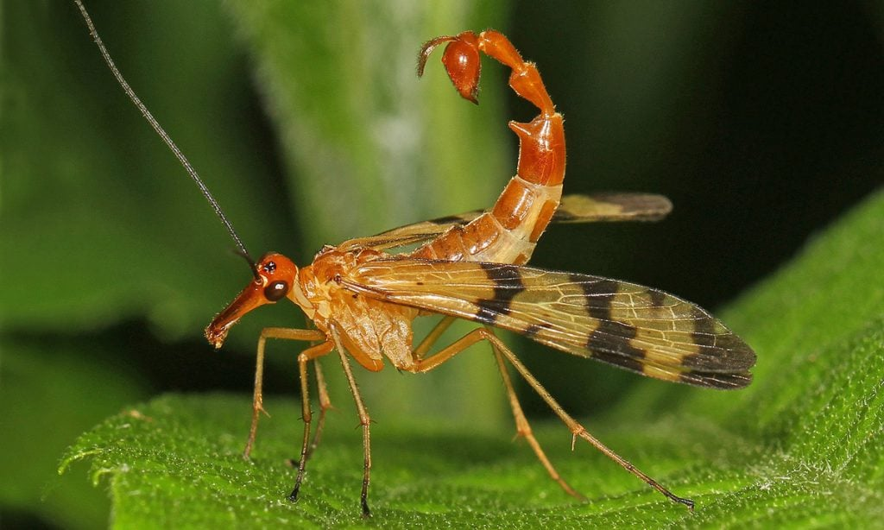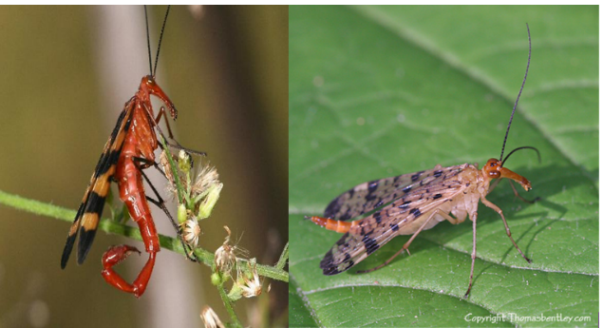

3-Order :Siphonaptera , Fleas As adults,
All fleas are blood-sucking external parasites. Most species feed on mammals, although a few (less than 10%) live on birds. This is an appropriate appellation for these secondarily wingless insects whose mouthparts are adapted for piercing skin and sucking blood. Characteristics:
1-Fleas are small, ranging in size from approximately (1-10)m in length depending on the species.
2-wingless insects. Laterally compressed bodies.
3-Piercing-sucking mouthparts.
4-Enlarged hind legs adapted for jumping.
5-Strong tarsal claws adapted for holding onto their hosts.
6-Backward pointing hairs and bristles for ease of movement through the hair of a host.
7-Small antennae which tuck away into special groves in the head.

Major Families
1-Family: Pulicidae (common fleas) – This family includes most species with economic or medical importance: -
-the cat flea - Ctenocephalides felis
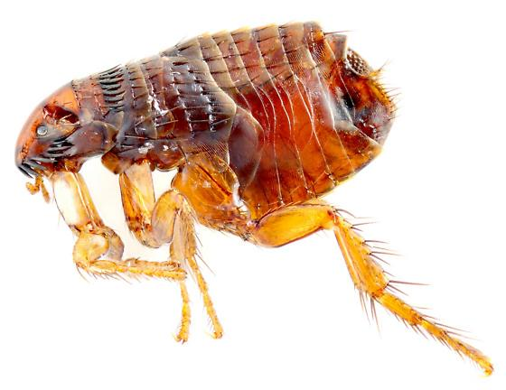
-the dog flea - Ctenocephalides canis
-the human flea - Pulex irritans
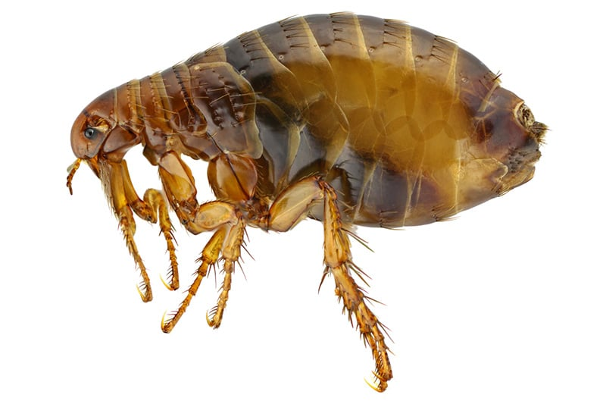
-the rabbit flea -Spilopsyllus cuniculi
2-Family Ceratophyllidae
3-Family Leptopsyllidae e.g. Leptopsylla segnis
4-Family Vermipsyllida

4-Order: Hymenoptera (Ichneumonflies, Ants, Bees, Wasps.)
Hymenoptera is a large order (over 153,000 species) which plays all sorts of interesting ecological roles in the environment and ranging from predators to parasitoids to pollinators. Honey bees are the most familiar as they provide essential pollination.
Characters:
1. Mouthparts are adapted for chewing. In bees both labium and maxillae are integrated to form the chewing lapping.
2. Pronotum is collar like. Mesothorax is enlarged. Metathorax is small. Both prothorax and metathorax are fused with mesothorax.
3. Wings membranous. Wing venation is reduced. Both forwings and hindwings are coupled by a row of hookle (hamuli) present on the leading edge of the hindwing.
4. Abdomen is basally constricted. The first abdominal segment is called propodeum. It is fused with metathorax. The second segment is known as pedicel which connects the thorax and abdomen. Abdomen beyond the pedicel is called gaster.
5. Ovipositor modified for oviposition or stinging or sawing or piercing plant tissue.
6-Larva is rarely eruciform. Pupa is exarate enclosed in a silken cocoon secreted from labial glands.
Classification
This order is subdivided into two suborders.
Symphyta Apocrita
1-Abdomen is broadly joined to the Abdomen is petiolated.
the thorax.
2-Larva is a caterpillar and Larva is a grub and it belongs
belongs to eruciform type to apodous eucephalous type
3-Both thoracic and abdominal Legs are absent
legs are present in larvae
4-Ovipositor is saw like and Ovipositor is not saw like and
suited for piercing the plant is suited for piercing in para
tissue sitic groups or for stinging in other groups.
5-They are phytophagous They are generally parasitic

Classification:

A-Suborder: Symphyta.
1.Family: Tenthredinidae (Sawflies)
2.Family: Cephidae

B-Suborder : Apocrita

Major Families;

1-Family: Sphecidae ( Thread waisted wasp, Digger wasp, Mud dauber)
2-Family: Braconidae

3-Family: Evanidae

4-Family: Vespidae (Yellow jackets, Hornets)
Characters:
1-Lateral extensions of the pronotum reach the point of insertion of wings
5-Abdomen is conical
3-They construct nest with `wasp paper', a substance made from fragments of chewed wood mixed with saliva.
4-They are either solitary or social wasps.
5-They are generally predaceous on Lepidopteran caterpillars.
Yellow banded wasp Vespa cincta is a bee enemy.
Red wasps Vespa orientalis

5-Family: Formicidae (Ants).
Characters:

1-Antennae are geniculate.

2- Mandibles are well developed. Wings are present only in sexually mature forms.

3-They are social insects with three castes queen, males and workers. e.g. Ammophila sp

6-Family: Apidae (Honey bees)

1-Body is covered with branching or plumose hairs.

2-Mouthparts are chewing and lapping type. Mandibles are suited for crushing and shaping wax for building combs.

3-Legs are specialized for pollen collection. Scopa (pollen basket) is present on hind tibia. They are social insects with three castes viz., queen, drone and workers. Indian honey bee Apis indica is a productive insect.

5-Order: Lepidoptera Common names: Moths, Butterflies, Skippers
About 180,000 species of moths and butterflies are in the order Lepidoptera. beautiful, colorful and patterned wings they are known for. Butterflies and moths are often recognized as important pollinators because the adults sip nectar from flowers.
Characters:
1-Body, wings, appendages, are densely clothed with overlapping scales. 2-Mouthparts in adults are of siphoning type. Mandibles are absent.
3-Wings are membranous and are covered with overlapping pigmented scales. Wings are coupled by either frenate or amplexiform type of wing coupling.
4-Larvae are polypod-eruciform type.
5-Pupa is generally obtect. It is either naked or enclosed in a cocoon made out of soil, frass, silk or larval hairs.
Suborder: Ditrysia;
in which the female insects have two pores. The copulatory pore is located in eighth abdominal sternite and the egg pore in ninth abdominal sternite. Remaining insects are grouped under the suborder
2- SubOrder: Monotrysia: in which the female insects have one pore.

BUTTERFLY FAMILIES
1. Family:- Nymphalidae
2. Family:-Lycaenidae
3. Family:-Papilionidae (Swallow tails) e.g. Citrus butterfly , Papilio demoleus.

4. Family:- Pieridae (whites or Sulphurs)
Characters:
1-They are white or yellow or orange coloured with black markings.
2-Larva is green, elongate and covered with fine hairs. e.g. Pieris rapae
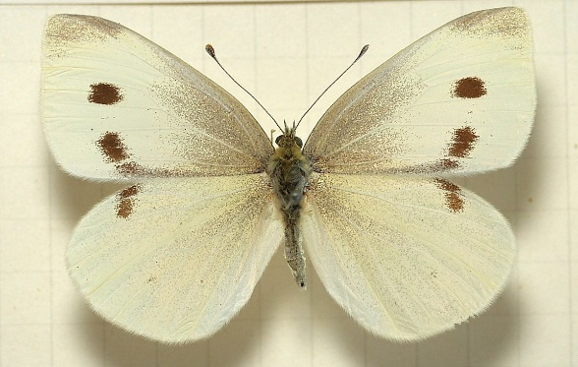
MOTH FAMILIES
1 Family:-Arctiidae (Tiger moths)
2- Family:-Bombycidae (Silk worm moths)
e.g. Mulberry silk worm, Bombyx mori
3- Family:-Lymantridae (Tussock moths).
4- Family:-Noctuidae (Noctua moths).
5- Family:-Sphingidae (Hawk moths, Sphinx moths, Horn worms)
Characters:
1-They are large sized stoutly built moths.
2-Antenna is thick towards middle and hooked at the tip.
3-Proboscis is very long.
4-Forewings are elongated and pointed with very oblique outer margin.
5-Hindwings are reduced in width fitting into the in dented margin of forewings. E.g. Celerio lineate
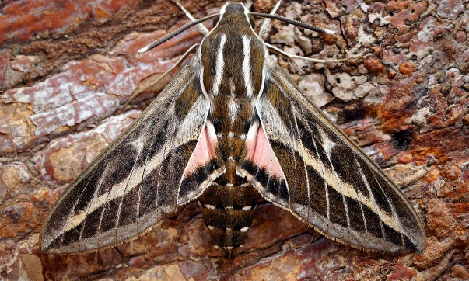

6-Order: Diptera ( True flies, Mosquitoes, Gnats, Midges)
While an estimated 1,000,000 species are in the Diptera order, one of the most economically impactful insects in human society today. Mosquitos and houseflies are well-known to transmit diseases such as malaria or cholera (respectively) to millions of people every year.
Characters:
1-They are small to medium sized, soft bodied insects, body regions are distinct
2- All thoracic segments are fused together
3- Head is often hemispherical and attached to the thorax by a slender neck.
4- Mouthparts are of piercing sucking or sponging or cutting sucking.
5-They have a single pair of wings. Forewings are larger, membranous and used for flight. Hindwings are highly reduced, knobbed at the end and are called halteres.
6-Larvae of more common forms are known as maggots. They are apodous and acephalous.
8-Pupa belongs to the coarctate type.

Classification: This order is divided in to three suborders
A- Suborder: Nematocera (Thread-horn)
1- Antenna is long and many segmented in adult.
2- Larval head is well developed.
3- Larval mandibles act horizontally.
4-Pupa is weakly obtect.
Major Families:
1.Family: Culicidae (Mosquitoes)
e.g. Filarial mosquito : Culex sp transmits filariasis.
2.Family: Cecidomyiidae(Gall midges)
B-Suborder: Brachycera(Short-horn)
1-Antenna is short and few segmented in adult.
2-Larval head is retractile into the thorax

3- Larval mandibles act vertically
4-Pupa is exarate.
Major Families:
1.Family: Tabanidae (Horse flies) e.g. Tabanus eggeri
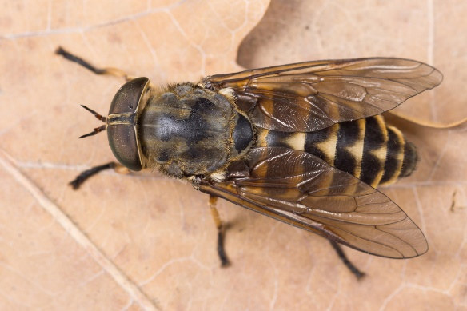
C-Sub order:Cyclorrhapha(Circular-crack)
1-Antenna is aristate in adult.
2-Larval head is vestigial with mouth hooks.
3-Larval mouth hooks act vertically.
4-Pupa is coarctate.
Major Families:
1. Family :Syrphidae (Hover flies, Flower flies) e.g. Syrphus americanus 2.Family:Tephritidae(Fruit flies)
3.Family: Tachinidae(Tachinid flies)
4.Family: Muscidae (House fly) Common house fly: Musca domestica

7-Order:Trichoptera;THRIPS CADDISFLIES
The order Trichoptera, which are commonly called caddisflies, contains approximately 14,500 species worldwide. Adult caddisflies are usually nocturnal and resemble moths, which they are closely related to. The wings of caddisfly adults are covered in hairs, which have the same origin as the flattened scales of moths and butterflies.Trichoptera larvae are frequently associated with creeks, streams and rivers and are usually intolerant of pollution, so the presence or absence of caddisflies can help determine whether a body of water is polluted or not. Larvae are important prey for fish and other larger, aquatic insects.
Characters:
1-Piercing mouthparts
2-Two pairs of wings held like a pup-tent over body
3-Wings covered in hair
5- Complete metamorphosis
6- Immatures are aquatic
