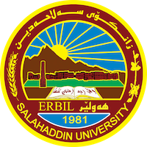
Academic Curriculum Vitae
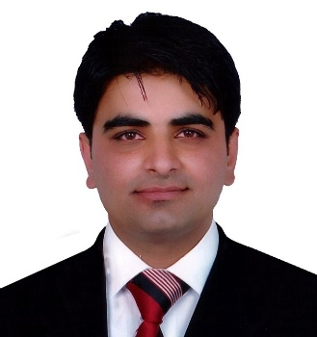
Personal Information:
Full Name: Ghazi Sabah Ahmed
Academic Title: assistant Lecturer
Email: ghazi.ahmed@su.edu.krd
Mobile:07504730955

Education:
- B.Sc. in Mathematics. Mathematics Department- College of Basic Education- Salahaddin University- Erbil in 2006.
- M.Sc. degree in Numerical Analysis at the Eastern Mediterranean University in Cyprus in 2015.
Employment:
- Teaching assistant at the College of basic education / Salahuddin University, Erbil, on 2/12/2007.
- I started a master's degree in 2012-2013 at Eastern Mediterranean University in Cyprus / Department of Science and Art.
- I have been teaching in the Department of Mathematics, College of Basic Education, Salaheddin University, Erbil, since 2019 until now.

Teaching experience:
- Working as Teacher in University of Salaheddin Erbil– College of basic education – Mathematics Department since 2019.
Lessons taught:
- Numerical Analysis / third stage
- MATLAB programming / second stage
- Computer Skills / first stage

Other Qualifications

LANGUAGES
Good on English, very good in Arabic, and Kurdish (Mother Language).

Professional Social Network Accounts:

- Ghazi AHMED | Assistant Lecturer | Master of Science | Salahaddin University - Erbil, Erbil | SUH | College of Basic Education, Mathematics | Research profile (researchgate.net)

- Ghazi Ahmed - Assistant Lecturer - College of Easic Education | LinkedIn

- Ghazi Sabah Ahmed‬ - Google Scholar‬

- Ghazi Ahmed (0009-0001-1192-1265) (orcid.org)

