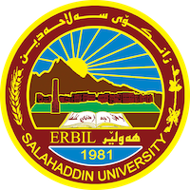
Academic Curriculum Vitae
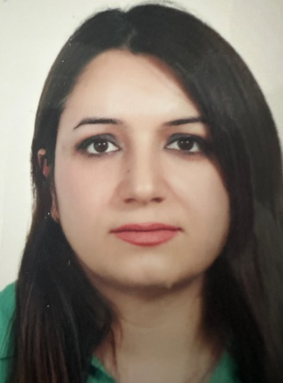
Personal Information:
Full Name: Gona Sirwan Sharif
Academic Title: lecturer
Email: gona.sharif@su.edu.krd
Mobile:07702155967

Education:
- State all educations accomplished
- BSc: 2005 college of agricultural engineering science
- MSc: 2012 college of agricultural engineering science
- Phd:2020 college of agricultural engineering science

Employment:
- State employment starting from first employment
I began my employment within the College of Agriculture at the Horticulture department of the University of Sulaymania on March 11, 2006.
Qualifications
Teaching qualifications:
IT qualifications: word, excel, power point
Language qualifications IELTS: 5
Any professional qualification: NONE
You could put any professional courses you have attended:
election course,
IELTS Course,
general English course,

Teaching experience:
- State all teaching courses you delivered, stating undergraduate or post graduate
- A) College of Agriculture, Plant protection department/University of Salahaddin-Erbil (November 2012 - present)

- As an assistant lecturer, my teaching experience includes:

- Assisting in teaching Insect Physiology to third-year students from 2012 to 2013.
- Assisting in teaching Field Crop Insects to fourth-year students from 2013 to 2014.
- Assisting in teaching Insect Storage to fourth-year students from 2014 to 2015.
- Serving as a member of the examination committee for the 2nd trial (first & second semester of 2012-2013).
- Serving as a member of the examination committee for the 2013-2014 semester.
- Being a member of the Quality Assurance committee in the Plant Protection department from 2013 to 2014.
- (B) College of Agriculture, Plant protection department/University of Salahaddin-Erbil (October 2008 - October 2009)

- As an assistant agricultural engineer at the University of Salahaddin-Erbil, my duties included:

- Assisting in teaching Biological Control.
- Assisting in teaching Field Crop Disease.
- Assisting in teaching Bee Breeding.
- Assisting in teaching Medical and Veterinary Insects.
- Assisting in teaching Forest Insects.
- Assisting in teaching Insect Physiology.
- Being a member of the welcoming committee for new students in the Agriculture college in 2008-2009.
- (C) College of Agriculture, Horticulture department/University of Sulaymania (June 2006 - September 2008)

- As an assistant agricultural engineer at the University of Sulaymania, I assisted the lecturer assistant in teaching:

- Insect Morphology.
- Insect Taxonomy.
- Courses, trainings, lab supervision, etc.,

Research and publications
- State all researches, publication you made.
1.Detailed Review of the Morphology and Life Cycle of the Codling Moth, Cydia Pomonella (l.) (Lepidoptera, Tortricidae), and Its DNA Barcodes
2. Cydia pomonella (L.) (Lepidoptera: Tortricidae) Larvae Infestation on Apple Trees According to Canopy Aspects

Conferences and courses attended
- Give details of any conferences you have attended, and those at which you have presented delivered poster presentations.

Funding and academic awards
- List any bursaries, scholarships, travel grants or other sources of funding that you were awarded for research projects or to attend meetings or conferences.
- none

Professional memberships
- List any membership you hold of any professional body or learned society relevant to your research or other life activities.
- Kurdistan agricultural syndicate
- Kurdistan teacher union

Professional Social Network Accounts:

- List your profile links of ReserchGate, LinkedIn, etc.

It is also recommended to create an academic cover letter for your CV, for further information about the cover letter, please visit below link:
https://career-advice.jobs.ac.uk/cv-and-cover-letter-advice/academic-cover-letter/

