Intelligent Home Automation System

A B.Sc. project Submitted to the department of Electrical Engineering in Partial Fulfillment of the Requirements for the degree of B.Sc. In Electrical Engineering

By:
- Snur Kamiran
- Hajar Nazhad
- Abdullah Joma
- Barez Qaraman

Supervised by: Mr.Goran W. Hama Ali

Dedication

We dedicate this project to Almighty God for His enablement towards the completion of our research project to our supervisor, our parents and guidance.

Acknowledgment

This research work has been a great journey for us and has helped us to understand an area of work that is vast and wonderful. It has been completed with months of hard work and dedication and would not have been possible if not for the blessing and guidance we have received from a number of people. For this we are particularly indebted to our supervisor Mr. Goran W. Hama Wali who has not only been a guide but also a mentor whom we could depend on for advice, encouragement, and support.
And we would like to thank our families for their support and understanding given to us during this period.

Abstract

Easy Home or Home automation plays a very important role in modern era because of its flexibility inusing it at different places with high precision which will save money and time by decreasing human hardwork. Prime focus of this technology is to control the household equipment’s like light, fan, door, AC etc. automatically. This research paper has detailed information on intelligent automation system in homes and cities using Arduino, bluetooth and how we can control home appliances using Android application.

Table of Contents
Dedication 2
Acknowledgment 3
Abstract 4
Table of Contents 5
List of Figures 6
Chapter One: Introduction 7
- Problem statement 8
- Objective 9
Chapter Two: Definitions 11
- Microcontrollers 11
- Sensors 13
- Actuators 20
- Communication & other devices 24
Chapter Three: Methodology 25
Chapter Four: Test & Results 29
Chapter Five: Conclusion 30
Appendix – Arduino Code 31

List of Figures

Figure 1: Arduino UNO 11
Figure 2: Raspberry PI 12
Figure 3: Motion Sensor (HC-SR501). 13
Figure 4: Gas Sensor (MQ2) 14
Figure 5: Flame Sensor 15
Figure 6: Temperature Sensor (DHT22) 16
Figure 7: Light vs resistance 17
Figure 8: Light Sensor (LDR) 17
Figure 9: Ultrasonic Sensor (HC-SR04) 18
Figure 10: IR Sensor & its demonstration 19
Figure 11: Servo Motor 20
Figure 12: Buzzer 21
Figure 13: Relay Module 21
Figure 14: 16*2 LCD display 22
Figure 15: 3v Water pump 23
Figure 16: Bluetooth Module (HC-05) 24
Figure 17: Breadboard 24
Figure 18: Arduino in Action 25
Figure 19: 8 channel Relay Module in Action 25
Figure 20: Temperature Sensor and 9v Fan 26
Figure 21: Solar panel 27
Figure 22: Top view of the House 28
Figure 23: Wiring Diagram 28

Chapter one Introduction

Smart home is the integration of technology and services through home networking for a better quality of living. It uses different technologies to equip home parts for more intelligent monitoring and remote control and enabling them for influential harmonic interaction among them such that the everyday house works and activities are automated without user intervention or with the remote control of the user in an easier, more convenient, more efficient, safer, and less expensive way. In some cases, integrating the home services allows them to communicate with one another through the home controller, thereby enabling single button to control the various home systems according to preprogrammed scenarios or operating modes.
Smart homes have the potential to improve home comfort, convenience, security and energy management. Moreover it can be used for elder people and those with disabilities, providing safe and secure environments.

Problem statement

In the present day home automation is becoming essential for the purpose of improving our life condition. Convenience and ease of using home appliances is what home automation is offering. Home automation offers a futuristic way of life in which an individual gets to control his entire house using a smart phone, from turning on a TV to locking/unlocking doors, it also offers am efficient use of energy.
Sometimes a person in a room forgets to switch off the lights and fans which lead to wastage of energy. Automation leads to control of energy according to the human. When we don’t require energy it automatically get switched off and thus save power.
But to get acquire such system installed will cost a lot of money and that is the major reason of why home automation has not received much demand and attention, adding to that also the complexity of installing it and configuring it. Thus it is essential to make it cost effective and easy to configure, if this is granted to people then they will be welling to acquire it in their homes, Office and schools. In other words a system modification for the home automation is required in order to lower the price of applying it to houses. Also home automation offers ease of mind and body to handicapped and/or elders in their houses by just one click to do what they want as state above.

We can say traditional house faces the following problems:

- More human interaction.
- Less secure.
- Not convenience.
- Uncontrollable.

Objectives

Automation is a system installed into your home, either during the building stages, or retrofitted after the time. Smart Home Technology, or Home Automation, coordinates the technology in your home into one streamline system. Automation is then customized to fit your unique lifestyle through an interface that is easy enough for your family to enjoy.

- Security: safe from top to bottom... You will feel peaceful when you can control the safety of your family with smart security system...
No matter where you are, you can control your home security system. You can integrate door locks and set the alarm system with single (the gadgets send to the homeowner a notification) touch when you leave the house or before sleeping, security systems, CCTV camera and surveillance devices to your smart home automation system and turn your house into a secure fortress.

- Convenience: you do not necessarily need to go individually to each room in your house to ensure that the lights are switched off, your windows are closed or the fans are off and whatnot. All of this is easily controlled by the help of a smart home, and you can flick the switch on/off of each individual room or the entire house in one go.

- Make life easy: Comfort is key we all want as much of it as possible, and nothing says comfort like have things turn on exactly when and where you need them. You can start with accessories as simple as smart lights. These can trigger via voice commands, location rules, sensor detection, or hand-picked schedules.

For example with the help of smart lights, you can forget about leaving them switched on while you step out of your home every day for work.

- Controlling home appliances via applications for example watering your garden: RACHIO smart sprinkler waters your yard effortlessly and automatically, it creates tailored smart schedules based on the specific needs of your lawn. The RACHIO system is merely a smart controller, you would be using your own sprinkler system with it. Once the device is connected and ready to fire, all you need to do is to set up schedules on it using your smartphone. The best part of this gadget is that it has a built-in weather data of your geo-location and it would skip the sprinkling on that particular day and gadget alone.

- Save time: smart homes reduce the amount of time that we spend on little, arduous tasks on a daily basis. Tasks such as switching between certain appliances or having to go back home to see if you turned off the cooker, anyone who parks their car at home in a garage knows the feeling when you're halfway down the block only to frantically make a U-turn because you can't remember if you closed the garage door. We've all been there and we know the hassle. But what if it didn't have to be a hassle? What if you could just open an app to check your garage door and even use that app to open or close it? And what if you could ask the voice assistant on your phone to do it for you with just a simple command? All this is possible with intelligent home automation system.

Chapter two Definitions

Microcontrollers:

- Arduino Uno
Arduino is an open-source platform used for various electronics projects which consist of both a physical programmable circuit board Known as a microcontroller and software or IDE ( integrated development environment), that runs on your computer, used to write and upload computer code to the physical board.
The ATmega328P is Arduino Uno's microcontroller in the AVR microcontrollers family manufactured by Atmel which is now acquired by Microchip technology, has 14 digital I/O pins which (6 of them can be used as PWM outputs) and 6 analog inputs and 10-bit ADC which can read from 0 to 5v or you can use AREF pin to use an external source to get better resolution, an ICSP(In-circuit Serial programming) headers and it can support UART, SPI, 12C communications, a 16Mhz quartz crystal oscillator a USB connection, power jack, and reset button. Arduino runs on 5v, It has a 5v voltage regulator so that you can connect Ac to Dc adapters or batteries to power it safely. The digital I/O pins can source or sink 40mA so we must be aware of that not damaging the microcontroller.

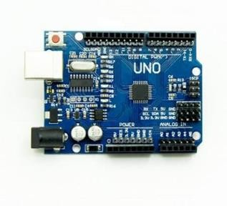

Figure 1: Arduino Uno

Raspberry pi
Raspberry Pi is a series of small single-board computers (SBCs) developed in the United Kingdom by the Raspberry Pi Foundation in association with Broadcom.
It is a capable little device that enables people of all ages to explore computing and to learn how to program in languages like Scratch and Python. It’s capable of doing everything you’d expect a desktop computer to do, from browsing the internet and playing high-definition video, to making spreadsheets, word-processing, and playing games. The Raspberry Pi is a very cheap computer rather than a microcontroller that runs on Linux, but it also provides a set of GPIO (general purpose input/output) pins, allowing you to control electronic components for physical computing and explore the Internet of Things (IOT). There are three series of Raspberry Pi(Raspberry Pi, Raspberry Pi Zero, Raspberry Pi Pico), and several generations of each have been released. Raspberry Pi SBCs feature a Broadcom system on a chip (SOC) with an integrated ARM-compatible central processing unit (CPU) and on-chip graphics processing unit (GPU), while Raspberry Pi Pico has a RP2040 system on chip with an integrated ARM-compatible central processing unit (CPU).
You can program it using either Python or Scratch programming language, you can add an external keyboard, monitor camera SD card memory as well as a 5v power supply to be able to use it.

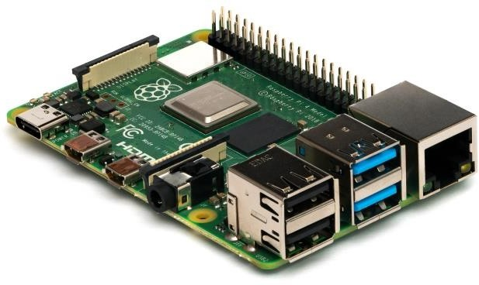
Figure 2: Raspberry PI

Sensors:

Motion sensor(PIR sensor)
PIR (passive infrared) sensor is specially designed to detect levels of infrared radiation. It consists of two main parts: A Pyroelectric Sensor and A special lens called the Fresnel lens which focuses the infrared signals onto the pyroelectric sensor. A Pyroelectric Sensor has two rectangular slots in it made of a material that allows the infrared radiation to pass. Behind these, are two separate infrared sensor electrodes, one responsible for producing a positive output and the other a negative output. The reason for that is that we are looking for a change in IR levels and not ambient IR levels. The two electrodes are wired up so that they cancel each other out. If one half sees more or less IR radiation than the other, the output will swing high or low. It has 3 pins Vcc ground and digital output signal, you can adjust the range and how long the time remain high after detection by 2 potentiometers, the range is from 3 to 7 meters and the time is from 3 seconds to 5 minutes, and it has 2 modes of operation H & L mode, In H mode it will output high as long as the movement is there while in L mode the output will go high for the period set by potentiometer adjustment. It has some extra optional features which are RL and RT normally they don't appear in the module board but u can add it as per your application they will extend the operation of the module in extreme temperatures and work at night as well.

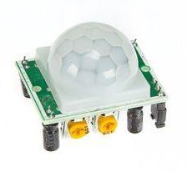
Figure 3: Motion Sensor (HC-SR501)

Gas sensor (MQ2)
MQ2 is one of the commonly used gas sensors in the MQ sensor series. It is a Metal Oxide Semiconductor (MOS) type Gas Sensor also known as Chemiresistors as the detection is based upon a change of resistance of the sensing material when the Gas comes in contact with the material. Using a simple voltage divider network, concentrations of the gas can be detected.
MQ2 Gas sensor works on 5V DC and draws around 800mW. It can detect LPG, Smoke, Alcohol, Propane, Hydrogen, Methane, and Carbon Monoxide concentrations anywhere from 200 to 10000ppm. It has 4 pins VCC & ground digital & analog output data, and u can control the sensitivity of the sensor by a little trimmer potentiometer turning clockwise to increase sensitivity and vice versa.

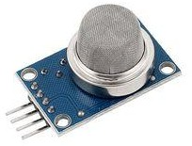

Figure 4: Gas Sensor (MQ2)

Flame sensor
The Grove – Flame Sensor can be used to detect fire sources or other light sources of the wavelength in the range of 760nm – 1100 nm. It is based on the YG1006 sensor which is a high speed and high sensitive NPN silicon phototransistor. Due to its black epoxy, the sensor is sensitive to infrared radiation. In a fire fighting robot game, the sensor plays a very important role; it can be used as a robot’s eyes to find the fire source. It has 4 pins Vcc & ground and digital & analog output data; you can control the sensitivity through onboard potentiometer with a detection angle of 60 degrees.

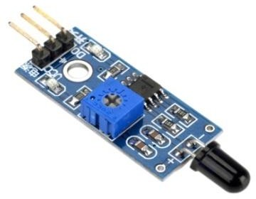

Figure 5: Flame Sensor

Temperature & Humidity Sensor (DHT22)
We have two versions of the DHTxx sensor series (DHT11 & DHT22). They look a bit similar and have the same pinout, but have different characteristics. We are here using DHT22.
The DHT22 is the more expensive version that has better specifications. Its temperature measuring range is from -40°C to +125°C with +-0.5 degrees accuracy, DHT22 sensor has better humidity measuring range, from 0 to 100% with 2-5% accuracy.
It senses temperature by NTC thermistor which is nothing more than a resistor that decreases when the temperature goes up it has negative temperature coefficient while the humidity is capacitive based humidity sensor it has 2 electrodes and a dielectric which is humidity dependent, higher relative humidity increases the value of the capacitor formed by these 2 electrodes and the humidity dependent dielectric and vice versa. It has 4 pins which 3 of them are used VCC ground and digital output signal.

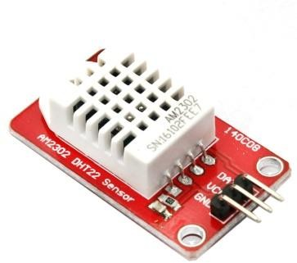

Figure 6: Temperature Sensor (DHT22)

Light sensor (LDR)
A Light Sensor generates an output signal indicating the intensity of light by measuring the radiant energy that exists in a very narrow range of frequencies basically called “light”, and which ranges in frequency from “Infra-red” to “Visible” up to “Ultraviolet” light spectrum.
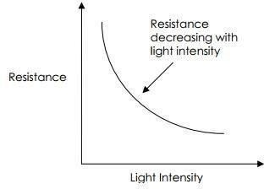
The most common type of LDR has a resistance that falls with an increase in the light intensity falling upon the device. The resistance of an LDR may typically have the following resistances:

Daylight = 5000Ω Dark = 20000000Ω

Figure 7: Light vs Resistance

You can therefore see that there is a large variation between these figures. If you plotted this variation on a graph you would get something similar to that shown by the graph shown above.

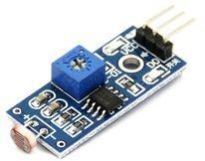

Figure 8: Light Sensor (LDR)

Ultrasonic sensor(HC-SR04)
An ultrasonic sensor is an electronic device that measures the distance of a target object by emitting ultrasonic sound waves, and converts the reflected sound into an electrical signal. Ultrasonic waves travel faster than the speed of audible sound (i.e. the sound that humans can hear). In order to calculate the distance between the sensor and the object, the sensor measures the time it takes between the emissions of the sound by the transmitter to its contact with the receiver.

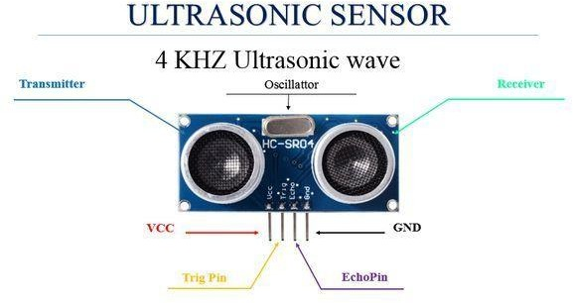

Figure 9: Ultrasonic Sensor (HC-SR04)

IR sensor
IR sensor is an electronic device that emits the light in order to sense some object of the surroundings. An IR sensor can measure the heat of an object as well as detects the motion. Usually, in the infrared spectrum, all the objects radiate some form of thermal radiation. These types of radiations are invisible to our eyes, but infrared sensor can detect these radiations. The emitter is simply an IR LED (Light Emitting Diode) and the detector is simply an IR photodiode. Photodiode is sensitive to IR light of the same wavelength which is emitted by the IR LED. When IR light falls on the photodiode, the resistances and the output voltages will change in proportion to the magnitude of the IR light received.

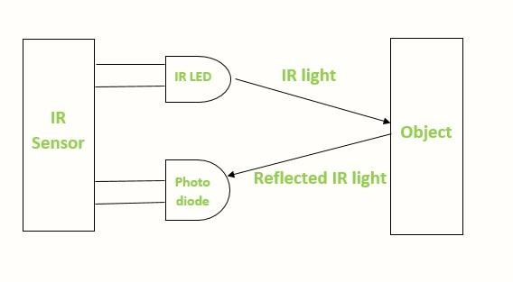
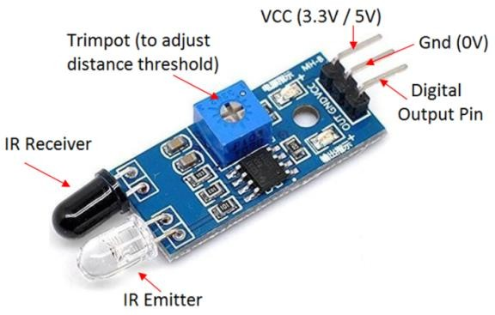
Figure 10: IR Sensor and its demonstration

Actuators:
- Servo motor
Servo is a general term for a closed-loop control system.
A closed-loop system uses the feedback signal to adjust the speed and direction of the motor to achieve the desired result. RC servo motor works on the same principle. It contains a small DC motor connected to the output shaft through the gears. The output shaft drives a servo arm and is also connected to a potentiometer (pot). The potentiometer provides position feedback to the servo control unit where the current position of the motor is compared to the target position. According to the error, the control unit corrects the actual position of the motor so that it matches the target position. You can control the servo motor by sending a series of pulses to the signal line. A conventional analog servo motor expects to receive a pulse roughly every 20 milliseconds. The length of the pulse determines the position of the servo motor, for 0° angle, the length of the pulse should be 1ms if the pulse is higher than 1.5ms the servo will be at its center position if the pulse length is within 2ms the servo will at 180° while pulses ranging from 1ms to 2ms will move the servo shaft through the full 180° of its travel.

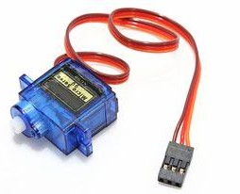

Figure 11: Servo Motor

Buzzer
A buzzer or beeper is an audio signaling device, which may be mechanical, electromechanical, or piezoelectric. Typical uses of buzzers and beepers include alarm devices, timers, and confirmation of user input such as a mouse click or keystroke.
There are two types of buzzers active & passive the active one works with DC while the passive one u have to feed an audio signal.

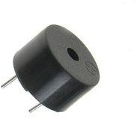

Relay

Figure 12: Buzzer

A relay is an electrically operated switch. It consists of a set of input terminals for a single or multiple control signals, and a set of operating contact terminals. The switch may have any number of contacts in multiple contact forms, such as make contacts, break contacts or combinations thereof. It has normally open and normally close you can use either NC or NO as per your application.

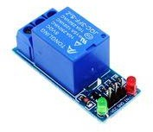

Figure 13: Relay Module

LCD
The term LCD stands for liquid crystal display. It is one kind of electronic display module used in an extensive range of applications like various circuits & devices like mobile phones, calculators, computers, TV sets, etc. These displays are mainly preferred for multi-segment light-emitting diodes and seven segments. The main benefits of using this module are inexpensive; simply programmable, animations, and there are no limitations for displaying custom characters, special and even animations, etc.

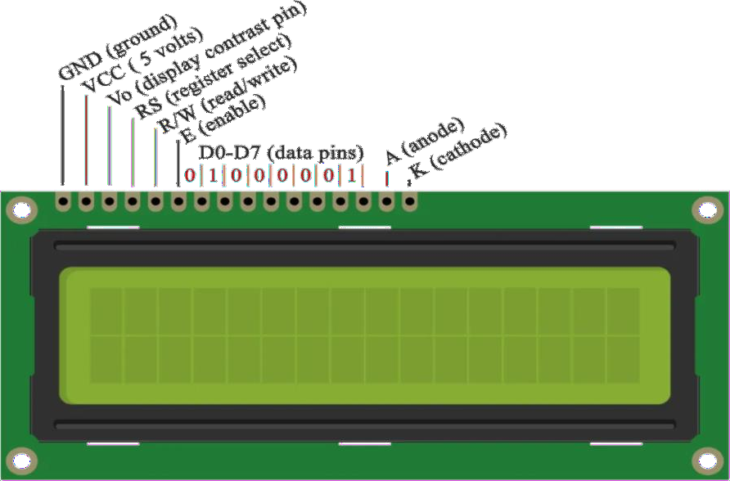

Figure 14: 16*2 LCD display

Water pump
This is a low cost mini submersible type water pump that works on 3-6V DC. It is extremely simple and easy to use. Just immerse the pump in water, connect a suitable pipe to the outlet and power the motor with 3-6V to start pumping water. Great for building science projects, fire-extinguishers, firefighting robots, fountains, waterfalls, plant watering systems etc.

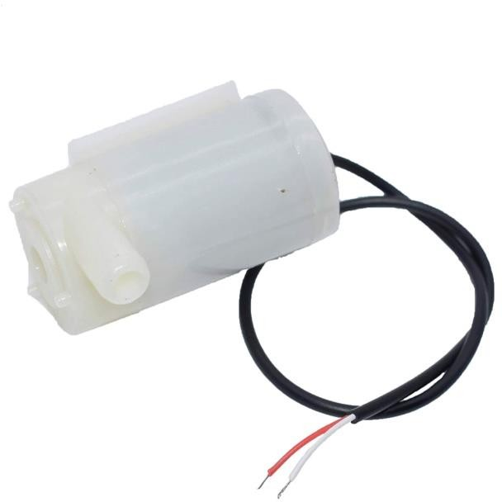

Figure 15: 3v water pump

Communication device:

- Bluetooth (HC-05)
HC 05 Bluetooth is a wireless communication protocol; it is used in two devices as a sending and receiving the information. The Bluetooth is free to use in the wireless communication protocol as the range of the Bluetooth is less than the other wireless communication protocols like Wi-Fi and ZigBee. The Bluetooth operates at the frequency of the 2.41 GHz and also used in many small ranges of applications.

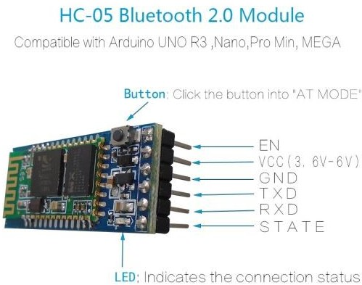

Figure 16: Bluetooth Module (HC-05)

Other devices: Breadboard
A breadboard is a simple device designed to let you create circuits without the need for soldering. They come in various sizes, and the design can vary, but as a general rule they look something like this:
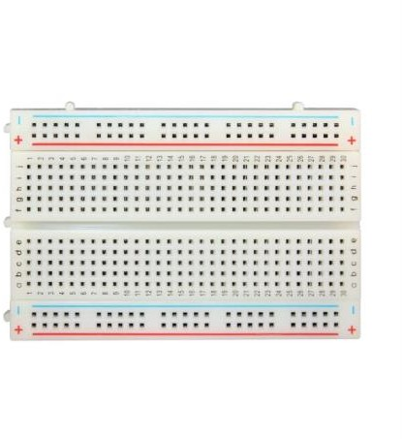

Figure 17: Breadboard

Chapter Three Methodology
- We are using Arduino Uno as our microcontroller, we are using it to receive signals from sensors and then send signals to the actuators to do a particular job.

Here is a picture of it:
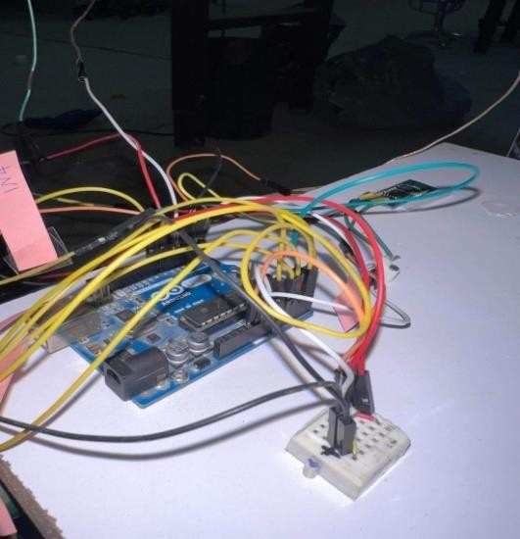
Figure 18: Arduino in Action

- Controlling several actuators with Arduino is not possible because it is limited to source or sink a very little current; here is why we will be using relay modules to control our actuators.

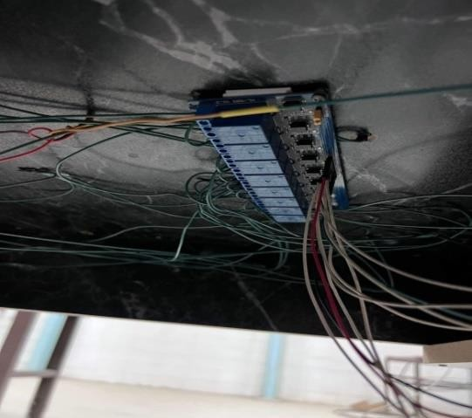

- Measuring temperature accurately is very essential when it comes to smart houses here is why we are using a digital temperature sensor that measure the temperature very accurately. We will be using DHT22 temperature sensor that senses the temperature and sends it to the Arduino to control a fan.
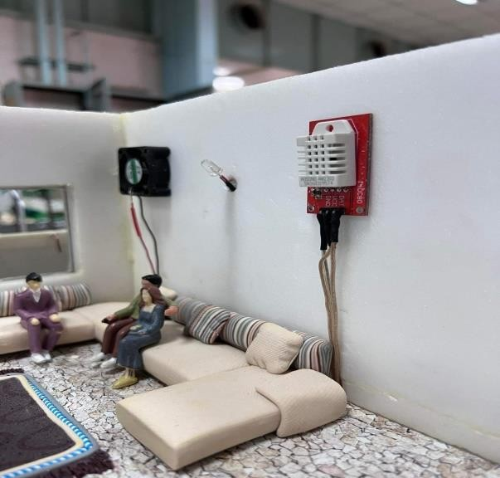
Figure 20: Temperature Sensor and 9v Fan

- Detecting Gas & fire is a safety feature that should be in every kitchen. Here we are using a (MQ2) as a gas sensor and (flame sensor) to detect any fire or flames that can occur and they send signals to Arduino to warm.
- Controlling our house lighting is very inefficient by just using our hands here is why we will be using (light sensor) to detect whether it is day or night and send signals to Arduino to control our lights.
- Searching for position to park your car without Knowing whether there is a empty or filled position is just a tiresome here is why we using (IR sensor) to detect whether the position is empty or fill and send signal to Arduino to monitor that with two LEDs red for filled green for empty.
- Opening a door automatically while you are just stay for a second infront of it is just an essential part of smart house, here we are using (HC-SR04) Ultrasonic sensor that it can sense whether motion is there or not and sends signal to
arduino to control a servo in order to open a door.

- Arduino can not work by itself we have to tell it what to do here we are using (HC-05) bluetooth module as our communication device to send a signal to arduino as per our requirement.
- Our project contains several actuators that arduino by itself can not supply them. We decided to supply our project with a 9v power source that we bulit it with 6 Lithium ion battery, a nominal voltage of Lithium ion battery is 3.7v.We connected 2 of them in series to to get 7.2v and 3 of them in parallel to increase (mAh) milliamps per hour and then we used a Dc to Dc converter module that can boost the battery voltage to 9v.
- Our apartments are supplied with a 5v solar panel than can light up all of them easily when the sun is there it will charge the internal battery and when you cover the panel the lights will turn on.

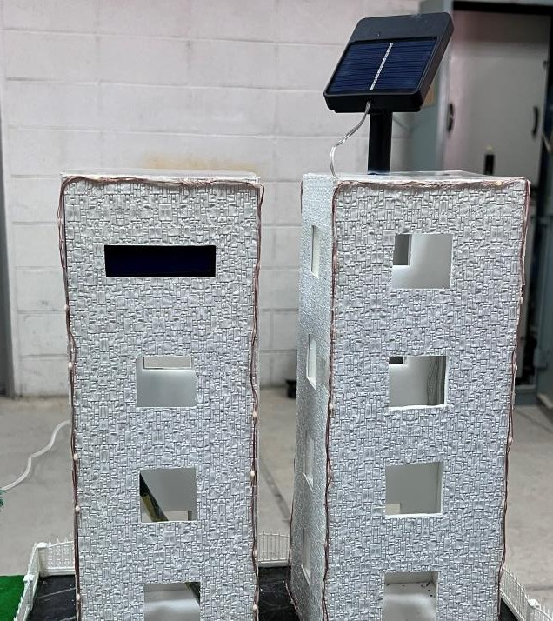

Figure 21: Solar Panel

Here is the picture of the house:
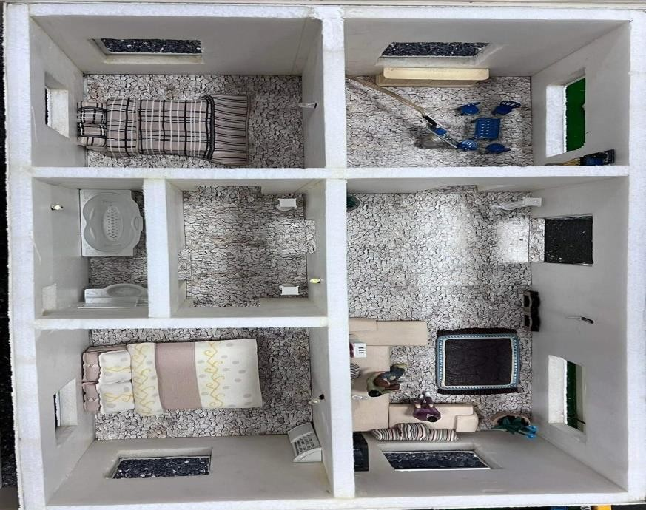

Figure 22: Top view of the

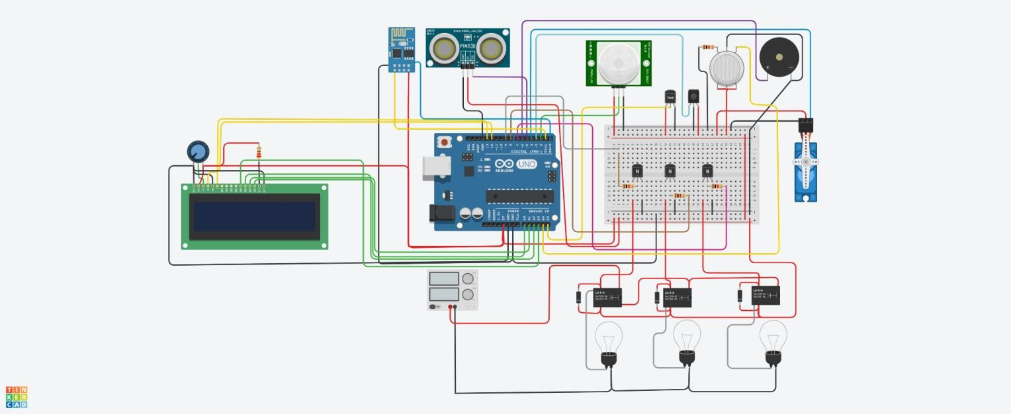
System design

Figure 23: Wiring Diagram

Chapter Four

Implementation & Result

In this chapter we will explain that how we implemented the sensors or actuaters and the results:

4.1 House lighting (LED)s: using LEDs for all parts of the house lighting and cotrolling it by a Bluetooth.

The code of the lighting:
'a' when turning ON and 'b' when turning OFF
const int led = 2;

void setup() {
Serial.begin(9600);
pinMode(led, OUTPUT);
}

void loop() {
char c = Serial.read();
if(c == 'a'){
digitalWrite(led, HIGH);
}
else if(c == 'b'){
digitalWrite(led, LOW);
}
else{

}
delay(25);
}

4.2 light sensor (LDR): we used it in the garden to turning on the garden lights at night. It sense a darkness the output will be high and makes the light glow in dark but in light the output will be low it turns the light off.

The code of sensor:
int ldr=A0;//Set A0(Analog Input) for LDR.
int value=0;
void setup() {
Serial.begin(9600);
pinMode(3,OUTPUT);
}

void loop() {
value=analogRead(ldr);//Reads the Value of LDR(light).
Serial.println("LDR value is :");//Prints the value of LDR to Serial Monitor.
Serial.println(value);
if(value<300)
{
digitalWrite(3,HIGH);//Makes the LED glow in Dark.
}
else
{
digitalWrite(3,LOW);//Turns the LED OFF in Light.
}
}

4.3 temperature sensor & fan: we used those in the living room, when the weather is hot the temprator sensor sense it and it makes the fan on.

The code of a sensor:

// Declare all the pins
int temp = A0;
int greenLed = 2;
int redLed = 4;
int fan = 7;
int buzzer = 8;

int thresholdValue = 0;
int celsius = 0;
int fahrenheit = 0;

// Functions for various work
void greenLightOn(){
digitalWrite(greenLed, HIGH);
}
void greenLightOff(){
digitalWrite(greenLed, LOW);
}
void redLightOn(){
digitalWrite(redLed, HIGH);
}
void redLightOff(){
digitalWrite(redLed, LOW);
}
void fanOn(){
digitalWrite(fan, HIGH);
}
void fanOff(){
digitalWrite(fan, LOW);
}
void buzzerOn(){
digitalWrite(buzzer, HIGH);
}
void buzzerOff(){
digitalWrite(buzzer, LOW);
}

void setup()
{
pinMode(redLed, OUTPUT);
pinMode(greenLed, OUTPUT);
pinMode(fan, OUTPUT);
pinMode(buzzer, OUTPUT);
pinMode(temp, INPUT);
Serial.begin(9600);
}

void loop(){

// Temperature calculation
celsius = map(((analogRead(A0) - 20) * 3.04), 0, 1023, -40, 125);
fahrenheit = ((celsius * 9) / 5 + 32);

Serial.print(celsius);
Serial.print(" C : ");
Serial.print(fahrenheit);
Serial.println(" F");

if( celsius<= 30){
greenLightOn();
redLightOff();
fanOff();
buzzerOff();
//Serial.println("green light on");
}
else if(celsius >= 31 && celsius <= 40){
greenLightOff();
fanOff();
buzzerOff();
redLightOn();
//Serial.println("red light on");
}
else if(celsius > 40){
redLightOn();
fanOn();
buzzerOn();
greenLightOff();

//Serial.println("Red Light On | Fan on");
}
else{
Serial.println("Temperature is Normal");
}
delay(1000);
}

4.4 Gas sensor (MQ2) & Buzzer: a gas sensor used in the kitchen and it sense a the atmospheres presence or concentration of gases.

When a gas sensor sense any gas or smoke in a kitchen it makes the buzzer on to alert us know that there is a gas presence.

The code of a sensor:
int red_LED_PIN = 11;
int green_LED_PIN = 9;
int blue_LED_PIN = 10;
int buzzer = 6;
int smoke_detector = A0;
int safety_lim = 60; //Sets smoke density safe limit

void setup() {
pinMode(red_LED_PIN, OUTPUT);
pinMode(green_LED_PIN, OUTPUT);
pinMode(blue_LED_PIN, OUTPUT);
pinMode(buzzer, OUTPUT);
pinMode(smoke_detector, INPUT);
Serial.begin(9600); //baud rate
}

void loop() {
int sensor_read = analogRead(smoke_detector);
//reads and stores the reading from the detector in sensor_read

Serial.print("Smoke Density: ");
Serial.println(sensor_read);

if (sensor_read > safety_lim)
// Checks if reading is beyond safety limit
{
analogWrite(red_LED_PIN,255);
analogWrite(green_LED_PIN, 0);
tone(buzzer,500, 100); //piezo rings
}
else
{
analogWrite(green_LED_PIN, 255);
analogWrite(red_LED_PIN,0);
noTone(buzzer); //peizo wont ring
}
delay(50);
}

4.5 flame sensor: also used it in the kitchen it detecting a flame and makes the buzzer on to alert tell us there is a big problem on the kitchen.

The code of a sensor:
int buzzer = 4;
int LED = 13;
int flame_sensor = 3;
int flame_detected;

void setup()
{
Serial.begin(9600);
pinMode(buzzer, OUTPUT);
pinMode(LED, OUTPUT);
pinMode(flame_sensor, INPUT);
}

void loop()
{
flame_detected = digitalRead(flame_sensor);
if (flame_detected == 1)
{
Serial.println("Flame detected.");
tone(buzzer,65,500);
digitalWrite(LED, HIGH);
}
else
{
Serial.println("no fire detected");
digitalWrite(LED, LOW);
}
delay(1000);
}

4.6 Ultrasonic sensor & Srvo motor:we used it in front of the house door to snese a car or a person that they come home then makes a servo motor on to opening the door.also we used the servo motor for the apartment garage door.

The code of s sensor:
#include <Servo.h>
Servo servo1;
int trigPin = 9;
int echoPin = 8;
long distance;
long duration;

void setup()
{
servo1.attach(7);
pinMode(trigPin, OUTPUT);
pinMode(echoPin, INPUT);// put your setup code here, to run once:
}

void loop() {
ultra();
servo1.write(0);
if(distance <= 10){
servo1.write(90);
}
}

void ultra(){
digitalWrite(trigPin, LOW);
delayMicroseconds(2);
digitalWrite(trigPin, HIGH);
delayMicroseconds(10);
digitalWrite(trigPin, LOW);
duration = pulseIn(echoPin, HIGH);
distance = duration*0.034/2;
}

4.7 IR sensor: the IR sensor used in the apartment garage and connected with two LEDs red and green to tell drivers that there is a place to parking or not if there is a palce it makes the green LED on if not then it makes the red LED on or glow.

The code of a sensor:
int IRSensor = 2; // connect ir sensor to arduino pin 2
int LED = 13; // conect Led to arduino pin 13

void setup()
{

pinMode (IRSensor, INPUT); // sensor pin INPUT
pinMode (LED, OUTPUT); // Led pin OUTPUT
}

void loop()
{
int statusSensor = digitalRead (IRSensor);

if (statusSensor == 1)
digitalWrite(LED, LOW); // LED LOW
}

else
{
digitalWrite(LED, HIGH); // LED High
}

}

4.8 Motion sensor: a motion sensor was used for a traffic lights when someone want to go through a street the motion sensor sense it and makes the traffic is red to stop cars then turn it back to green light for cars to go.

The code of a sensor:
int led = 13; // the pin that the LED is atteched to
int sensor = 2; // the pin that the sensor is atteched to
int state = LOW; // by default, no motion detected
int val = 0; // variable to store the sensor status (value)

void setup() {
pinMode(led, OUTPUT); // initalize LED as an output
pinMode(sensor, INPUT); // initialize sensor as an input
Serial.begin(9600); // initialize serial
}

void loop(){
val = digitalRead(sensor); // read sensor value
if (val == HIGH) { // check if the sensor is HIGH
digitalWrite(led, HIGH); // turn LED ON
delay(500); // delay 100 milliseconds

if (state == LOW) {
Serial.println("Motion detected!");
state = HIGH; // update variable state to HIGH
}
}
else {
digitalWrite(led, LOW); // turn LED OFF
delay(500); // delay 200 milliseconds

if (state == HIGH){
Serial.println("Motion stopped!");
state = LOW; // update variable state to LOW
}
}
}

4.9 LCD Desplay: the LCD display was used in the the apartment we set it in front of one of the appartments and we can identify apartment names and also for announcements.

The code for a LCD display:

#include <LiquidCrystal.h>

const int rs = 12, en = 11, d4 = 6, d5 = 5, d6 = 4, d7 = 3;
LiquidCrystal lcd(rs, en, d4, d5, d6, d7);

void setup() {

lcd.begin(16, 2); // set up the LCD's number of columns and rows:

lcd.print("Hello World!"); // Print a text to the LCD.
}

void loop() {

// set the cursor to column 0, line 1
// (note: line 1 is the second row, since counting begins with 0):
lcd.setCursor(0, 1);
// print the number of seconds since reset:
lcd.print(millis() / 1000);
}

4.10 Water pump: the water pump was used in the swimming pool we will controlling it manually by Bluetooth or automatically with water level to fill it full of water.

The code of it:

#include <EEPROM.h>

#include <LiquidCrystal.h>
LiquidCrystal lcd(2,3,4,5,6,7);

long duration, inches;
int set_val,percentage;
bool state,pump;

void setup() {

lcd.begin(16, 2);
lcd.print("WATER LEVEL:");
lcd.setCursor(0, 1);
lcd.print("PUMP:OFF MANUAL");

pinMode(8, OUTPUT);
pinMode(9, INPUT);
pinMode(10, INPUT_PULLUP);
pinMode(11, INPUT_PULLUP);
pinMode(12, OUTPUT);

set_val=EEPROM.read(0);
if(set_val>150)set_val=150;
}
void loop() {

digitalWrite(3, LOW);
delayMicroseconds(2);
digitalWrite(8, HIGH);
delayMicroseconds(10);
digitalWrite(8, LOW);
duration = pulseIn(9, HIGH);
inches = microsecondsToInches(duration);

percentage=(set_val-inches)*100/set_val;

lcd.setCursor(12, 0);
if(percentage<0)percentage=0;
lcd.print(percentage);
lcd.print("% ");

if(percentage<30&digitalRead(11))pump=1;
if(percentage>99)pump=0;
digitalWrite(12,!pump);

lcd.setCursor(5, 1);
if(pump==1)lcd.print("ON ");
else if(pump==0) lcd.print("OFF");

lcd.setCursor(9, 1);
if(!digitalRead(11))lcd.print("MANUAL");
else lcd.print("AUTO ");

if(!digitalRead(10)&!state&digitalRead(11)){
state=1;
set_val=inches;
EEPROM.write(0, set_val);
}

if(!digitalRead(10)&!state&!digitalRead(11)){
state=1;
pump=!pump;

}

if(digitalRead(10))state=0;

delay(500);
}
long microsecondsToInches(long microseconds) {
return microseconds / 74 / 2;
}

Chapter Five Conclusion

From the above research paper, it is concluded that all the home automation system techniques uses wireless technology. Arduino, Bluetooth and Android based home automation techniques have been implemented in order to provide ease to the people to control their home appliances.
Different home automation techniques using Arduino, Bluetooth and Android are given with their design, implementation which gives the successful layout of their strengths and weaknesses.
Main purpose of home automation system is to provide ease to people to control different home appliances with the help of the android application present in their mobile phones and to save electricity, time and money. This system also helps the user to protect their homes from fire and explosions caused by gas leakage in the kitchen when they are away from the home by using alarm. The system is also used to display any information we want on LCD screen.

Appendix Arduino Code

