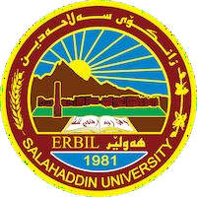
Academic Curriculum Vitae

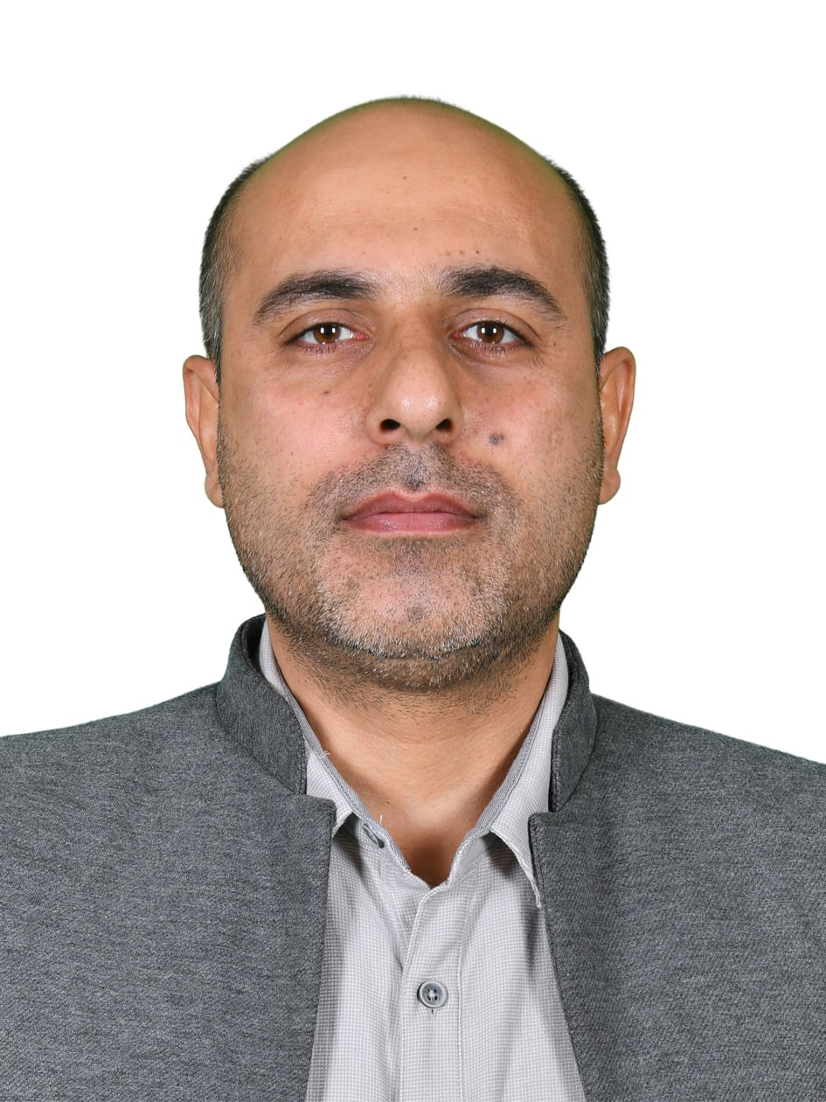

Personal Information:
Full Name: Govand Musa Qader
Academic Title: Lecturer
Email: (university email) govand.qader@su.edu.krd Mobile: 07504762169

Education:

B. Sc. | Salahaddin | Science | Biology | 2007 | Iraq
M. Sc. | Salahaddin | Science | Biology | 2015 | Iraq
Ph. D.

Employment:
Salahaddin University-College of Science, Biology department, 19/4/2009 Until now

Qualifications

Teaching qualifications:
Genetics and Molecular biology

IT qualifications:
Microsoft word, Powerpoint, Excell,

Language qualifications:
Kurdish, Arabic, English.

Teaching experience:

1. Genetics | 5. Molecular biology | 9- Molecular techniques

Research and publications

1-The status of cancer publications in the Kurdistan region of Iraq. | Journal of Cancer Policy |  |  | (2020)
2-Cardiac, Hepatic and Renal Dysfunction and IL-18 Polymorphism in Breast, Colorectal, and Prostate Cancer Patients. | Asian Pacific Journal of Cancer Prevention |  |  | (2021)
3-Detection of blaCTX-M Genes among Extended Spectrum Beta Lactamase producing Pseudomonas aeruginosa isolated from Clinical Specimens in Erbil | Indian Journal of Pharmaceutical Sciences |  |  | (2021)
4-Cancer Incidence in the Kurdistan Region of Iraq: Results of a Seven-Year Cancer Registration in Erbil and Duhok Governorates | Asian Pac J Cancer Prev, |  |  | (2022)
5- Cytogenetics and Molecular Genetic Studies of number of Chronic Myelogenous Leukemia in Arbil Province | Zanco journal |  |  | (2017)
6-Molecular Marker Study for Hyles euphorbiae (Lepidoptera: Sphingidae) Based on Mitochondrial DNA Genes in Erbil Province | Zanco journal |  |  | (2020)
7-Glutathione S-Transferase Mu 1 and Glutathione S-transferase theta 1 Genes Polymorphism and Susceptibility to Chronic Myeloid Leukemia in Erbil-Iraq Kurdistan Region | Zanco journal |  |  | (2020)
8-Molecular detection of Metallo-Beta-Lactamase and alginate in multidrug resistance Pseudomonas aeruginosa isolated from the clinical specime | JOURNAL of MEDICINE and LIFE |  |  | (2022)

Conferences and courses attended

Funding and academic awards

Professional memberships
- Kurdistan biology syndicate.
- Kurdistan teaching syndicate.

Professional Social Network Accounts:
- Researchgate link ((3) Govand Qader (researchgate.net)).
- Googlescholar link (https://scholar.google.com/citations?hl=en&view_op=list_works&gmla=AJsN-F7XLyi1l-1Sulj78QNjTR4e5ML7jHWE4AlD0GMHZxWBBVuycpHtjHdJmtCjQvObRabKO-nUKPcRXgFO3EGczNkDvxW6jw&user=sliXK60AAAAJ).

Academic cover letter
I awarded M.Sc. of Genetics in 2015 and pursuit in biology department, college of science, Salahaddin University in 2015 as assistant lecturer. Then, I started to work in the same department, as an assistant lecturer then upgrading to lecturer in 2020.

