زانكۆى سه‌لاحه‌ددين- هه‌ولێر

Salahaddin University - Erbil

The Peaceful uses of Radioisotopes

A Project Submitted to the Department of

Physics Education, Salahaddin University - Erbil

In the Partial Fulfillment of the Requirement for the Degree of Bachelor of Science -BSc- in (Physics Education)

Prepared By:
Kamaran Abdulrahman Hamad

Project Supervisor:
Ass. Prof. Dr. Habeeb Hanna Mansour

April - 2023

ii

ABSTRACT

Isotopes, which are nuclides with the same number of protons but varying numbers of neutrons, are the focus of this paper. Some isotopes are unstable and undergo decay through alpha (α), beta (β), and gamma (γ) radiation, which are collectively known as radioisotopes.
Radioisotopes can be either naturally occurring or artificially produced. The energy released during their decay can be harnessed for peaceful purposes in a variety of fields, including industrial, medical, and agricultural applications. This paper provides a detailed explanation of the properties of radioisotopes, including their decay rates and half-lives.
It then explores their potential uses, such as in medical imaging and cancer treatment, food preservation, and pest control. The advantages and challenges associated with using radioisotopes in these applications are also discussed. In conclusion, radioisotopes have tremendous potential for beneficial uses in various fields, but it is crucial to ensure their safe handling and disposal to minimize any potential risks to human health and the environment.

DEDICATION

This is for…
¬ Allah Almighty, my Creator and my Master.

¬ My great teacher and messenger, Mohammed (May Allah bless and grant him), who taught us the purpose of life.
¬ My Home-land Kurdistan, the warmest womb.

¬ The Salahaddin University; my second magnificent home.

¬ My great parents, who never stop giving of themselves in countless ways.

¬ My beloved brothers and sisters.

¬ To all my family, the symbol of love and giving.

¬ My friends who encourage and support me.

¬ All the people in my life who touch my heart.

This research project has been written under my supervision and has been submitted for the award of the degree of BSc. in (Physics).

Supervisor
Signature:
Name: Ass. Prof. Dr. Habeeb Hanna Mansour Date: / /2023

I confirm that all requirements have been completed.

Signature:
Name:
Head of the Department of Physics Date: / /2023

ACKNOWLEDGMENT

First and foremost, I must acknowledge my limitless thanks to Allah, the Ever- Magnificent; the Ever-Thankful, for His helps and bless. I owe a deep debt of gratitude to the physics department and Salahaddin University for giving us an opportunity to complete this work. I am very appreciative to my colleagues in the physics department. I am grateful to some people, who worked hard with me from the beginning till the completion of the present research particularly my supervisor Dr. Habeeb Hanna Mansour who has been always generous during all phases of the research. I also would like to express my wholehearted thanks to my family for the generous support they provided me throughout my entire life and particularly through the process of pursuing the thesis. Last but not least, deepest thanks go to all people who took part in making this thesis real.

LIST OF CONTENTS

Abstract iii
Dedication iv
Acknowledgment vi
List of Contents vii
List of Figures ix
List of Tables xi
- Introduction 1
  - Overview 1
  - Literature Review 3
- Radioactivity 4
  - Background 4
  - Half-Life 5
  - Units of Activity 6
  - Radioactive Decay Chains 7
  - Radioactive Decay 8
    - Alpha decay 8
    - Beta decay 9
    - Gamma Rays 11
  - Decay scheme 14
  - Ionizing and Penetration Powers 15
- Radioisotope Applications 17
  - Industrial Application 17
  - Medical Application 19
  - Agriculture Application 21
    - Food irradiation 22
  - Radioisotopes in Other Fields 24
  - Some radioisotope Schemes 25
  - Disadvantages of Radioisotopes 31
- Conclusion 33
References 34

LIST OF FIGURES

Figure 1.1: Production of Radioisotopes.
Figure 2.1: The number of nuclei in a sample radioactive element as a function of time.
Figure 2.2: illustrate the alpha decay of Nucleus.
Figure 2.3: Beta Minus Decay.
Figure 2.4: Beta Plus Decay.
Figure 2.5: Illustrate the Electron Capture Process
Figure 2.6: Gamma Decay
Figure 2.7: Photoelectric Effect.
Figure 2.8: Compton scattering effect.
Figure 2.9: Pair Production.
Figure 2.10: Scheme Diagram.
Figure 2.11: Comparison Between Penetration Types of Radiation.
Figure 3.1: Underground Leakage Detecting.
Figure 3.2: Principle of a Filling Control.
Figure 3.3: Medical Application ¹⁶⁶Ho of Radioactive Isotopes.
Figure 3.4: Thyroid Uptake and Scan using Radioactive Iodine.
Figure 3.5: Radioactive Isotopes Application in Agriculture.
Figure3.6. a: Benefits of food irradiation.
Figure3.6. b: Foods treated by irradiation.

Figure 3.7: Smoke Detector.
Figure 3.8: Decay scheme of Carbon-14.
Figure 3.9: Cesium-137 Scheme.
Figure 3.10: Decay Scheme of Cobalt-60.
Figure 3.11: Decay Scheme of Holmium-166.
Figure 3.12: Decay scheme of Americium-241.
Figure 3.13: Decay Scheme of the Potassium.

LIST OF TABLES

Table 1.1: Gives a list of some radioisotopes with type of radiation emission and half-life.
Table 2.1: Four radioactive decay chains are parents and daughter stable.
Table 2.2: Show Comparison of Alpha and Beta Particles, and Gamma Ray.
Table 3.1: present some medical applications of radioisotopes.
Table 3.2: Food irradiation applications

  - OVERVIEW

INTRODUCTION

Isotopes are at the heart of nuclear physics. They represent the several thousand different ways that protons and neutrons can combine to form different types of nuclei. Isotopes are only (Thoennessen, 2016) nuclides with the same number of protons but different numbers of neutrons. Such as ⁵⁸Co, ⁶⁰Co and ⁸⁵Kr, ⁹⁷Kr . The isotopes may be stable or radioactive, which spontaneously emit radiations such as alpha (α), beta (β) or gamma (γ) rays. The first radioisotopes experiment was performed by George de Hevesy in 1911(Kasban et al., 2009), transformed their nuclei to a stable state. This decaying property of radioisotopes is called half-life (Khan, 2017). “Half-life” is a measurement of how long it takes for half a sample of a unique radioactive substance that is, a radioisotope to decay by emitting radiation. For example, tritium, a heavy form of hydrogen, has a half-life of 12.3 years and decays to helium-3 via beta radiation emission (Iya, 1984). Radioisotopes are produced by bombardment of a stable isotope with neutrons or charged particles, (Schmor, 2010) as show in the (figure 1.1). Table 1.1 show some radioisotopes which are different by types of radiation and half-life. Because of these differences, the applications of radioisotopes also vary. Radioisotopes are used in many sectors including medicine, industry, agriculture, food processing, research and development (Sahoo and Sahoo, 2006). Our aim in this paper is to highlight the proper use of radioisotopes in everyday life and their impact on world development. We will discuss each field separately and identify the radioisotopes used in it.

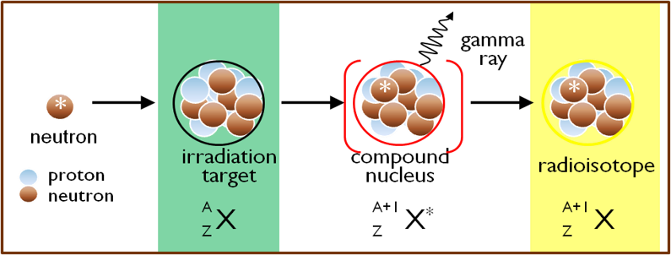

Figure 1.1: Production of Radioisotopes.
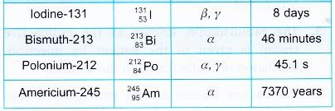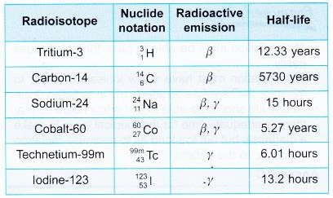

Table 1.1: Gives a list of some radioisotopes with type of radiation emission and half-life.

  - LITERATURE REVIEW
The radioisotopes may be natural such as 232Th and 235U or can be produced artificially (Kasban et al., 2009). Radioisotopes are produced in a nuclear reactor by exposing appropriate target material to the neutrons in the reactor, thereby causing a nuclear reaction Radioisotopes used in different section of agriculture to occur which leads to the production of desired radioisotope (Sahoo and Sahoo, 2006). The artificial production of radioisotopes produces by various cyclotrons (Schmor, 2010), (Mushtaq, 2012), (Hayes, 2018), (de Lima, 1998), (Jadiyappa,
2018) and (Xiao, 1996).

This artificial radioisotope uses for different applications and become an important area of nuclear technology, such as industrial, agriculture and medicine (Sahoo and Sahoo, 2006). Focus on the peaceful use of radioisotopes in industrial and agriculture instead of war and bomb had been done in the 1960s in the Spain (Barca-Salom, 2009). (Animal Production, Crop improvement, Plant nutrition, Food processing and protection, Insect pest management) (Balwinder et al., 2013) , (Chandrajith, 2010).
Background and some of the strategies pertaining to radiolabeled monoclonal antibody therapies with a focus on experiences reported for radiolabeled monoclonal antibody (mAb), and an overview of radiolabeled mAb directed cancer therapy (Milenic and Brechbiel, 2004). Safe use of radioisotopes in medical applications is the main issue, safe procedures for radioactive waste disposal and they must not be forgotten. (Ravichandran et al., 2011)

  - BACKGROUND

RADIOACTIVITY

Radioactivity was discovered in 1896 by the French physicist, Henri Becquerel working in Paris. Radioactive decay is the process in which an unstable nucleus spontaneously loses energy by emitting ionizing particles and radiation. This decay, or loss of energy, results in an atom of one type, called the parent nuclide, transforming to an atom of a different type, named the daughter nuclide (Decay and Law, n.d.).
There are approximately 3,000 known nuclides, approximately 8-10% of which are stable, the other ~90% is radioactive and only a very small percent of these isotopes occurs in nature. The radioactivity of nuclide depends on rate of n/z; n are neutrons number and z proton’s number (Anglart, 2011). Some isotopes are unstable due to a specific combination of neutrons and protons which occurs naturally (for example in potassium-40 which forms part of all our bodies) or can be artificially produced (Singh, 2011).
Two major sources of artificial radioisotopes are accelerators and reactors. Radioisotopes produced in reactors represent a large percentage of the total use of radioisotopes due to a number of factors. The reactor offers large volume for irradiation, simultaneous irradiation of several samples, economy of production and possibility to produce a wide variety of radioisotopes. The accelerator- produced isotopes relatively constitute a smaller percentage of total use. The accelerators are generally used to produce those isotopes which cannot be produced by reactor or which have unique properties (International Atomic Energy Agency, 2003).

The radioactive decay of nuclei has a stochastic character and the probability of decay is typically described by the decay constant λ. Thus, if N is the number of the particular radioactive nuclei present at any time t, the number of nuclei ∆N that will decay during a period of time ∆t is determined as,
∆𝑁 = −𝛾𝑁∆𝑡

This gives the following differential equation for N

𝑑𝑁
𝑑𝑡 = −𝜆N
λN is radioactivity, and Integration of this equation:

𝑁 = 𝑁𝑜𝑒^{−ℎ𝑡}

No is the number of radioactive nuclei at time t = 0, t is the half-life (Anglart, 2011).
  - HALF-LIFE
It is defined as the time required for the number of radioactive nuclei of a given kind to decay to half its initial value. However, the activity does not fall at a steady rate, so it is not the case that the activity will have fallen to nothing after two half- lives.Instead, the activity falls at an ever-decreasing rate so that in every half-life the activity will halve (Baker, 1966). We see the number of decayed nuclei exponentially decrease with time (figure2.1). The corresponding half-life time t1/2 is given by:

t1 = ln2
2 𝜆

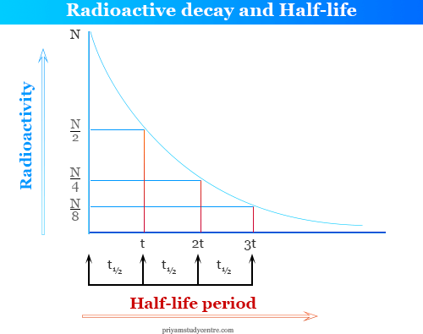

Figure 2.1: The number of nuclei in a sample radioactive element as a function of time.

  - UNITS OF ACTIVITY
A sample which decays with 1 disintegration per second is defined to have an activity of 1 Becquerel (1 Bq) and this unit is the SI unit. The second unit of activity is curie f (1 Ci) is equivalent to 3.7 *10^10 Bq. There are many other units but they are rarely used. (Anglart, 2011).

  - RADIOACTIVE DECAY CHAINS

Radioactive decay series can be defined as groups of isotopes representing various stages of radioactive decay in which heavier members of the group are transformed into successively lighter ones, the lightest being stable.
Three naturally occurring radioactive decay chain families are found in significant amounts on earth, and one artificial radioactive decay chains (Ali, 2008). This radioactive series decay shows in the (Table 2.1.):

Series | Parent | Mass Numbers | Product | Half-life  (Years) | Stable end product
Thorium | 232 Th  90 | 4n | Natural | 1.39*10^10 | 208  ₈₂ Pb
Neptunium | 237  ₉₃Np | 4n+1 | Artificial | 2.25*10^6 | 209  ₈₃ Bi
Uranium | 238  92 U | 4n+2 | Natural | 4.51*10^10 | 206  ₈₂ Pb
Actinium | 235  92U | 4n+3 | Natural | 7.07*10^8 | 207  ₈₂ Pb
Table 2.1: Four radioactive decay chains are parents and daughter stable. (Sahoo and Sahoo, 2006)

  - RADIOACTIVE DECAY
The notion of radioactivity is useful in making distinction between emission of rays or particles by a highly unstable system from radiation emitted spontaneously by a system that’s nuclear and atomic degrees of freedom are close to equilibrium. (Pfützner et al., 2012) Describe all types of decay radiation bay unstable nucleus:
    - ALPHA DECAY
Most alpha emitters are heavy nuclei with mass number A >150. (Anglart, 2011) Alpha decay a group of two protons and two neutrons are ejected from the nucleus. These particles are held together by the nuclear force in a very stable group which is known as an alpha particle. This grouping of two protons and two neutrons also forms the nucleus of a helium atom (42He) illustrated in (figure 2.2). Many of the naturally occurring radionuclides investigated by Rutherford and Soddy exhibited alpha decay. (Baker, 1966) The Q value (energy of alpha decay) must be positive for the decay to take place at all. Otherwise, it is not possible for the particle to tunnel through the barrier and escape. Alpha particle has a high ability to ionizing the medium, low ability to penetrate the mediums, is about 3.5 cm in air and 20 m in a silicon detector. (Decay and Law, n.d.)
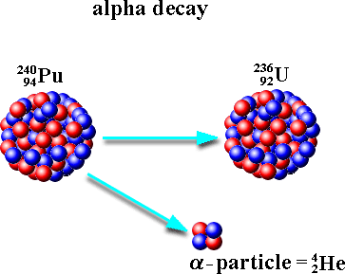

Figure 2.2: illustrate the alpha decay of Nucleus.

    - BETA DECAY
The beta decay is a radioactive decay in which a proton in a nucleus is converted into a neutron (or vice-versa). In the process the nucleus emits a beta particle (either an electron or a positron) and quasi-massless particle, the neutrino. Or be transformed by capturing an atomic electron in a process called electron capture. For this process occurs must be Q value is positive. (Murray and Holbert, 2015)

Beta Minus Decay

In β─ decay, the charge on the nucleus increases by one unit. The β─ particle is an electron (mass 0.0005486 u 511 keV and charge e⁻). It is considered to be created at the moment of decay. A second light particle, - antineutrino (ν⁻) - is also created and emitted for example (figure2.3). It has no charge and very small mass, which generally is assumed to be zero. It interacts extremely weakly with matter. (Decay and Law, n.d.)
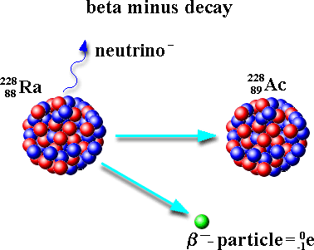

Figure 2.3: Beta Minus Decay.

Beta Plus Decay

Β⁺ decay changes a proton rich nucleus into a more stable isobar. The nuclear charge is decreased by one unit. A β⁺ particle is an antielectron, called a positron. (Decay and Law, n.d.) For example (figure 2.4).
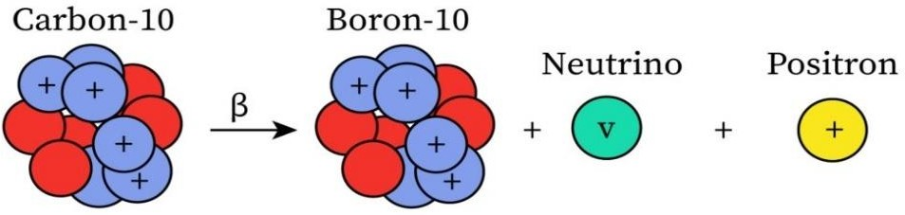

Figure 2.4: Beta Plus Decay.

Electron Captures Decay

A nuclide with too many protons can make its nucleus more stable by changing a proton into a neutron. One way in which this can be achieved is if the nucleus absorbs one of its orbiting electrons into the nucleus. An atomic electron from an inner orbit combines with one of the protons in the nucleus, to form a neutron and a neutrino, this process is illustrated in (figurer 2.5).
However, because Z has changed, the atom has transmuted from one element into another, the neutrino which is emitted. (Baker, 1966) Note that Q_{EC} is greater than Q by 2mc². In electron capture, the mass of an atomic electron is converted into energy, whereas, in β⁺ decay, energy is required to create a positron. This means that EC can occur when β ⁺ decay cannot. (Decay and Law, n.d.)

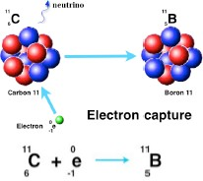

Figure 2.5: Illustrate the Electron Capture Process

    - GAMMA RAYS
Gamma rays are not particles like alpha and beta, but are examples of electromagnetic radiation (like high energy light) and consequently interact with matter in a rather different way. (Baker, 1966) In gamma decay nuclide doesn’t change for different nuclei, for example (figure 2.6).
Gamma rays interact with matter by three main ways for energies below 3MeV, these are the Photoelectric effect, Compton scattering and Pair production. For energies less than 1022keV photoelectric and Compton are possible, for energies above 1022keV Pair production is also possible. (Ali, 2008)

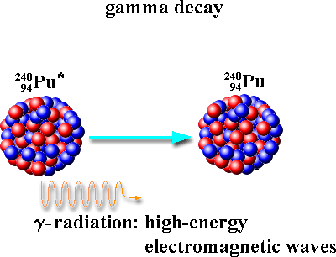

Figure 2.6: Gamma decay

Photoelectric effect

In the photo-electric effect when a low-energy gamma strikes an atom, the total energy of the gamma ray is expended in ejecting an electron from its orbit. (Ali, 2008) Can see (figure 2.7).
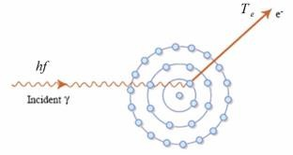
Figure 2.7: Photoelectric effect.

Compton Scattering

In Compton scattering the gamma ray interacts with an orbital or free electron; however, in this case, the photon loses only a fraction of its energy. The actual energy loss depends on the scattering angle (θ) of the gamma radiation on the electron. (Ali, 2008) This illustrated in (figure 2.8).
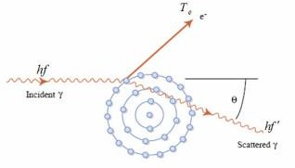

Figure 2.8: Compton scattering effect.

Pair production

In pair-production when a high energy gamma passes close enough to a heavy nucleus (pair production not happen in vacuum, because of violation of conservation of momentum), the gamma ray completely disappears and an electron-positron pair is formed. (Ali, 2008) This effect illustrated in (figure 2.9).

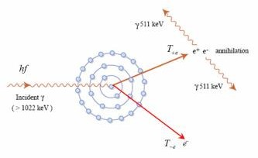

Figure 2.9: Pair production.

  - DECAY SCHEME
In the same way that atomic electrons can only exist in well-defined energy shells, the nucleons in an atomic nucleus also exist in specific energy levels. The situation in the nucleus is however complicated by the fact that there are two types of nucleons, protons and neutrons, to accommodate. (Baker, 1966)
The ways in which radioactive isotopes decay are usually represented in so called decay schemes or disintegration schemes. The decays of unstable nucleus we talked about them, the scheme illustrates of all decays on energy level diagram, (figure 2.10).

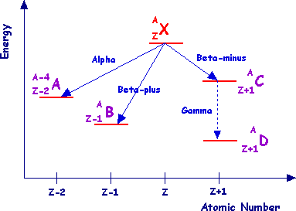

Figure 2.10: Scheme Diagram.

  - IONIZING AND PENETRATION POWERS
Ionizing power is the ability of radiation to damage molecules. When a radiation particle interacts with atoms, the interaction can cause the atom to lose electrons and thus become ionized.
The greater the likelihood that damage will occur by an interaction is the ionizing power of the radiation.
Penetration power is the ability of each type of radiation to pass through matter. The more material the radiation can pass through, the greater the penetration power and the more dangerous they are.
In general, the greater mass presents the greater the ionizing power and the lower the penetration power (Alviar-Agnew, 2008). Comparing only the three common types of ionizing radiation in the (table 2.2), and a comparison of Alpha particles, beta particles and gamma rays to power penetrations is shown in (figure2.11).

Particle | Mass | Penetrating Power | Ionizing Power | Shielding
Alpha | 4amu | Very low | Very high | Paper skin
Beta | 1/2000amu | Intermediate | Intermediate | Aluminum
Gamma | 0 (energy only) | Very high | Very low | 2-inch lead

Table 2.2: Show Comparison of Alpha and Beta Particles, and Gamma Ray. (Alviar-Agnew, 2008)

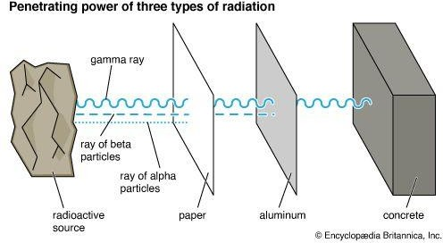

Figure 2.11: Comparison Between Penetration Types of Radiation.

