Chapter 3

RADIOISOTOPE APPLICATIONS
Focus on the peaceful use of radioisotopes in industrial and agriculture instead of war and bomb in the 1960s in the Spain (Alviar-Agnew, 2008). Radioisotopes, because of their radiation characteristics and the energy they possess, can be utilized in industry, agriculture, healthcare applications. (Sahoo and Sahoo, 2006)
Applications of Radioisotopes and radiations are helping us to find the solution of problems in much shorter time. (Balwinder et al., 2013) We will present in this chapter the applications of some of the prominent radioisotopes, along with the characteristics of the radioactive nucleus. First, we need to identify the three main areas in which radioisotopes are used, and then we will discuss radioactive nuclei to see where and how they are used.
  - INDUSTRIAL APPLICATION
The required steps for using radioisotopes in industry:
- Plant visit and feasibility assessment.
- Selection of a suitable radioisotope.
- Estimation of the amount of the required activity.
- Production or preparation of a radiotracer.
- Transportation of the radioisotope to the site.
- Injection of the radioisotope.
- Monitoring of the radioisotope.
- Data treatment, analysis and writing of the report. (Kasban et al., 2009)

Radioactive nuclei in industry used to smoke detectors, inspect airline luggage for hidden explosives, determine underground pipe holes, gauge the thickness of thin plastics, control level of material inside the enclosed body, fuel for nuclear power (Bureau of Radiological Health, 2011). For examples we can see in the (Figure 3.1) and (Figure 3.2):
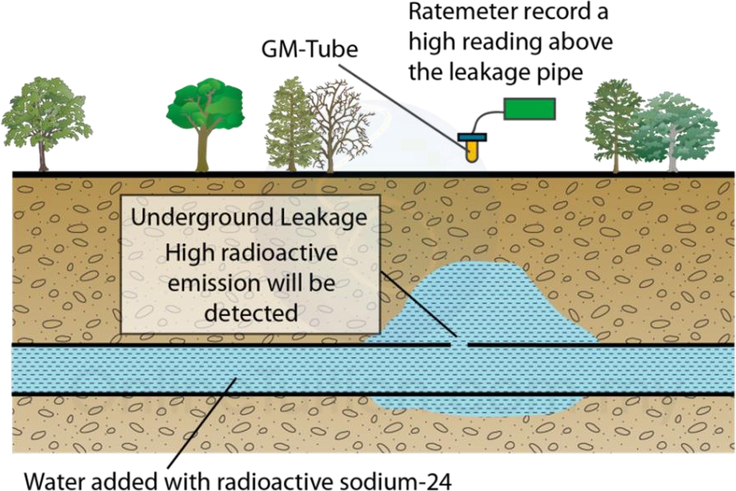

Figure 3.1: Underground Leakage Detecting.

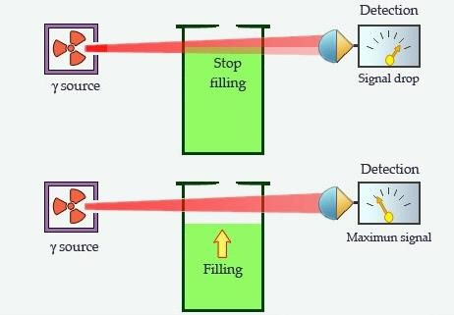
Figure 3.2: Principle of a Filling Control.

  - MEDICAL APPLICATION
Radioisotopes used in medicine produce by differential cyclotron. Radioactive isotopes have both diagnostic and therapeutic applications in Nuclear Medicine (Schmor, 2010). Using 166Ho displayed in (figure 3.3). The radiations given out by some radioisotopes are very effective in curing certain diseases. For example, radio-cobalt (60Co) is used in the treatment of brain tumor, radio-phosphorous (32P) in bone diseases and radio-iodine (131I) in thyroid cancer which displayed in (figure 3.4).
The radiations, besides destroying the ailing tissue, also damage the healthy tissue and hence a careful control over the quantity administered is necessary. Bacteria and other disease-carrying organisms can be destroyed by irradiating them with γ- rays. The process is used to sterilize medical instruments (Sahoo and Sahoo, 2006). In the (table 3.1) some radionuclides in medical application displayed.
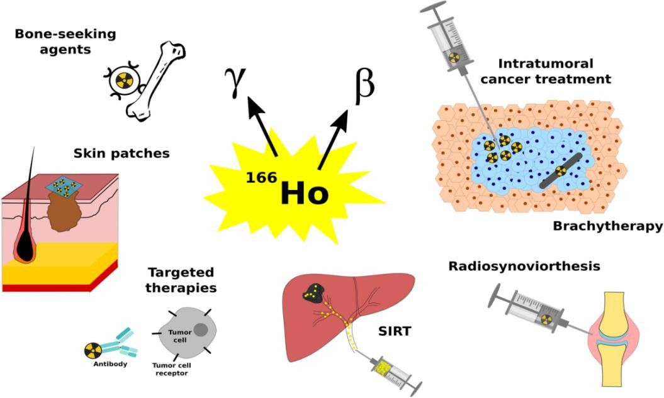

Figure 3.3: Medical Application ¹⁶⁶Ho of Radioactive Isotopes.

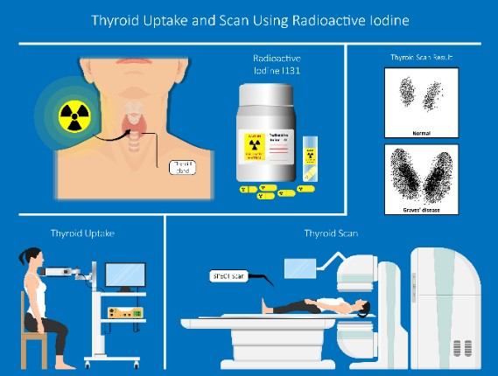

Figure 3.4: Thyroid Uptake and Scan using Radioactive Iodine.

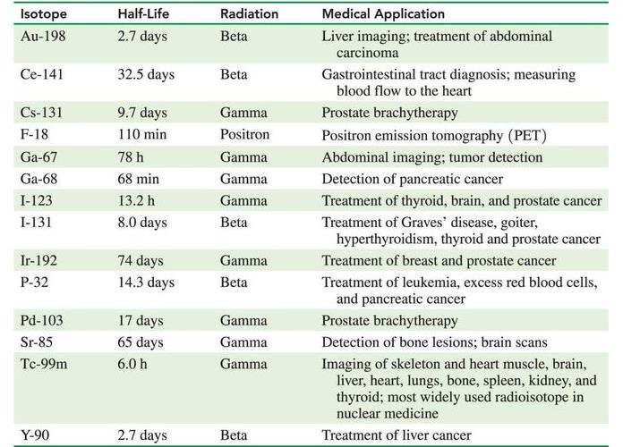

Table 3.1: present some medical applications of radioisotopes.

  - AGRICULTURE APPLICATION
Applications of Radioisotopes in Agricultural: Animal Production, Crop improvement, Plant nutrition, Food processing and protection and Insect pest management. Radioisotopes are used as a research tool to develop new strains of agricultural crops that are drought and disease resistant, are of higher quality, have shorter growing time and produce a higher yield (Balwinder et al., 2013).
Radiation can be used to destroy microbes in food and control Applications of Radioisotopes in Agriculture. The agents who cause spoilage (microbes, insects, etc.) are eliminated by irradiation from packaged food and packaging materials are impermeable to bacteria and insects so recontamination does not take place. Irradiation of food kills insects and parasites, inactivate bacterial spores and molds, prevent reproduction of microbes and insects, inhibit the sprouting of root crops, delays ripening of fruits and improve technological properties of food (Sahoo and Sahoo, 2006).
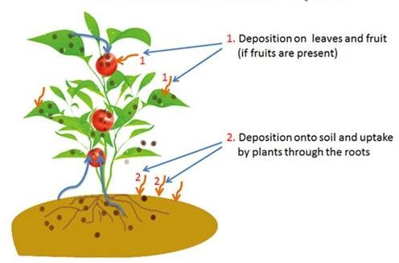

Figure 3.5: Radioactive Isotopes Application in Agriculture.

    - FOOD IRRADIATION
Some 25-30% of food harvested is lost as a result of spoilage before it can be consumed. This problem is particularly prevalent in hot, humid countries. Food irradiation is the process of exposing foodstuffs to gamma rays to kill bacteria that can cause food-borne disease, and to increase shelf-life. It has the same benefits as when food is heated, refrigerated, frozen, or treated with chemicals, but does not change the temperature or leave residues. In all parts of the world there is growing use of irradiation technology to preserve food.
More than 60 countries worldwide have introduced regulations allowing the use of irradiation for food products including spices, grains, fruit, vegetables, and meat. It can replace potentially harmful chemical fumigants that are used to eliminate insects from dried fruit and grain, legumes, and spices. Following three decades of testing, a worldwide standard was adopted in 1983 by a joint committee of the World Health Organization (WHO), the Food and Agriculture Organization of the United Nations (FAO), and the International Atomic Energy Agency (IAEA).
In 1997 another such joint committee said there was no need for the earlier- recommended upper limit on radiation dose to foods. The IAEA and FAO are working together with the International Plant Protection Convention (IPPC) and the Codex Aliment Arius Commission to standardize worldwide use of irradiation for foodstuffs. Contrary to the belief of some people, irradiation of food does not make the food itself radioactive. In the (figure3.6a and b) some advantages of irradiation are displayed (Alviar-Agnew, 2008).

Low dose (up to 1 kGy) | Inhibition of sprouting Insect and parasite disinfestation  Delay ripening | Potatoes, onions, garlic, ginger, yam Cereals, fresh fruit, dried foods, Fresh fruit, vegetables
Medium dose (1-10 kGy) | Extend shelf-life Halt spoilage, kill pathogens | Fish, strawberries, mushrooms Seafood, poultry, meat
High dose (10-50 kGy) | Industrial sterilisation Decontamination | Meat, poultry, seafood, prepared foods, Spices, etc.
Table 3.2: Food irradiation applications

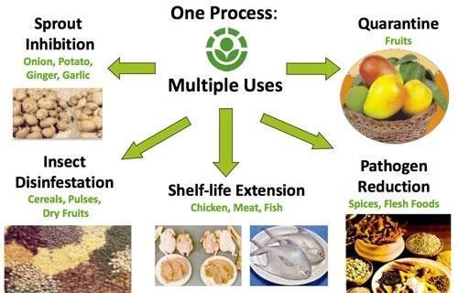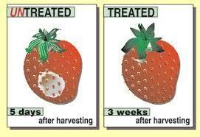

(Figure3.6. a) (Figure3.6. b) Benefits of food irradiation. Foods treated by irradiation.

  - RADIOISOTOPES IN OTHER FIELDS
Archaeology: Radioactive Carbon-14 dating is a widely used technique by archaeologists to estimate the age of various ancient rocks, monuments, and other fossil materials.
Isotope Hydrology: This is a technique to estimate the age and origin of water by Carbon-14 as all-natural water bodies contain dissolved carbon dioxide in the water. This technique is also used in estimating the age of snow and icebergs.
Pest Control: Radioisotopes are used in pest control by sterilizing male flies by γ radiations so that they cannot reproduce and multiply in number.
Smoke Detectors: One of the radioisotopes, Americium-241, which is α ray emitter is used in very small amounts in ionization-type smoke detectors. The emission of α ray from Am-241 ionizes the air present between two electrode plates in the ionizing chamber which is attached to a battery that supplies a potential that causes movement of these ions, thus generating a small electric current. When smoke enters the chamber, the movement of the ions is obstructed, reducing the conductivity of the air. This causes a sudden drop in the current, triggering an alarm that helps in detecting smoke and avoid fire accidents.
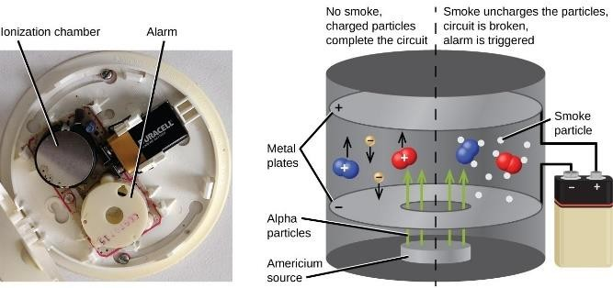

Figure 3.7: Smoke Detector.

  - SOME RADIOISOTOPE SCHEMES

Carbon-14: Some properties of carbon-14: Decay scheme is one of the most important properties for all radioactive nucleuses, decay scheme of ¹⁴₆C in (figure 3.8) illustrated. Carbon has 15 isotopes, with masses of 8 to 22. Only isotopes 12 and 13 are stable. The radioactive half-life is higher than a year only for carbon-14, its maximum value for the other isotopes being around 20 minutes. It has a half-life of 5,700 years, (Pilcher, 1991)
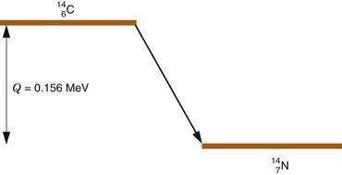

Figure 3.8: Decay scheme of Carbon-14.

Some applications of carbon-14: Carbon-14 is a very useful radionuclide which has extensive applications to dating of objects and as a tracer (Jull, 2013), and used in biological research, agriculture, pollution control, and archeology (Bureau of Radiological Health, 2011).

Cesuim-137: Cesium (Cs) is a soft, flexible, silvery-white metal that becomes liquid near room temperature, the most common radioactive form of cesium is Cs- 137, the half-life Cs-137 is 30 years. A Cs-137 atom emits radiation in the form of medium energy gamma rays, and to a lesser extent, high-energy beta particles, which disrupt molecules in cells and deposits energy in tissues, causing damage (Gad and Pham, 2014). Decay scheme of cesium-137 displayed in (figure 3.9).
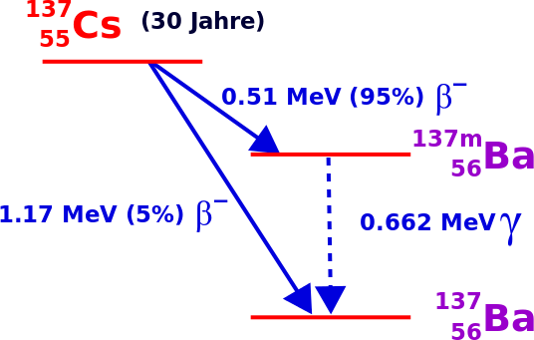

Figure 3.9: Cesium-137 Scheme.

Cesium-137 is used in small amounts for calibration of radiation detection equipment, such as Geiger- Mueller counters. In larger amounts, Cs-137 is used in: Medical radiation therapy devices for treating cancer, industrial gauges that detect the flow of liquid through pipes and other industrial devices that measure the thickness of materials, such as paper or sheets of metal.

Cobalt-60: Cobalt was discovered by Georg Brandt, a Swedish chemist, in 1735. Cobalt-60 emits two high energy gamma rays, making cobalt-60 both an internal and external hazard. Half-life of cobalt-60 is 5.2714 years (Ntekim et al., 2010).The decay scheme of cobalt-60 displayed in (figure 3.10).
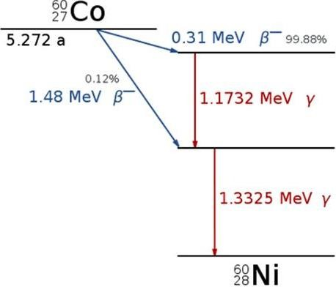

Figure 3.10: Decay Scheme of Cobalt-60.

Cobalt-60 used to sterilize surgical instruments, and to improve the safety and reliability of industrial fuel oil burners. Used in cancer treatment, food irradiation, gauges, and radiography. An external sealed source of cobalt-60 is used in a therapy unit as a source of intense gamma radiation for the treatment of a variety of cancers. Cobalt-60 is also used as a medical tracer.
A medical tracer is a material that is introduced into the body to make possible the observation of chemical, physical or biological processes in the body. Sterilization: Many medical products today are sterilized by gamma rays from a cobalt -60 source, a technique which is generally much cheaper and more effective than steam heat sterilization. Cobalt-60 is also used for industrial radiography, detecting flaws in metal parts, and in density and fill height switches.

Holmium-166: Holmium-166 (¹⁶⁶Ho) can be produced by two methods; neutron activation by (n, γ) irradiation in a nuclear reactor, or by neutron activation of dysprosium-164 (¹⁶⁴Dy), which displayed in (figure3.11). Because holmium-165 (¹⁶⁵Ho) has a natural abundance of 100% and a cross section of 64 b, it can be neutron activated in a relatively short neutron activation time resulting in ¹⁶⁶Ho with a high purity of the isotope.

The second method is via neutron activation of ¹⁶⁴Dy by two neutrons. Dysprosium-164 has a natural abundance of 28.2% and enriched material will have a purity of over 90%. By capture of two neutrons, ¹⁶⁴Dy will be converted into ¹⁶⁶Dy which will decay into carrier-free ¹⁶⁶Ho as the daughter radionuclide.
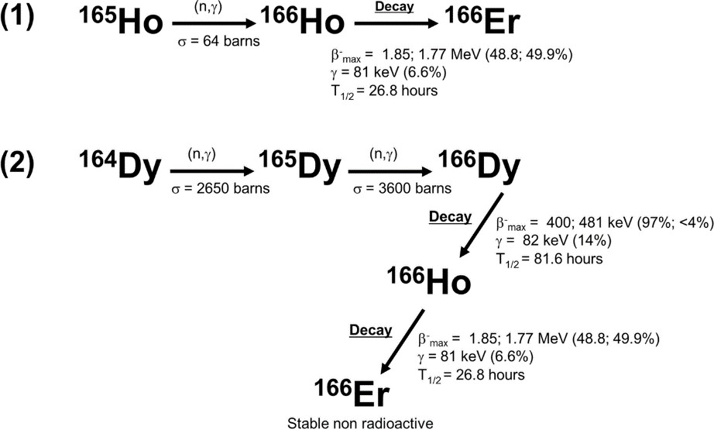

Figure 3.11: Decay Scheme of Holmium-166.

Americum-241: Today, americium-241 is produced artificially from the decay of ²⁴¹Pu, and has half-life is 470 years (Washington State Department of Health – Office of Radiation, 2002). Decay scheme of ²⁴¹Am illustrated in (figure 3.12).
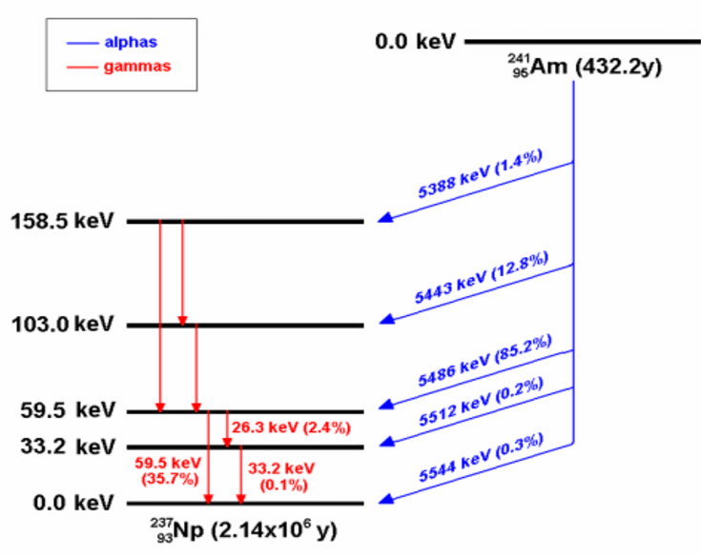

(figure3.12): Decay scheme of Americium-241.

Americium-241 most common application is as an ionization source in smoke detectors, and most of the several kilograms of americium made each year are used in this way. Smoke detectors rely on alpha radiation from americium-241, which ionizes the air in a gap between two electrodes, causing a very small electrical current to flow between Americium-241.
When smoke enters the space between the electrodes, the alpha radiation is absorbed by soot particles, the current drops, and the alarm is sounded. Help determine where oil wells should be drilled, and can use for determine energy level in closed system.

Potassium-40: Potassium is a soft, silver-white metal. An important constituent of soil, it is widely distributed in nature and is present in all plant and animal tissues. ⁴⁰K is a naturally occurring radioactive isotope of potassium, displayed in (figure 3.13). Two stable (nonradioactive) isotopes of potassium exist, ³⁹K and ⁴¹K. ⁴⁰K represents 0.012% of naturally occurring potassium. The half-life of ⁴⁰K is 1.3 billion years (Peterson et al., 2007).
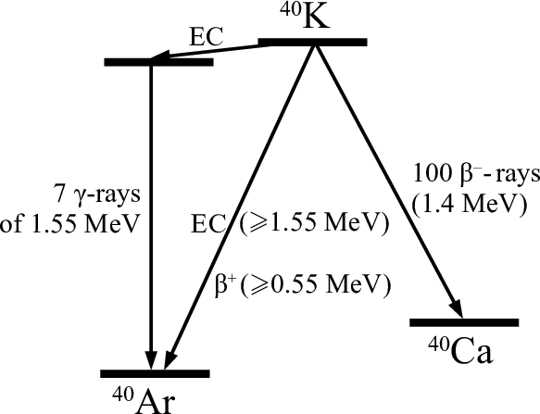

Figure 3.13: Decay Scheme of the Potassium.

Potassium is one of the most reactive metals in nature, and it forms a number of compounds that have many commercial uses. It is also used in medicine to treat rheumatism and overactive thyroid glands. The very slow decay of potassium 40 into argon is highly useful for dating rocks.

  - DISADVANTAGES OF RADIOISOTOPES
With all the radiation from natural and man-made sources, we should quite reasonably be concerned about how all the radiation might affect our health. The damage to living systems is done by radioactive emissions when the particles or rays strike tissue, cells, or molecules and alter them (Alviar-Agnew, 2008).
In Medical Field: The major drawback of using radioactive isotopes in the medical field is their severe side effects such as skin diseases, lung cancer, nausea, etc., caused to the patients as well as the health workers who operate these devices and carry on such treatments.
Genetic Mutations: Radioactive rays enter the human body and cause mutations in the DNA sequence. Harmful and undesirable mutations may cause genetic disorders or even cancer. for example, cystic fibrosis in human beings. Many genetic disorders in plants, animals and human beings are caused due to such mutations.
Environmental Effects: Pollution caused by the introduction of radioactive substances into the environment due to testing of nuclear weapons, nuclear explosions, mining of radioactive ores, etc., is known as radioactive pollution. Such pollution is caused due to nuclear accidents in nuclear energy power plants, spillage of radioactive wastes in water bodies, testing of nuclear weapons, use of radioisotopes for medical and laboratory purposes, etc.

CONCLUSION
In conclusion, isotopes play an essential role in various fields, including medicine, agriculture, and industry. Radioisotopes, which are isotopes that are unstable and undergo radioactive decay, have unique properties that make them useful in different applications. The three types of radioactive decay, α, β, and γ, can be harnessed to provide energy or be used in medical procedures, among other things.
Radioisotopes can be naturally occurring, but they can also be artificially produced. Nuclear reactors, accelerators, and cyclotrons are commonly used to produce radioisotopes artificially. The energy released during radioactive decay can be used for various purposes, including generating electricity in nuclear power plants and treating cancer with radiation therapy. Also play an essential role in agriculture. They can be used to increase crop yields, as well as for soil and plant analysis. In medicine, radioisotopes can be used to diagnose and treat various diseases, including cancer. Radioisotopes can be used as tracers to determine how the body absorbs, uses, and metabolizes drugs.
It is worth noting that radioisotopes require careful handling due to their potential hazards. Specialized equipment and procedures are necessary to ensure their safe use. Despite this, their benefits far outweigh the risks when used appropriately.
radioisotopes are powerful tools that have numerous applications in different fields. They have played a critical role in advancing science and technology, and their importance is expected to increase in the future. It is crucial that we continue to study and use radioisotopes responsibly to harness their benefits while minimizing the risks.

REFERENCES

¬ Ali, F.A., 2008.
¬ Anglart, H., 2011. Kth.Diva-Portal.Org 2–3.
¬ Baker, D.G., 1966. Radiation Botany 6, 182.
¬ Balwinder, S., Jaspreet, S., Amritpal, K., 2013. International Journal of Biotechnology and Bioengineering Research 4(3)167-17, 167–174.
¬ Barca-Salom, F.X., 2009. Dynamis 29, 307–336.
¬ Decay, R., Law, R.D., n.d. 1–8.
¬ Gad, S.C., Pham, T., 2014. Encyclopedia of Toxicology: Third Edition 776– 778.
¬ Alviar-Agnew, M., 2008. Book 2–6.
¬ International Atomic Energy Agency, 2003. Iaea-Tecdoc-1340 1–254.
¬ Iya, V.K., 1984. Chemical Engineering World 19, 71–78.
¬ Jull, A.J.T., 2013. J Phys Conf Ser 436.
¬ Kasban, H., Zahran, O., El-samie, F.E.A., 2009. Ojeee 2, 284–292.
¬ Khan, N.T., 2017. J Biomol Res Ther 06, 2–4.
¬ Milenic, D.E., Brechbiel, M.W., 2004. Cancer Biol Ther 3, 361–370.
¬ Murray, R.L., Holbert, K.E., 2015. Nuclear Energy (Seventh Edition) 31–46.
¬ Ntekim, A., Adenipekun, A., Akinlade, B., Campbell, O., 2010. Clin Med Insights Oncol 4, 89–94.
¬ Peterson, J., MacDonell, M., Haroun, L., Monette, F., Hildebrand, R.D., Taboas, a, 2007. Human Health Fact Sheet, Argonne 38–39.
¬ Pfützner, M., Karny, M., Grigorenko, L. V., Riisager, K., 2012. Rev Mod Phys 84, 567–619.

¬ Pilcher, J.R., 1991. Quaternary dating methods - a user’s guide 16–36.
¬ Washington State Department of Health – Office of Radiation, 2002. 241.
¬ Sahoo, Sukadev, Sahoo, Sonali, 2006. Phys Educ 5–11.
¬ Schmor, P.W., 2010. CYCLOTRONS 2010 - 19th International Conference on Cyclotrons and Their Applications 419–424.
¬ Singh, N., 2011. Radioisotopes: Applications in physical sciences. BoD-- Books on Demand.
¬ Thoennessen, M., 2016. The Discovery of Isotopes, The Discovery of Isotopes.
¬ Bureau of Radiological Health, 2011.
¬ Mushtaq, A., 2012. Producing radioisotopes in power reactors. Journal of Radioanalytical and Nuclear Chemistry, 292(2), pp.793-802.
¬ Hayes, R.B., 2018. Applications of Radioisotopes. In Nuclear Energy (pp.
395-410). Springer, New York, NY.
¬ de Lima, J.J.P., 1998. Radioisotopes in medicine. European journal of physics, 19(6), p
¬ Jadiyappa, S., 2018. Radioisotope: applications, effects, and occupational protection (pp. 19-47). InTech.
¬ Xiao, L., 1996. Production and application of isotopes in China. Journal of radioanalytical and nuclear chemistry, 205(1), pp.9-20.
¬ Chandrajith, R., Seneviratna, S., Wickramaarachchi, K., Attanayake, T., Aturaliya, T.N.C. and Dissanayake, C.B., 2010. Natural radionuclides and trace elements in rice field soils in relation to fertilizer application: study of a chronic kidney disease area in Sri Lanka. Environmental Earth Sciences, 60, pp.193-201.

زانكۆی سهالحهدین – ههول ێ
Salahaddin University - Erbil

ئایزۆتۆپەکان
ڕادیۆ

ن ئاشتییانەی
بەکارهێنا

پرۆژهی دهرچوون
پێشكهش به به یش (پهروهردهی ف زییا ، زانكۆی سهالحهددین – ههول vی) كراوه
وهك بهشێك له پێداویستیهكا زن بهدهستهێنا زن بڕوانامهی بهكالۆریۆس له زانس یت (پهروهردهی ف زییا)

ئامادهكراوه له الیهن:
كامهران عبدالرحمن حمد

به سهرپهرش یت:
پ.ی.د. حبیب حنا منصور

نیسان - 0202

