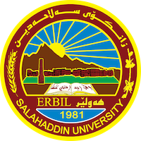
Academic CV
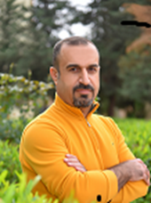
Personal Information:
Full Name: Hamed Abdullah Saleh
Academic Title: Assistant Professor
Email: ( hamed.salih@su.edu.krd )
Mobile:009647504659310

Education:
1- Bachelor's degree from the Faculty of Arts / Saleh Al-Din University / Department of Geography
2- Master from Salahaddin University / Faculty of Arts / Department of Geography
3 - PhD from the University of Mosul / College of Education / Department of Geography

Employment:
1- Appointed for the first time in the Faculty of Basic Education with the rank (Demonstrator) on 20-12-2002

Qualifications
- Teaching Methods Course at the University Salahuddin Erbil 2007
- Microsoft Excel Education Course
- English Language Strengthening Course at the English Language Center at the University Salahaddin 2006
- Entrepreneurship Course at the University of Noottenberg, Germany 2017
- Friendly School Course 2009

Teaching Experience:
- Bachelor teaching experience from 2007 to 2023
- Teaching experience of more than four postgraduate courses Master (Teaching Environmental Problems)

Research & Publications
. 1- The role of the United Nations in solving the problem of the Kurdish regions outside the administration of the Kurdistan Region
2- The impact of transportation on noise pollution in the city of Quay-
3- Analysis of the OPEC oil price crisis during the period between 1961 - 2019)
4- Sustainable tourism development in Soran district, reality and future prospects
5- The role of small and medium industries in achieving sustainable development in the governorates of central and southern Iraq as a model
6- Sustainable health development in the Kurdistan Region of Iraq, its reality and future prospects
7-

Conferences and courses attended
- Attending more than 25 internal and external conferences to deliver research in them.

Funding and Academic Awards
- List any scholarships, scholarships, travel grants, or other sources of funding you have received for research projects or to attend meetings or conferences.

Professional Memberships
- Advisor to a Kurdish academic journal
- Member of the Kurdistan Teachers Union
- Member of the Union of Universities Blinds.
- Human Development Organization

Professional social networking accounts:

- https://scholar.google.com/citations?user=d8brpZEAAAAJ&hl=ar
- https://www.researchgate.net/profile/Hamed-Abdulla
- https://orcid.org/signin
- https://www.linkedin.com/feed/

