Titration
Is a procedure use to determine the concentration of some substance by the controlled addition of a solution into a reaction flask from a burette.
Types of titration:
- acid – base (neutralization tit.)
- oxidation – reduction titration (redox tit.)
- complex formation titration.
- Precipitation titration.

Standard solution
Is a solution with accurately known concentration.
A primary standard compounds should fulfill these requirements:
- It should be 100% pure.
- It should be stable to drying temperature, light and air.
- It should be readily available and low cost.
- It should have a high formula weight.
Equivalence point
Is the point in the titration in which enough standard solution has been added to react with the substance being determined. The reactants are mixed in exact molar proportions represented by the balanced equation.
End point
The point at which the indicator changes colour.
Indicator
A compound which changes colour at a specific pH value or in the presence of a particular substance, and can be used to monitor acidity, alkalinity, or the progress of a reaction.
Experiment:
Preparation and standardization of 0.1N of sodium hydroxide
HCl + NaOH NaCl + H₂O
Procedure
- A- prepare 0.1N of hydrochloric acid in 250 ml d.w.
B- prepare 0.1N of sodium hydroxide in 250 ml d.w.
- Pipette 10 ml of NaOH solution to a conical flask, and then add 2-3 drops of methyl orange indicator.
- Titrate the solution with HCl solution in burette until the color change from yellow to red.
- Repeat the titration process.
- Calculate the concentration of NaOH solution.
( N x V ) _{HCl} = ( N x V) _{NaOH}
- Write all Chemical Compounds and all Apparatus used in this experiment.

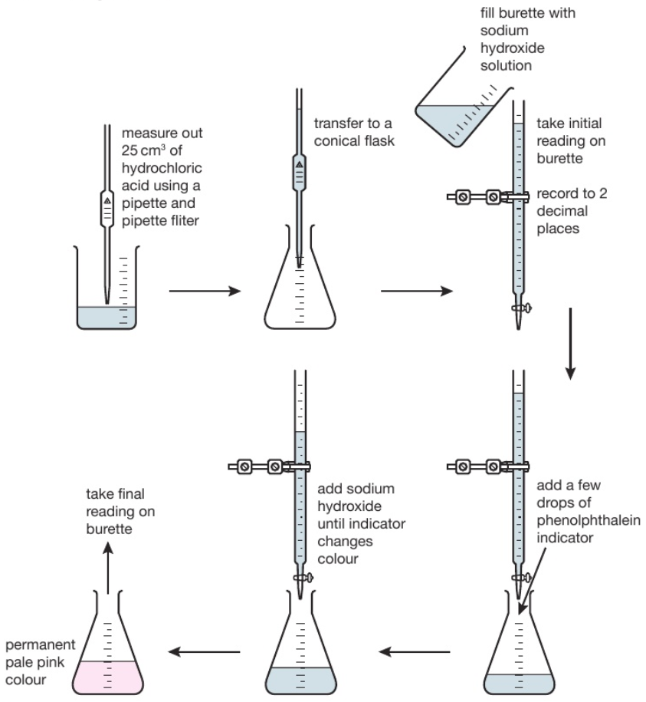

The diagram shows the titration method for a neutralisation reaction between hydrochloric acid and sodium hydroxide, using phenolphthalein as an indicator. The indicator changes colour when neutralisation occurs.

