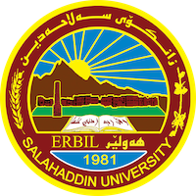
Academic Curriculum Vitae
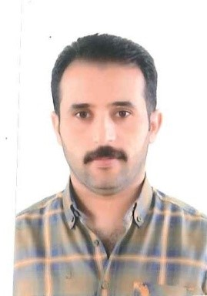
Personal Information:
Full Name: Harem Haider Qader
Academic Title: Assistant Leturer
Email: harem.qader@su.edu.krd
Mobile:07504493751

Education:
I got Bachelor Degree/ MA in English Language in the College of languages/ University of Salahaddin- Hawler (2005) .
I got my Master Degree/ MA in English language and literature at Istanbul Aydin University - Turkey (2015).
Employment:
2003 Salahaddin University- Hawler/

Qualifications
- Method Teaching Qualifications
- English Language Efficiency Qualifications ILETS.
- Microsoft office

Teaching experience:
- Teaching the subject of Academic Skills 2019- 2020.
- Teaching the subject of General English for University Students and English for Specific Purposes/ ESP 2017 until now.

Conferences and courses attended
- 2nd Student Research Project & Idea Grant Conference Salahaddin University-Erbil, 2022 9th March
- 4th Student Research Project Conference, Salahaddin University-Erbil, May 2022
- 3rd International Conference on Accounting, Business, Economics and Politics, June 29th-30th, 2021.

Professional memberships
- Member of Quality Assurance within the tourism department at Salahaddin University-Erbil 2019-2020.
- Member of Quality Assurance within the tourism department at Salahaddin University-Erbil 2021-2022.
- Member of Examination committee at the College of Administration and Economics, 2018-2019.
- Member of Examination committee at the College of Administration and Economics, 2019-2020.
- Member of Examination committee at the College of Administration and Economics, 2020-2021.
- Member of Examination committee at the College of Administration and Economics, 2021-2022.
- Member of the 4th Student Research Project conference preparation, Salahaddin University-Erbil, May 2022.

Professional Social Network Accounts:

- Research gate: https://www.researchgate.net/profile/Harem-Qader
- Google scholar: https://scholar.google.com/citations?hl=en&user=B0SeJRwAAAAJ
- LinkedIn: https://www.linkedin.com/in/harem-qader-8275a7188/
- ORCID: https://orcid.org/my-orcid
- Facebook: https://www.facebook.com/harem.mamundy

