Electrodeposition of Nickel-copper alloy from aqueous solutions in the presence of organic additives

Garib Qadir and Hassan Hadi*
Chemistry department, college of education, Salahaddin University-Erbil, Erbil, Iraq
Email of corresponding author: hassan.abdullah@su.edu.krd

Abstract
On copper substrates, nickel-copper (Ni-Cu) alloy films were deposited from aqueous solutions in the presence of organic additives under galvanostatic conditions. The electrodeposition process and the electrocatalytic behavior of coated thin film were investigated using cyclic voltammetry, spectroscopic and X-ray techniques. The elctrodeposition aqueous solution was composed of nickel and copper ions with some organic additives. Organic additives were added in order to enhance the surface morphology. The coating quality and surface morphology were tested using different X-ray techniques, such as EDX, SEM, and XRD. It was found that the addition of organic additives to the electrodeposition aqueous baths reduces the deposition rate and fracture density.

Keywords: Electrodeposition, nickel, aqueous solution, nicotinic acid, cyclic voltammetry, surface characterizations, hardness

1-Introduction
It is well known that water is the most often used electrolytic solutions for the precipitation of metals and mixture of metals (alloys). Only 30 of the 70 known metals of the periodic table may be efficiently precipitated from aqueous electrolyte of their salts due to the low electrode potential in comparison with hydrogen (Pandey et al., 2017). Metals can be also classified as, active metals with high electrode potential such as aluminum, beryllium, alkali and alkaline earth metals. The electrodeposit of this class is difficult in aqueous solutions due to the high electrode potentials of these metals. The other class has less activity which can only be thermodynamically deposited in aqueous solutions like tungsten, molybdenum, and germanium (Menzies, 1962).
Many studies focusing on the electrodeposition of metals in non-aqueous solution, have shown that its essential to avoid air and water which is often known as glove box (Jayakrishnan et al., 1981). At the same time, aqueous deposition techniques still have some drawbacks like low coating hardness, current efficiency, difficult process control and solution complexity (Brooman, 1991).
Solvent and electrolyte media may enhance functionality, environmental sustainability, and process control while also providing access to reactive metal deposits that were previously inaccessible (eg Al). Additionally, there are notable variations in how the coated layer forms and nucleates on surfaces due to the basic differences between solvents like water and ionic liquids (IL) and deep eutectic solvents (DES) (Liu et al., 2016).
Indeed, aqueous solution may have better properties to be more favorable for the electrodeposition of metals, in comparison of non-aqueous solvents, such as wider potential windows, higher conductivity and high solubility of metal salts (Abbott and McKenzie, 2006). On the other hand, the electrodeposition of metals using non-aqueous solution like ionic liquids, is not necessarily a better choice due to the higher cost of the electrolytes, however it is still having its importance for the production of better deposit morphology in comparison with aqueous systems. Studying these two types of electrolyte may provide essential information to address these possible morphological differences (Al-Murshedi et al., 2019)
Only a few articles have examined the impact of bath additives on electrodeposition (Wen, 2005, Huang et al., 2001). One of these studies is the electrodeposition of (Ir-Ni) in aqueous solution which represents a promising alternatives to produce a protective coating that resists harsh conditions. The activity of this type of protection is attributed to the high melting point, high hardness and the most important the low oxygen permeability and high chemical compatibility (Wu and Chen, 2017, Wu et al., 2017).
Nickel and its alloys are of great interest in a variety of areas, primarily because of their numerous potential uses in corrosion resistance and catalysis (Mech, 2017, Wu and Jiang, 2017). The creation of Ni oxides limits Ni's performance in high-temperature air environments, despite the metal having some amazing physical and chemical characteristics. However, there are several drawbacks of electroplating of copper in aqueous solutions such as the electrolyte stability and the morphology and physical properties of the deposits (Jiangang et al., 2012).
Compared to the deposition of individual metals, the electrodeposition of alloys needs more demanding procedure since the interaction of citrate with metal salts may affect the deposition process and the quality of the deposits (Wu et al., 2014).
The aims of the current study involve studying the electrodeposition of Ni-Cu thin film alloy in aqueous solution in the presence of organic derivatives. Different spectroscopic, physical and X-ray techniques were used to study the electrodeposition solution and the quality of the coated surface in terms of chemical composition, morphology, and crystallographic structure of Ni-Cu alloy films. Additionally, the hypothesized mechanism of Ni-Cu electrodeposition is discussed.

2. Chemicals and experimental methods
2.1. Chemicals
Nickel salts (NiCl₂ .6H₂O) from Biochem chemopharma, 98%. The concentration of nickel salts in aqueous solution was 0.6 M (except where explicitly stated). Sodium chloride (NaCl) and boric acid were purchased from BDH Chemical 99.8%, were used without recrystallization.
2.2. Electrochemical measurements
Conductometrt/preerision/pH/Conductivity/TDS Meter NPUT DC5V was used to measure the conductivity of the electrolytes as a function of temperature. Potentiostat/Galvanostat model CS310M controlled with GPES2 software was used for cyclicvoltammetry investigations. Three electrode system consisting of platinum working electrode with a surface area of 0.12 cm², a platinum flag counter-electrode and a silver/silver chloride as a reference electrode. All the electrodes were polished with 0.05-0.1 mm g-alumina paste and cleaned with deionized water and acetone. All the experiments and the cyclic voltammograms were conducted at 90 °C with a scan rate of 5–10 mV/s.
Copper substrate with a dimension of 70x20mm and 0.6mm thickness were used for the bulk electrolysis as cathodic plates. Prior to their use, these plates were mechanically polished and cleaned with ammonium persulfate followed by water and dried. The anode of the cell was iridium oxide-coated titanium mesh electrode, 60-50 mm. In all of the experiments the deposition was carried out using a constant current for 1 to 2 hours then the copper substrates were removed, washed with deionized water only and weight substrate before and after coating.
2.3. Characterizations
UV-vis spectrophotometer: Spectrophotometer, Model AE-S60-2U S/N:RE1502001 Power: DC6, 3A.20W was used with a 10 mm cell path length and a λmax was determined using the spectrophotometer’s software.
Surface morphology: the surface morphology was characterized using SEM, EDX and XRD as follows, scanning electron microscopy (SEM) (Model1040 (Ficshione, USA), energy dispersive X-ray spectroscopy (EDX), using a Model R-AXIS RAPIDII (Rigaku, Japan). The hardness was measured with a Mitutoyo model MVK-G100 hardness meter.

3- Results and discussion
3-1 -Cyclic voltammetry
The electrochemical characteristics of nickel atoms on copper substrate in aqueous solution have been demonstrated in earlier research to exhibit a noticeable variation in behavior with increasing temperature, similar to speciation. It was found that at low concentration and temperature has shown no observable deposition and stripping reactions during cyclicvoltammetric process. However, when the temperature and concentration are raised to and above 85°C, a quasi-reversible electrochemical deposition and stripping is noticed. At these elevated temperatures the CV of nickel ions in aqueous solution is recorded between -0.55 V and -0.7 V of cathodic deposition and between -0.5 V and +0.15 V of anodic stripping wave. Figure 1, shows the cyclicvoltagramm where the cathodic current is at -0.3 V onset potential with approximate peak magnitude of -0.0125 (A/cm²). In addition, the swept potential is shown at 0.6 V (with respect to Ag/AgCl electrode) and the anodic stripping potential is recorded at +0.2 V. (Abbott et al., 2015a), (Zhang et al., 2012).

Figure 1: Cyclic voltammogram at 90 °C of 0.6 M NiCl₂.6H₂O in aqueous electrolyte of 0.6 M boric acid and 0.3 M sodium Chloride. Measured using a Pt flag counter electrode, 1 mm Pt disc working electrode and Ag/AgCl reference electrode at a scan rate of 10 mV s⁻¹.

3.2. UV–Vis spectra

The UV-vis absorption spectrum was recorded between 300 and 800 nm as shown in Figure 2..
Figure2: UV–Vis spectra of 0.6 M NiCl₂.6H₂O in a aqueous solution with and without the addition of nicotinic acid additive at room temperature.

As shown in Figure 2, the addition of NA enhances the absorption spectra of 0.6M NiCl₂.6H₂O in an aqueous solution. However, NA has no impact on the wave length of the peaks at 376 nm and 700 nm and hence no impact on nickel speciation. Indeed, the formed nickel complex in aqueous solution has only one dominant thermochromic behavior with and without the addition of additive and that is the octahedral complex as shown Figure 2 where the second peak is related to the transition for a tetrahedral complex [NiCl₄]²⁻ (Linert et al., 2001).
Figure 3 illustrates the voltammograms of nickel in aqueous electrolyte with 0.02 M of NA solution at 90 ⁰C on a Pt electrode. Also, there was a lowering in current in the presence of NA despite the excess concentration of NiCl₂. The effect of additive is reflecting the surface modification and the reversibility of the electrodeposition process.
Figure 3 Cyclic voltammograms at 90 °C of 0.6 M NiCl₂.6H₂O in aqueous solution (black) with 0.02 M NA (red). Measured using referenced against (Ag/AgCl) wire, Pt flag counter electrode and Pt disc working electrode at scan rate of 10 mV s⁻¹.

Additionally, the addition of nicotinic acid to the aqueous solution causes the appearance of two anodic stripping characteristics, as shown in Figure 3. The four phases of crystal growth's morphologies being stripped away is the most typical explanation for this kind of event. In this case, Ni metal is likely being peeled off of some crystal growth faces due to preferential adsorption by the NA, which shows that the additives can influence the orientation of crystal formation during deposition. The conclusion that NA reduces the nickel ions electrochemically in aqueous solution more efficiently at low concentrations than at high concentrations indicates that NA adsorbs on surfaces via the nitrogen atom of pyridine and that is one of the characters of copper substrates. If this is the case, nicotinic acid would be present in the adsorbed NA molecule. In this instance, it is anticipated that the functionalized acid surface will interact more strongly with the dissolved nickel metal ion, making the electrochemical reduction is simpler than in the case of functionalized ester surface.
Figure 4: Cyclic voltammograms at 90 °C of nickel ions in aqueous solution of 0.01 M CuCl₂.2H₂O. Measured using (Silver/Silver chloride) reference electrode against Pt counter electrode at a scan rate of 10 mV s⁻¹.

Figure 4 shows the cyclic voltammogram of the present copper chloride in an aqueous solution. This voltammogramm is characterized by a cathodic deposition between -0.7 and -0.9 V and an anodic stripping between –0.15 V and +0.2 V. In addition, the cathodic current is -0.65 V potential with a peak magnitude of -0.0225 (A/cm²) at 90°C temperature.

3.3. Chronocoulometry
One of the common electrochemical methods in electro analytical chemistry is chronocoulometry, which uses the Cottrell equation (equation 1) to find the charge as a function of time where D is the diffusion coefficient, Co is the initial concentration, n is the number of involved electrons, s is time in seconds, A is the surface area of electrode, and F is Faraday constant. The total charge (Q) consumed is determined by the integrated Cottrell equation, which is represented in equation 2. (Ciobanu et al., 2007).

$I=\frac{nFA C_{0 }√D}{√πt}$ …………(1)

$Q=\frac{2nFAC_{0 }D^{1/2}t^{1/2}}{π^{1/2}}$ ………….(2)

According to equation 2, the corresponding reaction is reduction - oxidation process happens at the electrode's surface with a total charge, Q is anticipated linearly with the square root of time. Figure 5, illustrates the charge vs t^{1/2} plot for the nickel chloride in aqueous solution, both with and without the addition of NA. Both systems clearly exhibit nonlinear patterns with an increase of electron transfer rates with time. This may be attributed to the significant amount of nickel chloride with or without additives. Several intriguing behavioral tendencies can be identified in comparison with the solution of NA additive such as the lower charge transfer at any given time.
Additionally, the difference in chronocoulometry of the solution with and without NA appears to indicate a higher cathodic reaction in the case of the pure nickel solution. We infer that the higher charge seen in the presence of NA may not only be the result of metal development but also may be connected to the NA structure. Incredibly, a different reaction was also apparent since the overall charge in the NA additive solution was more than it was in the pure nickel solution. In conclusion, it can be said that each of the electrolyte systems has a different rate of metal development process.

Figure 5: Chronocoulometry graph of nickel chloride in aqueous solution (black) and with the addition of 0.02 M NA (red). The potential was fixed at +0.6 V with respect to silver/silver chloride wire for 10 s then at -0.3 V for 30 min using Pt disc working electrode, Pt flag counter electrode and silver/silver chloride wire reference electrode.

3.4. X-Ray Diffraction (XRD)
Figure 6 shows the results of XRD analysis of Ni deposited from aqueous solution at 88 °C with current density of 0.06 A dm⁻³. The most important peaks in XRD pattern of nickel deposition from different electrolyte at the same conditions via conventional method are at [100], [200] and [300] which show the most preferential crystal lattice direction of electroplated nickel. Although these peaks have relatively the same intensity, the full width at half maximum (FWHM) is different. Actually, finer grain size results in broader peaks as detailed in the Scherrer equation (Tang et al., 2016).
Figure 6. XRD results of the aqueous solution Ni deposited on Cu substrate at 80°C.

3.5. Effect of copper substrate
Nickel is widely used as a protective coating on aluminum alloys, cast zinc, and mild steel alloys. It may be used in many different double and triple films, and it notably excels when combined with chromium to provide a durable surface. (Dennis and Such, 1993)
The film's adherence to the substrate is a critical property of the coating. Lack of adhesion can be caused by insufficient or inappropriate pre-treatment of the metal substrate surface.

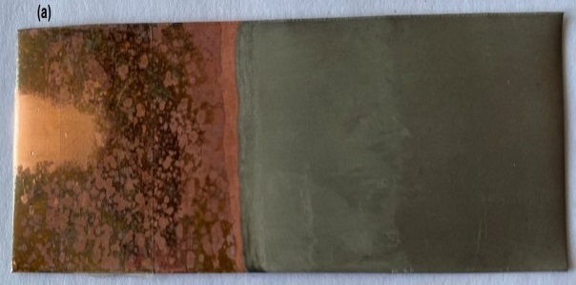 | 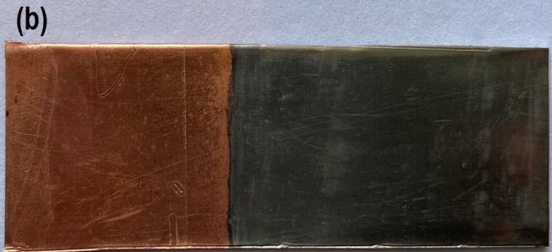
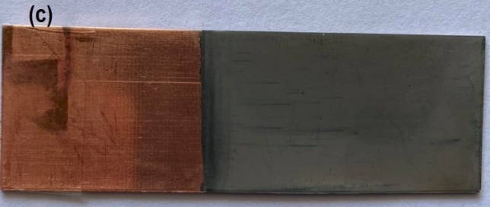
Figure 7. Photograph of the coated nickel thin layer deposited onto a copper substrate in an aqueous solution (a), and after the addition of 0.02 M NA, (b) and after the addition of 0.001 M CuCl₂.2H₂O (c). All at 90 ºC and current density of 1.5 A dm⁻³ for 1 hour.
Organic additives that have been adsorbed on the metal cathode's surface may have an impact on the electrochemical reaction's activation energy, electro crystallization process, rates of mass and charge transfer (Paunovic and Schlesinger, 2006) (Karahan, 2013). Additives are used in electroplating to control hydrogen evolution and increase the quality of the electrodeposit in terms of crystal texture, grain size, and roughness which affect residual stresses, enhance the surface hardness and produce mirror-like surface.
Obviously, the presence of copper ions in the solution has an impact on the characters of the aqueous electrochemical solution and on the physical features and hence the quality of the coatings produced (Endres et al., 2008). Figure 7 shows the nickel deposition on a copper substrate with a current density of 1.5 A dm⁻² for one hour.

3.6. SEM Study and Deposit Morphologies
It was shown above that the additives studied here have a limited impact on the speciation of nickel ions but a significant impact on their electrochemical properties. To ensure consistency between plating's, copper was used as the standard substrate with an iridium oxide covered counter electrode and plating was performed at 90 °C for 20 min at 1.2 Adm⁻².
SEM images of the coated substrates at different conditions are shown in Figure 8. In order to compare the morphology of the substrate with and without using organic additive, SEM was conducted for the coated substrate with and without additive. Dull mirror image and rough surface was shown for the substrate without using the organic additive as shown in Figure 8 (a) and (b). Smooth surface with a brighter nickel mirror and microcrystals was shown in the presence of nicotinic acid additive as shown in Figure 8 (c) and (d). In contrast, the electrodeposition of nickel in presence of copper ions has produced a rough surface with microcrystals of copper-nickel alloys as shown in Figure 8 (f) and (g). Generally, bright coated samples often include crystallites that are too tiny to be seen at this resolution, making it unlikely that any characteristics would be evident in the coatings.
 | 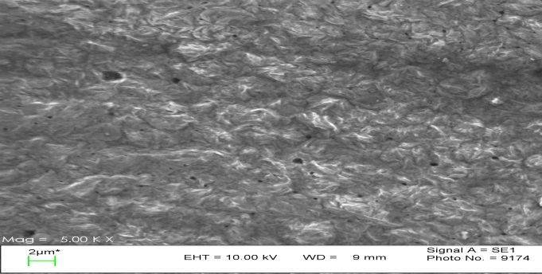  (b) | 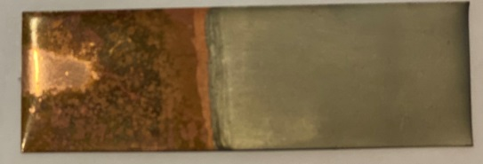  0.6 M NiCl₂.6H₂O + 0.6M Boric Acid + 0.3M NaCl in Aqueous Solution  (a)
 | 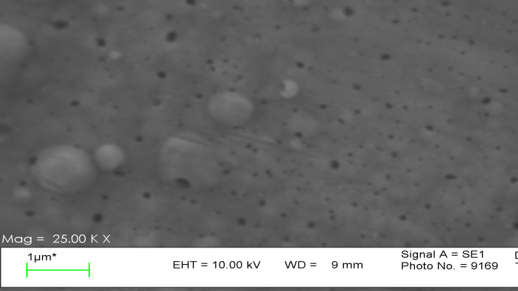  (d) | 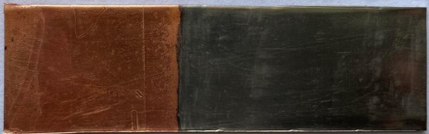  0.6 M NiCl₂.6H₂O + 0.6M Boric Acid + 0.3M NaCl + 0.02M Nicotinic Acid in Aqueous Solution  (c)
 | 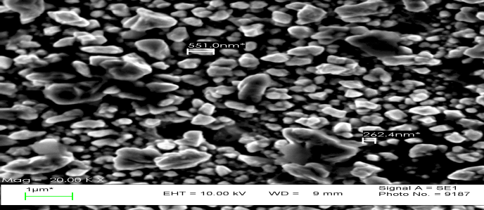  (f) | 0.6 M NiCl₂.6H₂O + 0.6M Boric Acid + 0.3M NaCl + 0.03M Nicotinic Acid in Aqueous Solution + 0.01M CuCl2.2H2O  (e)
 | 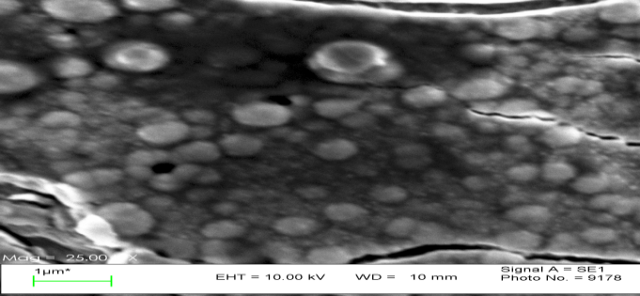  (h) | 0.6 M NiCl₂.6H₂O + 0.6M Boric Acid + 0.3M NaCl + 0.06M Nicotinic Acid in Aqueous Solution + 0.01M CuCl₂.2H₂O  (g)
Figure 8. SEM images and photos of electrodeposited Ni from 0.6M NiCl₂.6H₂O in aqueous solution. (a) and (b) without additives, (c) and (d) with 0.02M nicotinic acid additive, (e) and (f) with 0.03M nicotinic acid and 0.01M CuCl₂.2H₂O and (g) and (h) with 0.6M nicotinic acid and 0.01M of CuCl₂.2H₂O. Plating performed at 90 °C on a copper substrate at 1.2 A dm⁻² for 20 mins with an iridium oxide coated titanium counter electrode.

3.7. Energy dispersive X-ray spectroscopy (EDX)
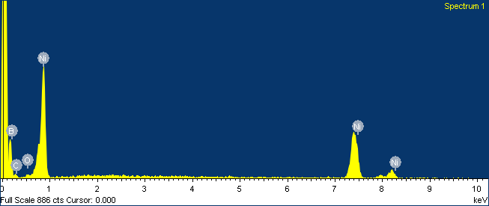
Figure 9. Energy dispersive X-ray spectroscopy (EDX) of copper substrate in aqueous solution of NiCl₂.6H₂O.

Table 1. Elements analysis of copper substrate after electrodeposition
Element | App | Intensity | Weight% | Weight% | Atomic%
 | Conc. | Corrn. |  | Sigma
B K | 0.56 | 0.2538 | 2.19 | 0.69 | 56.58
C K | 0.28 | 0.1881 | 1.51 | 0.29 | 35.09
O K | 0.11 | 0.5778 | 0.18 | 0.08 | 3.20
Ni K | 0.88 | 0.8133 | 1.08 | 0.15 | 5.13
Totals |  |  | 4.95

3.8. Hardness
It well known that the hardness test is one of the most essential test for any coated metal as it shows the mechanical strength of the coated area. The results of the hardness test of the coated substrate in aqueous solution are listed in Table 2. It was found that the coated thin film of pure nickel has shown the highest hardness followed by the mixture of copper – nickel deposits in aqueous solution. In general, the nickel electrodeposition in the presence copper has shown less hardness although, by increasing the concentration of copper the hardness of the coated thin film increases but not to the level of pure nickel strength. Also this result may indicate the effect of copper atoms on the formulation of the electrolyte and the nucleation development of nickel coating.

Table 1. The hardness (HVO3) of the nickel and mixture of nickel and copper at different concentration.
Sample | HVO3 (kgf/mm²) |  |  | Mean value
 | P1 | P2 | P3
0.6 M NiCl₂.6H₂O + boric acid + 0.3 M NaCl in D.W | 66.81 | 69.74 | 67.28 | 67.94
0.6 M NiCl₂.6H₂O + boric acid + 0.3 M NaCl + 0.01 M CuCl₂.2H₂O and 0.02 NA in D.W | 64.32 | 56.55 | 54.07 | 58.31
0.6 M NiCl₂.6H₂O + boric acid + 0.3 M NaCl + 0.01 M CuCl₂.2H₂O and 0.03 NA in D.W | 59.36 | 61.00 | 57.71 | 59.36
0.6 M NiCl₂.6H₂O + boric acid + 0.3 M NaCl + 0.01 M CuCl₂.2H₂O and 0.06 NA in D.W | 58.9 | 58.75 | 61.18 | 61.61

Conclusions
This study looked at the additives' synergistic impacts on the characteristics of Cu-Ni electrodeposition as well as the impact of the electrolyte chemistry and the operating circumstances on the partial current densities, chemical composition of the electrolyte, and the produced surface morphology of copper – nickel thin layer deposits. It was found that the aqueous electrolyte is suitable for the electrodeposition of copper nickel alloy. The effect of additives on the electrodeposition of nickel in an aqueous solution enhancing the coating quality through the nucleation and growth processes. The range of additives selected for the study here 0.02 M NA, was chosen from those often used in aqueous processes. In addition, these additives appear to have minimal impact on the bulk speciation of the nickel metal ion in the aqueous solution. It is believed that additives could positively influence the rate of electrodeposition process.

References
ABBOTT, A. P., BALLANTYNE, A., HARRIS, R. C., JUMA, J. A., RYDER, K. S. & FORREST, G. 2015a. A comparative study of nickel electrodeposition using deep eutectic solvents and aqueous solutions. Electrochimica Acta, 176, 718-726.
ABBOTT, A. P., FRISCH, G., HARTLEY, J., KARIM, W. O. & RYDER, K. S. 2015b. Anodic dissolution of metals in ionic liquids. Progress in natural science: Materials international, 25, 595-602.
ABBOTT, A. P. & MCKENZIE, K. J. 2006. Application of ionic liquids to the electrodeposition of metals. Physical Chemistry Chemical Physics, 8, 4265-4279.
AL-MURSHEDI, A. Y., HARTLEY, J. M., ABBOTT, A. P. & RYDER, K. 2019. Effect of water on the electrodeposition of copper on nickel in deep eutectic solvents. Transactions of the IMF, 97, 321-329.
BROOMAN, E. W. 1991. Electrodeposition from Non-Aqueous Electrolytes. Journal of the Korean institute of surface engineering, 24, 169-176.
CIOBANU, M., WILBURN, J., KRIM, M. & CLIFFEL, D. 2007. 1-Fundamentals. Handbook of electrochemistry, 3-29.
DENNIS, J. K. & SUCH, T. E. 1993. Nickel and chromium plating, Elsevier.
ENDRES, F., MACFARLANE, D. & ABBOTT, A. 2008. Electrodeposition from Ionic Liquids. Wiley-VCH Verlag GmbH & Co.
HUANG, C.-H., JAN, J.-R., SHU, W.-Y. & WU, H.-M. 2001. The sulfur-enhanced effect of absorbing hydrogen in electroformed nickel–rhenium alloy. Materials chemistry and physics, 70, 168-174.
JAYAKRISHNAN, S., PUSHPAVANAM, M. & SHENOI, B. 1981. Electrodeposition from organic solutions of metals that are difficult to deposit from aqueous solutions. Surface Technology, 13, 225-240.
JIANGANG, Q., SHIMING, X., TIAN, Z. & HAIJING, L. 2012. Effect of technical parameters on surface morphology of electrodeposition of iridium layer in aqueous system. Rare Metal Materials and Engineering, 41, 1139-1143.
KARAHAN, İ. H. 2013. Effects of pH value of the electrolyte and glycine additive on formation and properties of electrodeposited Zn-Fe coatings. The Scientific World Journal, 2013.
LINERT, W., FUKUDA, Y. & CAMARD, A. 2001. Chromotropism of coordination compounds and its applications in solution. Coordination Chemistry Reviews, 218, 113-152.
LIU, F., DENG, Y., HAN, X., HU, W. & ZHONG, C. 2016. Electrodeposition of metals and alloys from ionic liquids. Journal of Alloys and Compounds, 654, 163-170.
MECH, K. 2017. Influence of organic ligands on electrodeposition and surface properties of nickel films. Surface and Coatings Technology, 315, 232-239.
MENZIES, I. 1962. The Electrodeposition of the Less-Common Metals. Transactions of the IMF, 39, 172-182.
PANDEY, R. K., SAHU, S. & CHANDRA, S. 2017. Handrook Of Semiconductor Electrodeposition, CRC Press.
PAUNOVIC, M. & SCHLESINGER, M. 2006. Fundamentals of electrochemical deposition, john wiley & sons.
WEN, S. 2005. The electrodeposition and property study of nickel-rhenium alloy.
WU, W.-P. & JIANG, J.-J. 2017. Effect of plating temperature on electroless amorphous Ni–P film on Si wafers in an alkaline bath solution. Applied Nanoscience, 7, 325-333.
WU, W. & CHEN, Z. 2017. Iridium coating: processes, properties and application. Part I. Johnson Matthey Technol. Rev, 61, 16-28.
WU, W., ELIAZ, N. & GILEADI, E. 2014. The effects of pH and temperature on electrodeposition of Re-Ir-Ni coatings from aqueous solutions. Journal of The Electrochemical Society, 162, D20.
WU, W., ELIAZ, N. & GILEADI, E. 2016. Electrodeposition of Re-Ni alloys from aqueous solutions with organic additives. Thin Solid Films, 616, 828-837.
WU, W., JIANG, J., CHEN, Z., JIANG, P. & WANG, Z. 2017. Morphology and mechanical characteristics of monolayer and multilayer Ir coating by double glow plasma. Journal of Wuhan University of Technology-Mater. Sci. Ed., 32, 190-196.
ZHANG, H., LU, Y., GU, C.-D., WANG, X.-L. & TU, J.-P. 2012. Ionothermal synthesis and lithium storage performance of core/shell structured amorphous@ crystalline Ni–P nanoparticles. CrystEngComm, 14, 7942-7950.

