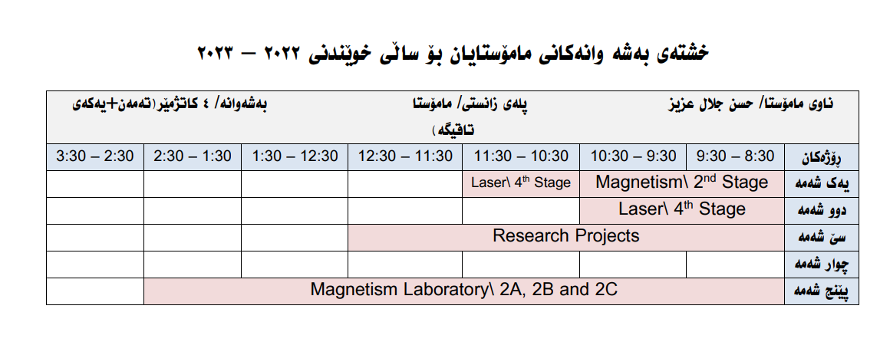

Surgery case report

Omer sabah jalal
5th grade – H1

Case report:

A 23 years old female patient visited the department of oral and maxillofacial surgery in tishik international university to extract her lower 8 for orthodontic purpose , her name was eysan aksandar she lives in erbil and she was a student in dentistry.
During taking history from the patient , the patient had no history of systemic disease or allergies , and she was not on regular medication.
During extra oral examination normal TMJ function and symmetrical facial appearance , and no lymph node enlargement noted.
For intra oral examination she has normal healthy mucosa with healthy pink gingiva.
Procedure:
•the surgery was performed under Local anesthesia via intra oral approach.
• Incision done because it was impacted tooth then a flap raised .
• after that by using straight low speed hand piece to remove bone to get extraction more easily And using less pressure during extraction to prevent nerve injury.
-Then use straight elevator to luxation.
- tooth removal.
• Clean the area with syringe of normal saline very well , then suturing.
• give instruction to the patient.

