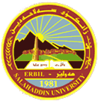
University of Salahaddin
College of Science
Department of Physics
General Physics

“Solar Energy Systems and Possibility for Application in Heating and Cooling”

Prepared by:

Kalsum A. Abdulrahman

Supervised by:

Dr. Hassan Sadi Ibrahim

Newroz 2722 March 2022

