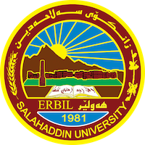
Academic Curriculum Vitae
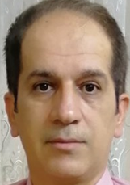
Personal Information:
Hassan Ghazi KakAmeen
Academic Title: Lecturer
Hassan.Kakameen@su.edu.krd
00964-0750 482 14 65
Education:
- B.Sc., Salahaddin University-Erbil, College of Science, Geology Department,1991.
- M.Sc., Salahaddin University-Erbil, College of Science, Geology Department,2004.
- Ph.D., Salahaddin University-Erbil, College of Science, Geology Department,2019.
Employment:
- 20-5-1995, Geology Department, College of Science, Salahaddin University-Erbil.

Qualifications
- Pedagogy course, Salahaddin University-Erbil, 2005.
- Computer course, Salahaddin University-Erbil, 2010.
- TOEFL, 2015.
- Expert in field study of the NW segment of the Iraqi Zagros Fold Thrust Belt.
- English language course (advance level), Salahaddin University-Erbil, 2019.

Teaching experience:
undergraduate: Ductile structural Geology-3rd year (Theory and practical). Brittle Structural Geology-3rd year (Theory and practical). Structural Geology- 3rd year (Theory and Practical). Geotectonics- 4th year. Geomorphology- 2nd year (Theory and practical). Field Geology- 3rd year. Remote Sensing- 2rd year. Crysatalography-1th year. Field Work Application Course-3rd year.

Research and publications
- BALAKI, H.G. AND Omar, A. A. (2018) Clues to inferred different thrust-related fold models and thin-thick skinned tectonics within a single folded structure in Iraqi Zagros, Kurdistan region. Arabian Journal of Geosciences .11. p.1-20. DOI 10.1007/s12517-018-3605-4. Balaki, H.G.K., Omar, A.A., 2019. Structural assessment of the Bradost and Berat
- structures in imbricate and high folded zones—Iraqi kurdistan Zagros belt. Arab. J.
- Geosci. 12, 1–21. https://doi.org/10.1007/s12517-019-4251-1.
Conferences and courses attended

Funding and academic awards

Professional memberships
- Geological Organization of Kurdistan. Geological Society of Iraq.

Professional Social Network Accounts:
Research Gate. Google Scholar. Orcid.

