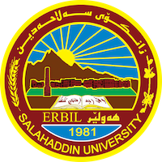
Academic Curriculum Vitae

Personal Information: 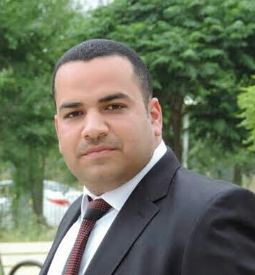
Full Name: Hassan Mahdi Salieh
Academic Title: lecturer
Email: (university email) hassan.salieh@su.edu.krd
Mobile: +9647701650250

Education:
- Bachelor degree: food science and biotechnology department. , College of Agriculture, Mosul University (2006-2007)
- Master degree: food science and biotechnology department. , College of Agriculture, Mosul University (2010)
Employment:
- Sulaimani Polytechnic University,Technical College of Applied science
- Salahaddin University, College of Education/ Shaqlawa, Biology Department

Qualifications
- Windows system, Internet, Microsoft office (Word, Power point, Excel) , Endnote
- Languages:Arabic language , English language, Kurdish language

Teaching experience:
- Basics of dairy science food science (Undergraduate / Second stage)
- Biochemistry (Undergraduate / Second stage)
- Dairy Science (Undergraduate / Fourth stage)
- Dairy processing (Undergraduate / Fourth stage)
- Food processing engineering (Undergraduate / Fourth stage)
- Food quality control (Undergraduate / Third stage)
- Invertebrate
Research and publications
- Effect of milk proteins aggregation using Transglutaminase and Maillard reaction on Ca2+ milk gel
- Utilization the Liquid Acidic Whey and Roselle Calyces Extract (Hibiscus sabdariffa L.) in Water Ice
- The use of whey and natural flavours in the manufacture of ices

Conferences and courses attended
The 4th International Conference of Food Industries & Nutrition Division , National Research Centre Cairo-Egypt
Professional memberships
Kurdistan agricultural engineers
Professional Social Network Accounts:

It is also recommended to create an academic cover letter for your CV, for further information about the cover letter, please visit below link:
https://career-advice.jobs.ac.uk/cv-and-cover-letter-advice/academic-cover-letter/

