QUESTION BANK

Q: answer with true or false
- In SEC, semi-rigid gels like bio beads are used for the separation of polar systems.
- Dialysis is chromatographic separation method used to separates molecules according to size through the use of semi- permeable membranes.
3 In SEC, smaller pore sizes are used for rapid desalting of proteins or protein purification.
4.Dialysis is a chromatographic separation method used to separates molecules according to size through the use of semi- permeable membranes.
5. Analyte can be separated from an interferent if there is no significant difference of their chemical or physical properties.
6. In size exclusion chromatography (SEC) technique, large molecules are ‘‘included’’ and elute first. However, small molecules are ‘‘excluded’’ and elute last.
7. Simple distillation is used for separation of liquids that have very high difference in boiling points.
8. Volatilization can be used as a separation method basis on change in physical state.
9.HPLC is similar to column chromatography but high pressure is used for effective separation.
- In normal phase chromatography, the mobile phase is polar in nature while in reverse phase the mobile phase is non-polar in nature.
- The used mobile phase is a liquid/gas and should have opposite polarity to stationary phase.
- An anionic resin typically has the following preference: PO₄³⁻ < SO₄²⁻ < Cl⁻.
- Strong ion exchangers resin can exchange their H⁺ or OH⁻ groups only below pH 7.
- Ions with lower valence are typically preferred by the ion exchange resin.
- Liquid-liquid extraction, also known as solvent extraction and partitioning, is a method to separate compounds based on their relative solubilities in two different miscible liquids.
- Distillation technique is best for separating a liquid from a solution.
- Dialysis is frequently used to purify proteins, hormones, and enzymes.
- The separation by magnet can be a physical way when you are talking about separating iron from cereals.

Q: choose the correct answer:
1.In SEC, The beads act as “traps” or “sieves” and function to filter .................... molecules which become temporarily trapped within the pores.
a- small b- big c- small and big d- none
2.Separation techniques such as ................. and .............. is based on change in physical state.
a- precipitation, distillation b- volatilization, distillation c- evaporation, distillation d- none
3.............. technique is used for desalting and determination of molecular weights like polymers.
a) SEC b) Dialysis c) GC d) TLC
4. In reverse phase chromatography, the stationary phase is ....... and mobile phase is ....... in nature.
a) polar, non-polar b) non-polar, non-polar c) non-polar, polar d) polar, polar
5. .................... chromatography, is also called molecular sieve chromatography, gel filtration chromatography or gel-permeation chromatography (GPC).
a) Gas b) Paper c) Liquid d) Size-exclusion
6. A good stationary phase (Beads) should be:
a) chemically inert b) inexpensive c) react with eluent d) all of them
7. Process in which ions of one substance are replaced by similarly charged ions of another substance.
a) gel permeation b) Percolation c) distillation d) ion exchange
- Sulfonic group (R-SO₃⁻H⁺) is an example of ………………………….. exchanger.
a)strongly acidic cationic b)strongly basic anionic c)weakly basic anionic d)weakly acidic cationic
9. The stationary phases are always inside a column except in ......................... chromatography.
a) paper and thin layer b) SEC and GC c) Paper and HPLC d) GC and thin layer
- ............ chromatography is a normal phase chromatography and its mobile phase is mostly CO₂.
a) Gas b) HPLC c) Liquid d) Super critical fluid
11. In HPLC system, the application of pressure ..................... the time of run.
a) decrease b) increase c) constant d) not affect
- In SEC pump, change of flow rate of only 0.1% can cause an error in molar mass ..........
a) 10 % b) 1% c) 0.1% d) 5%
- Separation techniques such as ................. and .............. is based on change in physical state.
a) precipitation, distillation b) volatilization, distillation c) evaporation, distillation d) none

Q: Mention types of mixture that is used during the following types of separation techniques:
- Mechanical (Sieving) ( Solid – Solid Mixture )
- Filtration ( )
- Re-crystallization ( )
- Sublimation ( )
- Extraction ( )
- Distillation ( )
Q:Mention three important uses of the size exclusion chromatography technique:
- ………………………………………
- ……………………………………..
- ……………………………………..

Q: A good stationary phase (Beads) should have following properties:
- ………………………………………
- ……………………………………..
- ……………………………………..
……………………………………..
Q: Write all parts name (1-7) of gas chromatography (GC) system components?
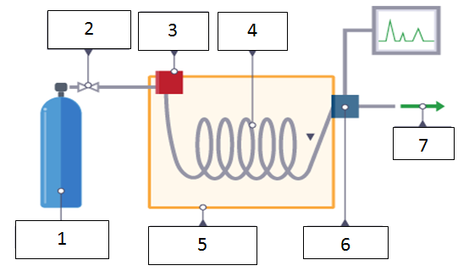

Q: Write all parts name (1-7) of HPLC system components?

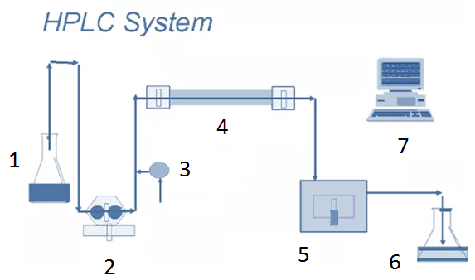

Q/ 0.75 g of YY compound dissolved in 50 mL water. Then, a suitable organic solvent (90 mL) is used to extract the dissolved compound. Find extraction percentage when the organic solvent was used with a THREE portions. It is known that KD is equal to 8.

