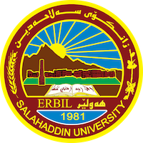
Academic Curriculum Vitae
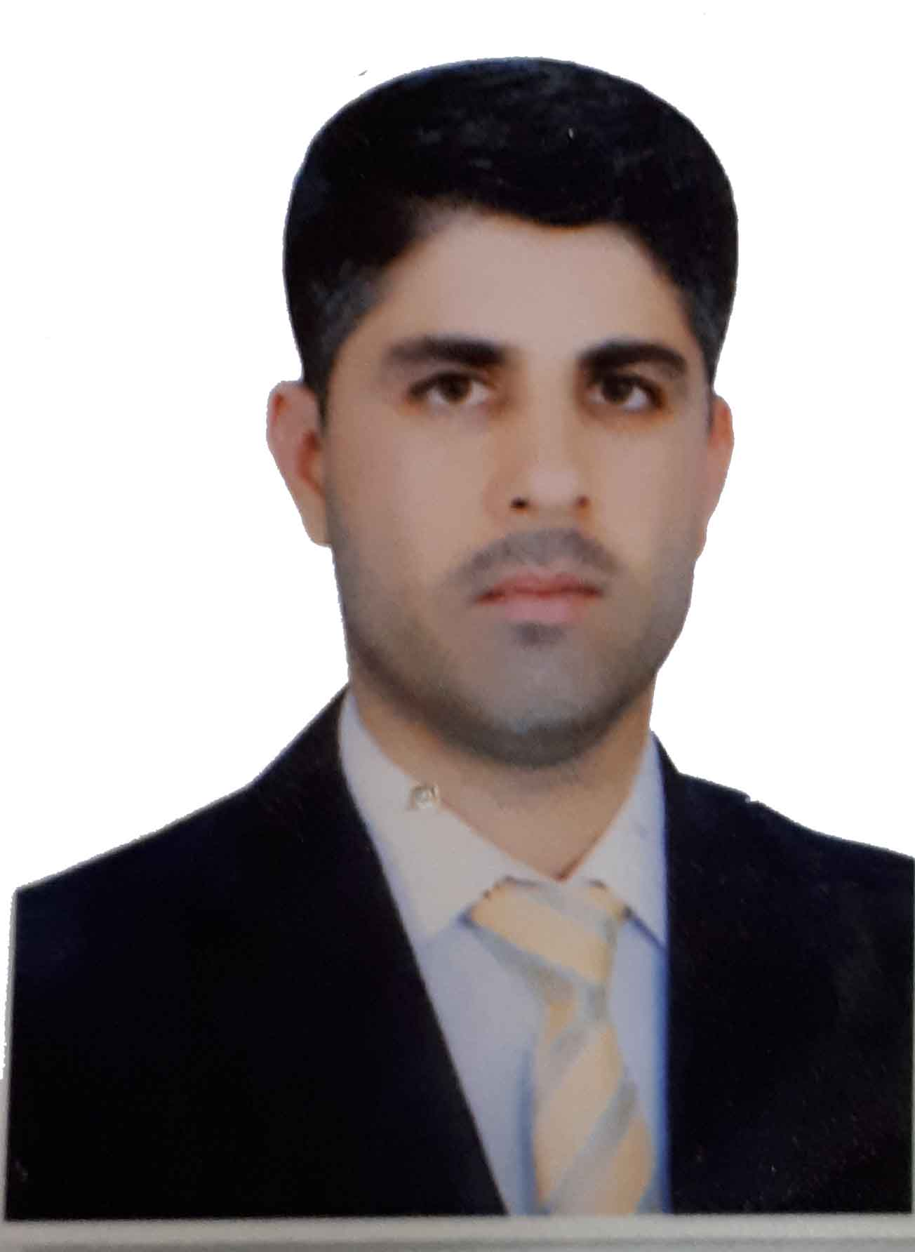
PersonalInformation:
Full Name: Hawraz Jawhar Majid
Academic Title: assistant lecturer
Email: (hawraz.majid@su.edu.krd)
Mobile:07504141682
Education:
- Bachelor degree at historical department salahadin university college of arts in 2005
- Master of history in Modern History salahadin university college of arts in 2012
Employment:
- Assistant Lecturer in history dipart mint of Sallahadin university college of arts
Qualifications
- In computer ( Word , excel , power poin)
Teaching experience:
- I teached in all stage, of college of arts in salahaddin uneversity.
Research and publications
- Book publicationed (Sulaimani city ( 14 July 1958 -17 July 1968 )
- Research publicationed (Russian Kurdologist Olga Ivanovna Zhiglina 1946-2013)

Conferences and courses attended
- I attended of conference about Erbil in Historcal Sources – Read and evaluate 2019/4/

Professional memberships
- I membership in )Historical Cultural Association(

Professional Social Network Accounts:

