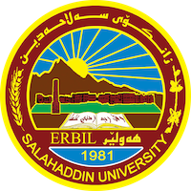
Academic Curriculum Vitae
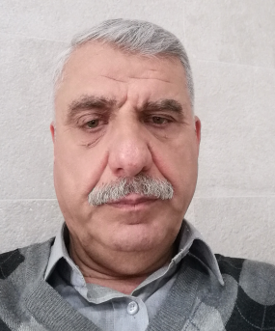
Personal Information:
Full Name: Hawro Khalil SHAKER
Academic Title: Dr. Assistant Professor
Email: hawro.shaker@Su.edu.krd
Mobile: 009647504708977

Education:
- B. Sc. Romania Engineerin g 1985- 1986 Romania
- M. Sc. Technology Machines 1986- 1987 Romania
- PhD Technology Machines 1987- 1989 Romania

Employment:
- Salahadin university college of engineering
- Mechanical & Mechatronics
- 29/12/1992

Qualifications
- Teaching qualifications
- IT qualifications
- Language qualifications such as TOEFL, IELTS or any equivalent
- Any professional qualification
- You could put any professional courses you have attended

Teaching experience:
- State all teaching courses you delivered, stating undergraduate or post graduate
- Courses, trainings, lab supervision, etc.,

Research and publications
- State all researches, publication you made.

Conferences and courses attended
- Internship Conference, Erbil Hotel, 2022

Professional memberships
- Kurdistan Engineering Union.
- Kurdistan teachers Union.

Professional Social Network Accounts:

- List your profile links of ReserchGate, LinkedIn, etc.

