Types of Casting Processes and their Applications
•
（1）Sand casting.
• （2）Investment casting.
• （3）Die casting.
• （4）Low pressure casting.
• （5）Centrifugal casting.
• （6）Gravity die casting.
• （7）Vacuum die casting.
• （8）Squeezing die casting.

sand casting process
investment casting process
aluminum casting process
centrifugal casting process
types of casting process
metal casting process
Casting processes: Molding materials and their requirements; Patterns: Types and various pattern materials. Various casting methods, viz., sand casting investment casting, pressure die casting, centrifugal casting, continuous casting, thin roll casting; Mould design; Casting defects and their remedies. (14 classes) Metal forming processes: Various metal forming techniques and their analysis, viz., forging, rolling, extrusion, wire drawing, sheet metal working, spinning, swaging, thread rolling; Super plastic deformation; Metal forming defects.

Advantages • Molten material can flow into very small sections so that intricate shapes can be made by this process. As a result, many other operations, such as machining, forging, and welding, can be minimized. • Possible to cast practically any material: ferrous or non-ferrous. • The necessary tools required for casting moulds are very simple and inexpensive. As a result, for production of a small lot, it is the ideal process. • There are certain parts (like turbine blades) made from metals and alloys that can only be processed this way. Turbine blades: Fully casting + last machining. • Size and weight of the product is not a limitation for the casting process.

The metal casting process begins by creating a mold, which is the ‘reverse’ shape of the part we need. The mold is made from a refractory material, for example, sand. The metal is heated in an oven until it melts, and the molten metal is poured into the mold cavity. The liquid takes the shape of the cavity, which is the shape of the part. It is cooled until it solidifies. Finally, the solidified metal part is removed from the mold.

Casting Definition – Casting means pouring molten metal poured into a refractory mold cavity and allows it to solidify. The solidified object is taken out from the mold either by breaking or taking the mold apart. The solidified object is called casting. The technique followed in the method is known as the casting process.
Read More: Difference Between Casting and Forging/Forming Processes

A large number of metal components in designs we use every day are made by casting.
The reasons for this include:
(a) Casting can produce very complex geometry parts with internal cavities and hollow sections.
(b) It can be used to make small (few hundred grams) to very large size parts (thousands of kilograms)
(c) It is economical, with very little wastage: the extra metal in each casting is re-melted and re-used
(d) Cast metal is isotropic – it has the same physical/mechanical properties along any direction.
Read also: Introduction To Pattern | Types Of Pattern used in Casting Process

Common examples of Casting: Door handles, locks, the outer casing or housing for motors, pumps, etc., wheels of many cars. Casting is also heavily used in the toy industry to make parts, e.g. toy cars, planes, and so on.
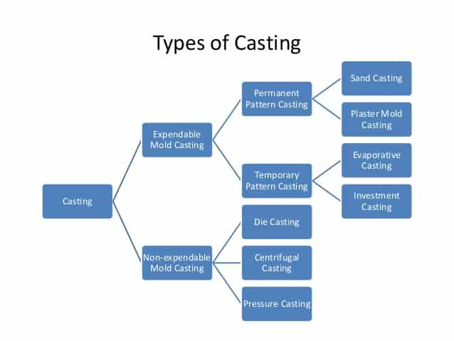
Types of casting

Classification Of Casting Processes :
1. Conventional Moulding Processes
- Green Sand Moulding
- Dry Sand Moulding
- Flaskless Moulding
2. Chemical Sand Moulding Processes
- Shell Moulding
- Sodium Silicate Moulding
- No-Brake Moulding
3. Permanent Mould Processes
- Gravity Die Casting
- Pressure Die Casting
4. Special Casting Processes
- Investment Casting
- Continuous Casting
- Vacuum Sealed Moulding
- Squeeze Casting process
- Centrifugal Casting
- Plaster Moulding
- Evaporative Pattern Casting
- Ceramic Shell Moulding
- Slush Casting
- Stir Casting

Types Of Casting Processes :
Two Main Categories of Metal Casting Processes
1.Expendable mold processes –
- A mold after process must be destroyed in order to remove the casting.
- A new mold is required for each new casting.
- Production rates often limited by time to make mold rather than casting itself.
- More complex shapes possible.
- Mold materials: sand, plaster, and similar materials + binders.
Expendable Mold Casting further Classified as,
- Sand Moulding
- Shell Moulding
- Investment Casting
- full mold casting
- Co2 Molding
2. Permanent mold processes –
- Mold is made of metal and can be used to make many castings.
- Part shapes are limited
- Permanent mold processes are more economic in high production operation;
- Mold: made of metal and, less commonly, a ceramic refractory material
Permanent mold Casting further Classified as,
- Centrifugal Casting
- Die Casting
- Slush Casting
- Squeeze Casting

Different types of castings, their advantages, disadvantages, and examples.

1. Sand Casting :
Sand casting is one of the most popular and simplest types of casting, and has been used for centuries. Sand casting allows for smaller batches than permanent mold casting and at a very reasonable cost.
Steps are used in the Sand casting process;
1. Pattern Making: Patterns are the replica of casting. Patterns are manufactured using wood, metals, wax, plaster of Paris, etc. For the preparation of patterns various tools and equipments are used.
2. Molding and Core making: Prepare a mold cavity by using patterns and use the core for making hollow parts in casting.
3. Melting and Casting: Melt the metal in the furnace and pour it in the mould cavity. Wait until it solidifies. As the casting gets solidify, remove the casted part from the sand.
4. Cleaning of Casting: After removing the casting from the sand cut the runners and risers, also trim the flash appears at parting line of the mould.
5. Testing of Casting: Test the casting for various defects.
Advantages of Sand casting – Wide range of metals, sizes, shapes, low cost
Disadvantages of sand casting-poor finish, wide tolerance
Examples of sand casting –Engine blocks, Cylinder heads

2. Shell mold Casting :
Shell molding is similar to sand casting, but the molding cavity is formed by a hardened “shell” of sand instead of a flask filled with sand. The sand used is finer than sand casting sand and is mixed with a resin so that it can be heated by the pattern and hardened into a shell around the pattern. Because of the resin and finer sand, it gives a much finer surface finish.
Shell molding, also known as shell-mold casting is an expendable mold casting process that uses a resin covered sand to form the mold. As compared to sand casting, this process has better dimensional accuracy, a higher productivity rate, and lower labor requirements. It is used for small to medium parts that require high precision. Shell mold casting is a metal casting process similar to sand casting, in that molten metal is poured into an expendable mold. However, in shell mold casting, the mold is a thin-walled shell created from applying a sand-resin mixture around a pattern. The pattern, a metal piece in the shape of the desired part, is reused to form multiple shell molds. A reusable pattern allows for higher production rates, while the disposable molds enable complex geometries to be cast. Shell mold casting requires the use of a metal pattern, oven, sand-resin mixture, dump box, and molten metal.
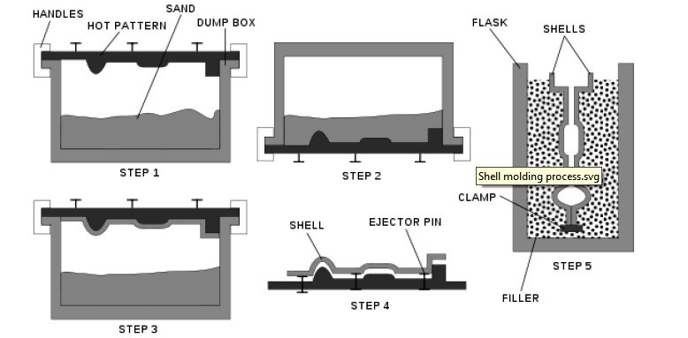shell molding process
Steps Of Shell Molding Process
Pattern creation – A two-piece metal pattern is created in the shape of the desired part, typically from iron or steel. Other materials are sometimes used, such as aluminum for low volume production or graphite for casting reactive materials.
Mold creation – First, each pattern half is heated to 175-370 °C (350-700 °F) and coated with a lubricant to facilitate removal. Next, the heated pattern is clamped to a dump box, which contains a mixture of sand and a resin binder. The dump box is inverted, allowing this sand-resin mixture to coat the pattern. The heated pattern partially cures the mixture, which now forms a shell around the pattern. Each pattern half and the surrounding shell is cured to completion in an oven and then the shell is ejected from the pattern.
Mold assembly – The two shell halves are joined together and securely clamped to form the complete shell mold. If any cores are required, they are inserted prior to closing the mold. The shell mold is then placed into a flask and supported by a backing material.
Pouring – The mold is securely clamped together while the molten metal is poured from a ladle into the gating system and fills the mold cavity.
Cooling – After the mold has been filled, the molten metal is allowed to cool and solidify into the shape of the final casting.
Casting removal – After the molten metal has cooled, the mold can be broken and the casting removed. Trimming and cleaning processes are required to remove any excess metal from the feed system and any sand from the mold.
Advantages of shell mold casting: better accuracy, finish, higher production rate
Disadvantages of shell mold casting: limited part size
Examples of shell mold casting: connecting rods, gear housings.
Read More: Shell Moulding – Steps, Advantages, and Disadvantages

3.Investment Casting :
Investment casting (known as lost-wax casting in art) is a process that has been practiced for thousands of years, with the lost-wax process being one of the oldest known metal-forming techniques. From 5000 years ago, when beeswax formed the pattern, to today’s high technology waxes, refractory materials, and specialist alloys, the castings ensure high-quality components are produced with the key benefits of accuracy, repeatability, versatility, and integrity.
Lost Wax Method :
It is also called the lost wax method. This method involves the use of an expendable pattern surrounded with a shell of refractory material to form a casting mold. Steps in investment casting are; making a master pattern, making wax patterns, making a tree of wax pattern coating it with a slurry of fine silica sand and water, melting out the wax pattern, and baking the mold, making a casting. It is generally adopted for ornaments and jewelry.
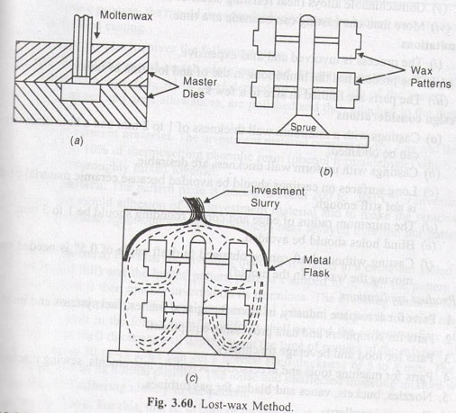Lost wax Method
Advantages of Investment casting :
- High dimensional accuracy and close tolerance can be achieved., Castings are free from usual defects, Intricate shapes can easily casted.,
- No parting line on casting.
Disadvantages Of Investment Casting :
The process is expensive., Only small jobs can be done.,
Applications of Investment Casting :
Parts of aircraft engines, Nozzles, vanes, and blades of turbines. Jewelry items parts of machine tools, instruments, etc.
Read More: Steps in Investment Casting Process

4. Centrifugal casting
In this process molten metal is poured in the mold and allowed to solidify while the mold is rotating. Metal is poured into the center of the mold at its axis of rotation. Due to centrifugal force the liquid metal is thrown out towards the periphery.
Centrifugal casting is both gravity- and pressure-independent, since it creates its own force feed using a temporary sand mold held in a spinning chamber at up to 900 N. Lead time, varies with the application. Semi- and true-centrifugal processing permit 30–50 pieces/hr-mold to be produced, with a practical limit for batch processing of approximately 9000 kg total mass with a typical per-item limit of 2.3–4.5 kg.
In centrifugal casting, centrifugal force plays a major role in shaping and feeding of the casting. In this process mold is rotated rapidly about its central axis as the metal is poured into it. Centrifugal force is utilized to distribute liquid metal over the outer surface of the mold. Hollow cylinders and other annular shapes are formed in this way. Centrifugal force tends the poured metal and the freezing metal to fly outward, away from the axis of rotation, and this tendency creates high pressure on the metal or casting while the lighter slag, oxides, and other inclusions being lighter, get pushed towards the center.
The axis may be horizontal, vertical, or inclined. Casting cools and solidifies from outside towards the axis of rotation; so it results in good directional solidification. Hence castings are free from shrinkage. It may be produced in metal or sand lined mold, depending largely upon the quantity desired.
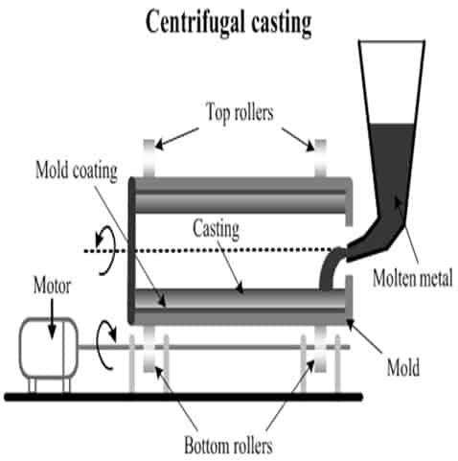Centrifugal casting
Advantages of centrifugal casting – Large cylindrical parts, good quality
Disadvantages of centrifugal casting- Expensive, limited shapes
Examples of centrifugal casting – pipes, boilers, flywheels

5.Permanent mold casting
Permanent mold casting is a metal casting process that employs reusable molds (“permanent molds”), usually made from metal. The most common process uses gravity to fill the mold. However, gas pressure or a vacuum are also used. A variation on the typical gravity casting process, called slush casting, produces hollow castings. Common casting metals are aluminum, magnesium, and copper alloys.
Advantages of permanent mold casting –good finish, low porosity, high production rate
Disadvantages of permanent mold casting- Expensive, limited shapes
Examples of permanent mold casting – gears, gear housings

6. Die Casting :
The die casting process forces molten metal under high pressure into mold cavities (which are machined into dies). Most die castings are made from nonferrous metals, specifically zinc, copper, and aluminum-based alloys, but ferrous metal die castings are possible. The die casting method is especially suited for applications where many small to medium-sized parts are needed with good detail, a fine surface quality and dimensional consistency.
Hot chamber die casting
In a hot chamber submerged plunger-type machine, the plunger operates in one end of a gooseneck casting which is submerged in the molten metal. With the plunger in the upper position, metal flow by gravity into this casting through holes, just below the plunger and the entrapped liquid metal is forced into the die through the gooseneck channel and in-gate . As the plunger retracts, the channel is again filled with the right amount of molten metal. The plunger made of refractory material may be actuated manually or mechanically and hydraulically. Heating is continued throughout the operation to keep the molten metal sufficiently liquid.
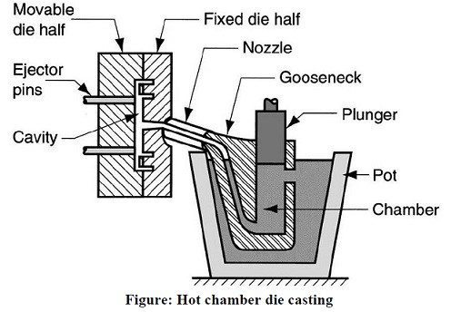hot chamber die casting
Advantages of die casting – Excellent dimensional accuracy, high production rate
Disadvantages of die mold casting- costly dies, small parts, non-ferrous metals
Examples of die mold casting – precision gears, camera bodies, car wheels

7. Plaster mold casting
Plaster casting is similar to sand casting except that plaster of paris is substituted for sand as a mold material. Generally, the form takes less than a week to prepare, after which a production rate of 1–10 units/hr·mold is achieved, with items as massive as 45 kg (99 lb) and as small as 30 g (1 oz) with very good surface finish and close tolerances.
Advantages of plaster mold casting – complex shapes, good surface finish
Disadvantages of plaster mold casting- non-ferrous metals, low production rate
Examples of plaster mold casting – prototypes of mechanical parts

8. Continuous casting
Continuous casting is a refinement of the casting process for the continuous, high-volume production of metal sections with a constant cross-section. Molten metal is poured into an open-ended, water-cooled mold, which allows a ‘skin’ of solid metal to form over the still-liquid center, gradually solidifying the metal from the outside in. After solidification, the strand, as it is sometimes called, is continuously withdrawn from the mold.
Advantages of Continuous casting
- 100 % casting yield.
- The process can be easily mechanized and thus unit labor cost is less.
- Casting surfaces are better
- Gain size and structure of the casting can be easily controlled
- HIgh production rates.
Disadvantages of Continuous Casting :
- Continuous and capable cooling of mold is required

