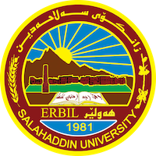
Academic Curriculum Vitae

Personal Information: 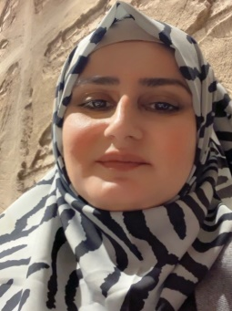
Full Name: Hawzheen Kareem Othman
Academic Title: Lecturer
Email: (university email): hawzheen.othman@su.edu.krd
Mobile:07504971568

Education:
- Bachelor degree in Biology- college of Science/ Salahaddin University - Hawler (2004-2005)
- Master of Science in animal physiology, Salahaddin University - Hawler (2011)
Effects of potassium and magnesium on some hemodynamic and related parameters in rats with induced hypertension

Employment:
Salahaddin University became my alma mater in 2005 when I successfully completed my studies and graduated. Building upon my undergraduate education, I pursued further academic pursuits and obtained a Master's degree in Animal Physiology in 2011. This specialized degree allowed me to delve deeper into the intricacies of animal physiology, expanding my understanding of this field. As I progressed in my academic career, my dedication and expertise were acknowledged, leading to a significant milestone in 2017.
Qualifications
- Teaching method course.
- IT
- Language qualifications such as IELTS

Teaching experience:
- Laboratory teaching experience : Hematology
- Animal Physiology
- Plant taxonomy
- Endocrinology
- Ecology
- Human anatomy

Research and publications
- Effects of potassium and magnesium on some hemodynamic and renal function related parameters in rats with induced hypertension. MSc, Thesis, 2015.
- Hemodynamic and oxidative stress effects of gamma-radiation in both male and female rats. Journal of ZankoiSulaimani (JZS) 2015 17-2 (part A)
- Change in the hemodynamic and thyroid functions in rats treated by opium, Diyala journal for pure science(DJPS), 2016
- Effects of high protein intake on kidney function and acid excretion in body builders
- Protective Effects of Omega3 on CCl₄-Induced Oxidative Stress and Nephrotoxicity in Female Albino Rats.
- Association of apelin, chemerin and omentin levels with oxidative stress markers in non-diabetic and induced diabetic rats
- The Roles of Potassium Channels and Nitric oxide in the Modulation of Apelin induced-relaxation in Isolated Diabetic Rat Aorta

Conferences and courses attended
- Give details of any conferences you have attended, and those at which you have presented delivered poster presentations.

Funding and academic awards
- List any bursaries, scholarships, travel grants or other sources of funding that you were awarded for research projects or to attend meetings or conferences.

Professional memberships
- Kurdistan Biology Syndicate/ Hawler
- Kurdistan Teacher Syndicate/ Hawler.

Professional Social Network Accounts:

- https://orcid.org/0000-0003-1904-3679
- https://scholar.google.com/citations?hl=en&user=A05UZakAAAAJ
- https://scholar.google.com/citations?view_op=search_authors&mauthors=Hawzheen+Kareem+Othman&hl=en&oi=ao

