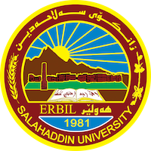
Academic Curriculum Vitae
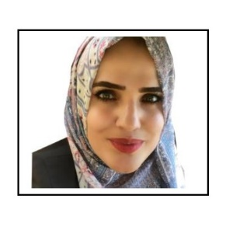
Personal Information:
Full Name: Hazha Kosrat Majeed
Academic Title: Assistant lecturer
Email: (hazha.majeed@su.edu.krd)
Mobile: 009647511547975

Education:
- Bachelor in Political Science - College of Law and Political Science, Salahaddin University-Erbil, in 2009
- MA in Political Science - College of Law and Political Science, Salahaddin University-Erbil, in 2015.

Employment:
Lecturer Salahaddin University-Erbil 2015- to present
I have been working in LFU (Lebanese French University) for 4 years as a lecture.

Qualifications
- I have experience teaching in several contemporary academic ways. I participated in many academic courses in this field, especially in guiding students towards developing their scientific level.
- I participated in a cores which was about (Diploma in neuro – linguistic programming) in Canadian training center of in neuro – linguistic programming/ Hawler.
- I participated in a cores which was about (NLP Assistant practitioner) in Canadian training center of in neuro – linguistic programming/ Hawler.
- I participated the first grade about (Women Leadership Preparing Course) in Women Leadership Preparing Organization.

Teaching experience:
- Five years of teaching in the field of political science, I studied these subjects (political system in USA, public policy, C.Law, media and public opinion, political Science)
Research and publications
Researches:
- Hazha Kosrat Majeed. The Role of political parties in political stability, QALAAI ZANIST JOURNAL, Volume 3 Issue 3, 2018.
- Hazha Kosrat Majeed. دور الجماعات الضغط في عملية صنع القرار السياسي في الولايات المتحدة, QALAAI ZANIST JOURNAL, Volume 2 Issue 4, 2017.

Conferences and courses attended

Funding and academic awards

Professional memberships
Professional Social Network Accounts:
https://scholar.google.com/citations?hl=en&user=zTY88toAAAAJ&view_op=list_works&gmla=AJsN-F6jI0ojwVAkTXJssbB0h4AgquzIHeUa2ikskNSVEu8EugJTi-9ASTxE5ZERepwvVkUrgpyT5Q8YxWaieYavPsjQqtN6HELneHNC9WVW7xdQvB2MkEnYYfP3k0S5bvh7OUyZ0dyQf-ZHZoHYMzW4lk8yJonNyA
https://www.researchgate.net/profile/Hazha-Majeed
https://www.facebook.com/hazha.kosrat.7

