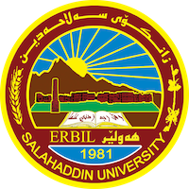
Academic Curriculum Vitae
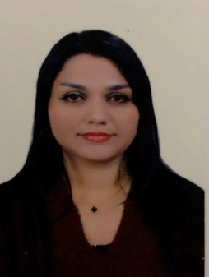
Personal Information:
Full Name: Hazhan Mala Hamadameen
Academic Title: Assistant lecturer
Email: hazhan.hamadameen@su.edu.krd
Mobile:07506831989

Education:
-Bachelor’s degree in philosophy/salahadin University/Kurdistan (2008 to 2012)
-master of philosophy/salahadin university(2014to 2017)
Diploma of teaching Method and Research Methodology (2018)
Employment:
-Teacher in Salahaddin University –collage of Arts-philosophy department since 2012tell now.
Qualifications
- 2018, Diploma of teaching Method and Research Methodology
- Teaching Excel program ,pedagogical training Avicenna center,2022
- Certificate of English course /intermediate level, The American university of Kurdistan, English language institute.
- IELTS 4.5 degree 12/12/2018, BRITISH COUNCIL.
- Certificate of completion English course intermediate level at Salahaddin university –Erbil
- Certificate of Cultural Heritage Protection Course in training unit Carabinieri Erbil,2018

Teaching experience:
- Teaching online philosophy course in (standard institute)

Research and publications
-The Fundament of Causality Problem by David Hum, Raman journal 2013 .

- The dimensions of being in Heidegger's philosophy,Qalaai Zanist journal,V0l(8),No(1).Spring 2023.
- Dimensions of human nature between Machiavelli and Thomas Hobbes, Qalaai Zanist journal,Vol(7)No(4),Winter 2022.

Conferences and courses attended
- Give details of any conferences you have attended, and those at which you have presented delivered poster presentations.

Funding and academic awards
- List any bursaries, scholarships, travel grants or other sources of funding that you were awarded for research projects or to attend meetings or conferences.
Professional memberships
- https://www.allbiz.se/kurddya-humanitarian-organization-kho-070-925-82-94
- I’m volunteer and Member of kurddya Humanitarian organization KHO
Professional Social Network Accounts:
-https://scholar.google.com/citations?user=RgPuTIEAAAAJ&hl=en&authuser=1
-https://www.researchgate.net/profile/Hazhan-Mala
-https://www.linkedin.com/in/hazhan-hamadameen-33b48723b

It is also recommended to create an academic cover letter for your CV, for further information about the cover letter, please visit below link:
https://career-advice.jobs.ac.uk/cv-and-cover-letter-advice/academic-cover-letter/

