Chapter One: An Introduce to Cost and its classification

First: Mean of cost:
- Cost: a sacrificed or forgone resource to achieve a specific objective.
- Actual cost : a cost that has occurred
- Budgeted cost : a predicted cost
- Cost object : anything for which a cost measurement is desired

Second: Cost Assignment (Product Units): a general term that encompasses the gathering of accumulated costs to a cost object in two ways:
  - Tracing costs with a direct relationship to the cost object, and
  - Allocating accumulated costs with an indirect relationship to a cost object.
    - Direct costs can be conveniently and economically traced (tracked) to a cost object. For instance( Material; like steel, tires for car, Labor; like assembly line wages) (D.M+D.L+D.Exp or called prime cost)
    - Indirect costs cannot be conveniently or economically traced (tracked) to a cost object. Instead of being traced, these costs are allocated to a cost object in a rational and systematic manner. For instance (Electricity, Rent, Property taxes, Plant administration expenses) (M.O.H= InD.M + InD.L + Other M.O.H).

Third: Cost Behavior Patterns: it is divided into two patterns are Variable Costs and Fixed Costs:
- Variable costs change, in total, in proportion to changes in the related level of activity or volume of output produced. Variable costs are constant on a per-unit basis. If a product takes 5 pounds of material each, it stays the same per unit regardless if one, ten or a thousand units are produced.
- Fixed costs remain unchanged, in total, for a given time period, despite changes in the related level of activity or volume of output produced. Fixed costs per unit change inversely with the level of production. As more units are produced, the same fixed cost is spread over more and more units, reducing the cost per unit
Variable cost total dollars change in proportion with output but remain unchanged per unit.
Fixed cost total dollars remain unchanged in relation to output but change inversely per unit.
- Picture B: Supervision Costs for the BMW X6 Assembly Line (in Millions)
- Picture A: Variable Costs of Steering Wheels at $500 per BMW X6 Assembled

Annual Total Fixed Supervision Costs for BMW X6 Assembly Line (1) | Number of X6s Produced (2) | Fixed Supervision Cost per X6 (3) = (1) , (2)
$2000000 | 10000 | $200
$2000000 | 25000 | $80
$2000000 | 50000 | $40
$2000000 | 80000 | $25
Number of X6s Produced (1) | Variable Cost per Steering Wheel (2) | Total Variable Cost of Steering Wheels (3) = (1) * (2)
1 | $600 | $600
1000 | $600 | $6000000
2000 | $600 | $1200000
3000 | $600 | $1800000

- Mixed costs have both fixed and variable elements.
We can express cost classification as:
- Costs may be classified as: (Direct/Indirect), and (Variable/Fixed)
- A (Direct & variable), B (Direct & fixed), C (Indirect & variable), and D (Indirect & fixed)
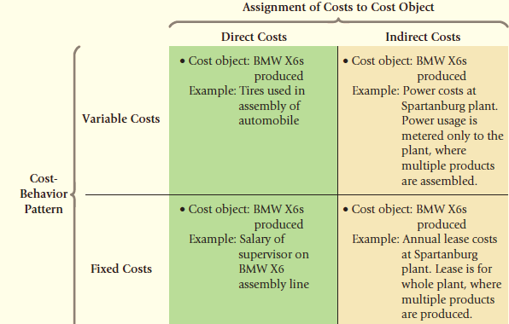

Forth: Total Costs & Unit Costs: A unit cost, also called an average cost, is calculated by dividing the total cost by the related number of units produced. Total cost is sum of variable costs and fixed costs divided by units produced.
Although unit costs are regularly used in financial reports and for making product mix and pricing decisions, managers should think in terms of total costs rather than unit costs for many decisions
Units Produced  (1) | Variable Cost per Unit  (2) | Total Variable Costs  (3) | Total Fixed Costs  (4) | Total Costs  (5) | Unit Cost  (6)
1000 | 600 | ? | 2000000 | ? | ?
2000 | 600 | ? | 2000000 | ? | ?
4000 | 600 | ? | 2000000 | ? | ?
7000 | 600 | ? | 2000000 | ? | ?
10000 | 600 | ? | 2000000 | ? | ?

Fifth: Types of Firms: there are three types of Firms, are:
- Manufacturing-sector companies purchase materials and components and convert them into various finished goods.
- Merchandising-sector companies purchase and then sell tangible products without changing their basic form.
- Service-sector companies provide services (intangible products) like legal advice or audits.

Sixth: Types of Inventories: there are three types of inventories in manufacturing firms, are:
- Direct materials inventory, resources in-stock and available for use
- Work-in-process (or progress) inventory, goods partially worked on but not yet completed, often abbreviated as WIP
- Finished goods inventory, goods completed but not yet sold
Note: Merchandising-sector companies hold only one type of inventory: merchandise inventory

Seventh: Inventoriable Costs Vs. Period Costs:
- Inventoriable Cost, are all costs of a product that are considered assets in a company’s balance sheet when the costs are incurred and that are expensed as cost of goods sold only when the product is sold. For manufacturing companies, all manufacturing costs (Prime Cost + M.O.H) are inventoriable costs.
- Period costs, are all costs in the income statement other than cost of goods sold. They are treated as expenses of the accounting period in which they are incurred.
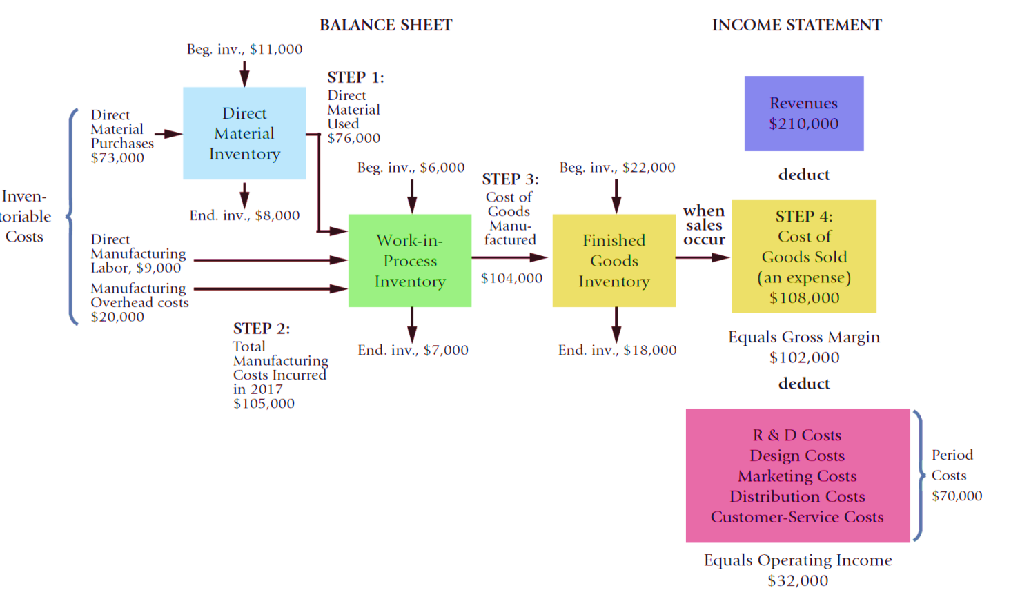
Chapter Two: Job-Order Costing System

First: Define of Job-Order Costing, is a system for assigning and accumulating manufacturing costs of an individual unit of output. The job order costing system is used when the various items produced are sufficiently different from each other and each has a significant cost.

Second: Seven-step Job Order costing, are:
- Identify the job that is the chosen cost object.
- Identify the direct costs of the job. (DM + DL)(500000+450000)
- Select the cost-allocation base(s) to use for allocating indirect costs to the job.(DLH) (28000)
- Identify the indirect costs associated with each cost-allocation base. (Determine the appropriate cost pools that are necessary.)(1120000)
- Compute the Rate per Unit of each cost-allocation base used to allocate indirect costs to the job (normal costing so use budgeted values)
Budgeted Manufacturing Overhead Rate = Budgeted Manufacturing Overhead Costs / Budgeted Total Quantity of Cost-Allocation Base (4÷3)($40)
- Compute the indirect costs allocated to the job:
Budgeted Allocation Rate x Actual Base Activity For the Job. (40×25000)
- Compute total job costs by adding all direct and indirect costs together.
Direct Manufacturing Costs:
Direct Materials 500000
Direct Labor 450000 950000
Manufacturing Overhead:
Indirect Costs (40×25000) 1000000
Total Mfg Costs of Job XYZ 1950000

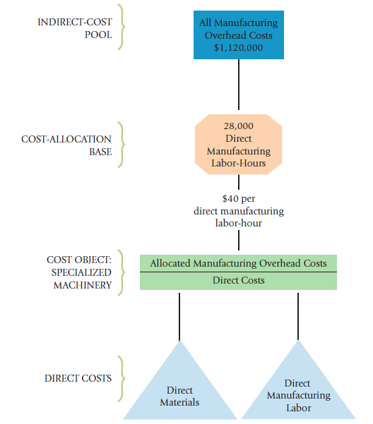

Third: Flow of Cost in Job Costing

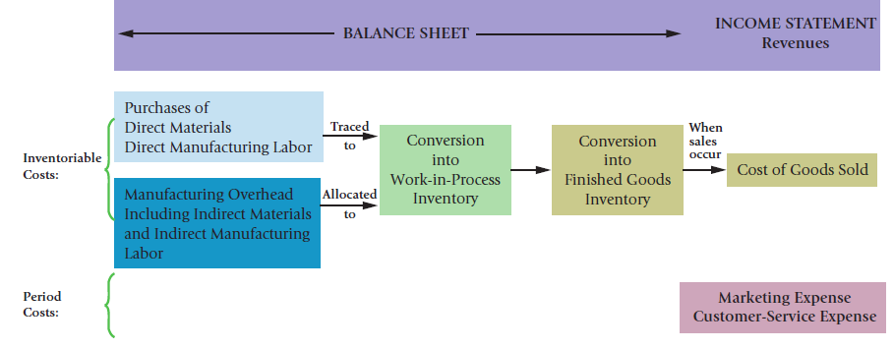

Forth: Journal Entries:
* All product costs are accumulated in the work-in-process control account.
Direct materials used
Direct labor incurred
Factory overhead allocated (or applied)
* Actual indirect costs (overhead) are accumulated in the manufacturing overhead control account.
1. Purchase of materials (direct & indirect) on credit:

Materials Control XX
Accounts Payable Control XX
2. Usage of direct and indirect (OH) materials into production:

Work-in-Process Control XX
Manufacturing Overhead Control XX
Materials Control XX

3. Manufacturing Payroll (direct & indirect)

Work-in-Process Control (direct) XX
Manufacturing Overhead Control (indirect) XX
Cash Control XX
4. Other manufacturing overhead costs incurred during the period:

Manufacturing Overhead Control XX
Cash Control XX
Accumulated Depreciation Control XX
5. Allocation (or application) of indirect costs (overhead) to the work-in-process account is based on a predetermined overhead rate.

Work-In-Process Control XX
Manufacturing Overhead Allocated XX

Note: actual overhead costs are never posted directly into work-in-process.
We entry for other M.O.H as salaries, insurance, depreciation…etc.

Manufacturing Overhead Control XX
Salaries, insurance, depreciation Control XX

6. Products are completed and transferred out of production (Work-in-Process) to Finished Goods in preparation for being sold.

Finished Goods Control XX
Work-In-Process Control XX
7. When goods are sold, the associated costs are transferred to an expense (cost) account.

Cost of Goods Sold XX
Finished Goods Control XX

Note: The difference between the sales and cost of goods sold amounts represents the gross margin (profit) on this particular transaction.
8. When marketing or customer-service costs are incurred, the appropriate expense account is increased and Cash Control is decreased (or Accounts payable Control would be increased, if the items/services are purchased on account)

Marketing Expense XX
Customer-Service Expense XX
Cash Control XX
9. Products are sold to customers on credit

Accounts Receivable Control XX
Sales XX

Fifth: Accounting for Overhead:
Recall that two different overhead accounts were used in the preceding journal entries:
- Manufacturing overhead control was debited for the actual overhead costs incurred.
- Manufacturing overhead allocated was credited for estimated (budgeted) overhead applied to production through the work-in-process account.
Actual costs will almost never equal budgeted costs. Accordingly, an imbalance situation exists between the two overhead accounts.
- If Overhead Control > Overhead Allocated, this is called UNDERALLOCATED overhead
- If Overhead Control < Overhead Allocated, this is called
- OVERALLOCATED overhead.
Sixth: Practical Examples:
Example 1. MX com. Products uses a job-costing system with two direct-cost categories (direct materials and direct manufacturing labor) and one manufacturing overhead cost pool. MX allocates manufacturing overhead costs using direct manufacturing labor costs. It provides the following information:
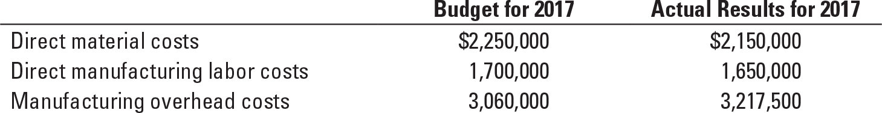
Required:
1.Compute the actual and budgeted manufacturing overhead rates for 2017.
2.Compute the cost of Job 626, During March; the job-cost record for Job 626 contained the following information:
Direct materials used | $55,000
Direct manufacturing labor costs | $45,000
3.At the end of 2017, compute the under- or overallocated manufacturing overhead under.
4. Journalize above transaction.

Example2: The (Nova) company implemented three orders which were made an offer by its customers to produce 1000, 1500, 1300 units (10-11-12) respectively
Details | Order 10 | Order 11 | Order 12 | Total
Material used | 7000 | 13000 | 25000 | 45000
Direct labor | 9000 | 14000 | 15000 | 38000

The com. Purchased 75000 of raw material during the period in cash, and it allocates %90 of the direct labor to manufacture overhead.
The actual overhead costs during period were as follows:
(Indirect material 20000$, indirect labor 10000$, salaries and depreciation 15000$, Marketing 5500$, Administrative 30000$.)
The all Orders are implemented (finished and sold) during the Period.
Selling Price as follows: 50$, 40$, and 55$ for three orders respectively
Required: (write off under/over allocated in cost of goods sold)
- Journalize for above transaction.
- Prepare general ledger
- Prepare income statement
- If order 12 unfinished, what will be happened?
- If order 11 unsold to the customer (not delivered), what will happen accounting?

Example3: Al-Fakhama Furniture Company started for producing two orders with number 10 and 11 in the month of 4/2014, and the following are the cost and production data for the month of 4:
- Production order 10 has 100 units, and Production order 11 has 150 units.
- The cost of material purchases amounted to 15,000$.
- The cost of materials used for production is 11,000$, of which 2,000$. Indirect materials.
- Production order No. 10 was used direct material, at a cost of 3500$. The remainder was used to Production Order No. 11.
- The payroll paid during the month amounted to 15,000$ (5000$ for order 10, and the rest for order 11), of which 3,000$. Indirect Labor.
- M.O.H is allocated on the basis of 80% of the direct labor cost.
- Actual M.O.H during the month reached 10,000$. (Excluding indirect materials and indirect labor)
- Order No. 10 was completed and sold at a price of $200 per unit, while Order No. 11 remained in process.
Required:
- Journalize above transaction, write-off under or overallocated overhead in c.o.g.s.
- Prepare Income Statement.

Example4: The University of UK Press is wholly owned by the university. The press uses normal costing to cost each job. Its job-costing system has two direct-cost categories (direct materials and direct manufacturing labor) and one indirect-cost pool (manufacturing overhead, allocated on the basis of direct manufacturing labor costs).
The following data (in thousands) pertain to 2017:
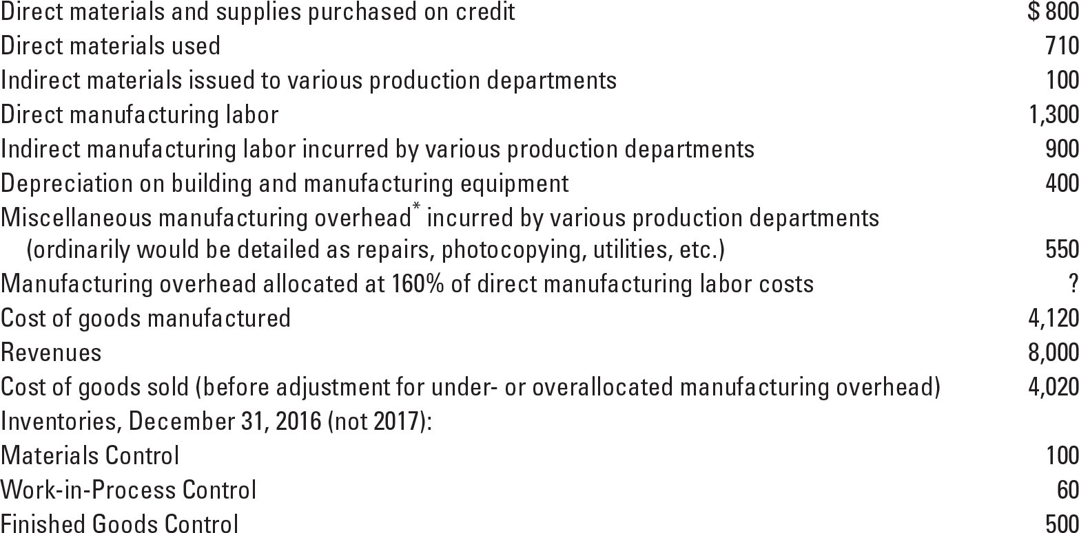
Required:
1. Prepare journal entries to summarize the 2017 transactions. As your final entry, dispose of the year-end under- or overallocated manufacturing overhead as a write-off to Cost of Goods Sold. Number your entries. Explanations for each entry may be omitted.
2. Show posted T-accounts for all inventories, Cost of Goods Sold, Manufacturing Overhead Control, and Manufacturing Overhead Allocated.

Example5: The following information takes place from north manufacturing com. during 2019:
Details | Jan 1- 2019 | Dec 31-2019
Material | 80000$ | 50000$
Work-in-process | 180000$ | 100000$
Finished good | 300000$ | 400000$
During the year the following transaction incurred:
- Material purchased at cost 420000$, and indirect material issued to production was 50000$.
- Total manufacturing payroll paid during the year was distributed based on 8:2 between direct and indirect labor 400000 $.
- Total FOH (factory overhead) included indirect material and labor was 440000$.
- Unit sold 4000 at price 500$ in cash.
- Cost of goods sold 1150000$
- Marketing and administrative expenses was 100000$.
- Estimated FOH (factory overhead) applied was 100% of direct material cost.
Required:
- Prepare journal entries.
- Prepare income statement for the year ended Dec. 31, 2006.

Example6: Lona. manufacturing company used job order costing system.
The following information takes from accounting record during April 2013.
- Beginning inventory:
Material 50000 $.
Work in process ( job no. 51) 80000$.
Finished goods inventory (job no. 52) 180000$.
- During the month purchased material on account cost 250000$.
- Total direct labor cost was 200000$, and indirect labor was 20000 $.
- Indirect material cost was 30000 $.
- Direct material cost used to job, and direct labor hours was:

Job no D.M cost used direct labor hours
51 100000 $ 3000 h
52 90000 $ 5000 h
- 60000 $ 2000 h

- F.O.H applied based at rate 15 $ per direct labor hours.
- Job no (51, 52) completed and transferred to finished good inventory.
- Job no (51, 52) was delivered to customer and received (600000 $, 650000 $).
- Another actual F.O.H was 120000 $.
- Marketing and administrative expenses was (%5) of job cost sold for each.
Required:
- Prepare journal entries.
- Prepare the ledger.
- Prepare the income statement.
Example7: If you have these information about a manufacturing firm which received two orders from its customer as follows:
- order no. 100 required 1000 unit from product (A), and order no. 110 required 1300 unit from product (B).
- It uses direct manufacturing labor cost as a basis to allocate manufacturing overhead.
- Budgeted manufacturing overhead was 2000000$, and budgeted direct manufacturing labor cost 2500000 $.
- Purchased 5000 pound with price 500$ per pound on credit.
- Direct material used was 90% (60% for order no. 100, and other for order no. 110), and other was as indirect material.
- Paid amount 1500000$ as wages, includes 1000000$ as direct (50% for each order).
- Paid amount 250000$ as salaries and insurance.
- Finished and delivered to the customer order no. 100, with selling price 120% form finish goods.
- Finished 80% of order no. 110.
Required: 1. Journalize, and prepare general ledger.
- Prepare income statement.

Seventh: Spoilage in Job-order costing: The concepts of spoilage apply to job-costing systems, we have two kinds of spoilage are;
- Normal Spoilage: normal spoilage costs in job-costing systems as in process-costing systems are inventoriable costs. When assigning costs, job-costing systems generally distinguish normal spoilage attributable to a specific job, and normal spoilage common to all jobs
A) Normal Spoilage Attributable to a Specific Job: When normal spoilage occurs the job bears the cost of the spoilage minus the disposal value of the spoilage. The journal entry will be;
Material Control (Normal spoilage units × Net disposal value) | XX
W.I.P Control | XX
]]
B) Normal Spoilage common to all jobs: the normal spoilage is allocated indirectly to the job as manufacturing overhead because the spoilage is common to all jobs. The journal entry will be as follows:
Material Control (Normal spoilage units × Net disposal value) | XX
M.O.H Control (Normal spoilage units × " manufacturing cost per - Net disposal value") | XX
W.I.P Control (Normal spoilage units × manufacturing cost per) | XX

- Abnormal Spoilage: Companies attempt to identify abnormal spoilage separately so they can work to eliminate it altogether. The costs of abnormal spoilage are written off as costs of the accounting and records in the entry as Loss from Abnormal Spoilage account (Debit). Unlike normal spoilage costs, abnormal spoilage costs are not included as a part of the cost of good units produced. As follows;
Material Control (Normal spoilage units × Net disposal value) | XX
Loss of abnormal spoilage (Normal spoilage units × " manufacturing cost per - Net disposal value") | XX
W.I.P Control (Normal spoilage units × manufacturing cost per) | XX

Example8: if you have this information about Kurdistan factory;
- Spoilage 5 units
- Completed 50 units
- The costs assigned prior to the inspection point are $2,000 per uint.
- When the spoilage is detected, the spoiled goods are inventoried at net disposal value. $600 per Unit
Required: Record the journal entries as 1) a Specific Job, 2) common to all Jobs, 3) abnormal Spoilage.

Example9: Plastique produces parts for use in various industries. Plastique uses a job-costing system; management expects normal spoilage at a rate of 2% of good parts. Data for last month is as follows:
Production (units) | 10,000
Good parts produced | 9,750
Direct material cost/unit | $ 5.00
Required: Record the journal entries if the spoilage was normal & abnormal (a) job specific or (b) common to all jobs. If you know the disposal value is $2/part.

Chapter Three: Process - Costing System

First: Define of Process Costing: Process costing is a system where the unit cost (Unit costs are calculated by dividing total costs incurred by the number of units of output from the production process) of a product or service is obtained by assigning total costs to many identical or similar units of output.
Note: Each unit receives the same or similar amounts of direct materials costs, direct manufacturing labor costs, and indirect manufacturing costs.

Second: Steps alloacation of process costing: there are Five steps process – costing allocation and they are:
- Summarize the flow of physical units of output.
- Compute output in terms of equivalent units.
- Summarize total costs to account for.
- Compute cost per equivalent unit.
- Assign total costs to units completed and to units in ending work-in-process.

Third: Cases of Process-Costing: there are three cases to calculate cost of production according process costing system, are:
- No beginning and ending work-in-process (W.I.P) inventories.
- No beginning work-in-process inventory and some ending work-in-process inventory.
- Both beginning and ending work-in-process inventories are present.
We're going to focus of last case (3) to calculate cost of production according the system.

Case 3: Process Costing with Some Beginning and Some Ending Work-in-Process Inventory:
To describe the five-step approach, we take two key methods (the weighted-average method and the first-in, first-out method). These different valuation methods produce different costs for the units completed and for the ending work-in-process inventory when the unit cost of inputs changes from one period to the next.

Note: Cases of adding material to the process, there are four cases and they are:
Cases of adding materials *** | W.I.P. Beginning % | W.I.P. Ending %
- Added material at the beginning of the process | 0% | 100%
- Added material at the Ending of the process | 100% | 0%
- Added material at the specific point :
- If W.I.P ending percentage reaches the point | 0% | 100%
- If W.I.P ending percentage doesn’t reaches the point. | 100% | 0%
- Added material evenly during the process | According to the percentage of completion | According to the percentage of completion

- Weighted-average method: The weighted-average method calculates the cost per equivalent unit of all work done to date (regardless of the accounting period in which it was done) and assigns this cost to equivalent units completed and transferred out of the process and to equivalent units in ending work-in-process inventory.
Applying the Five steps according to weighted-average method:
Flow of production | Physical Units | Equivalent Units
 |  | Direct Material | Conversion Cost  (DL+M.O.H)
W.I.P. Beginning (1) | **
Started Units during process (2) | **
To account for (Input) (1)+(2) | ***
Completed and transferred out units (4) | ** | 100% | 100%
W.I.P. Ending (5) (same completion %) | ** | *** | ***
Accounted for (Output) (4)+(5) Step1 | ***
Equivalent units of work done Step2 |  | ** | **
Cost of W.I.P. beginning | *** | ** | **
Cost added in current period | *** | ** | **
Total cost to account for Step3 | **** | *** | ***
Cost to account for |  | *** | ***
÷ Equivalent units of work done |  | ** | **
Cost per equivalent unit Step4 |  | ** | **
Assignment of cost: Step5
Completed and transferred out = Step2 × Step3 | *** | ** | **
+W.I.P. ending = Step2 × Step3 | *** | ** | **
=Total cost accounted for Step3 = Step5 | **** | *** | ***
- First-In, First-Out method: (1) assigns the cost of the previous accounting period’s equivalent units in beginning work-in-process inventory to the first units completed and transferred out of the process and (2) assigns the cost of equivalent units worked on during the current period first to complete the beginning inventory, next to start and complete new units, and finally to units in ending work-in-process inventory.
Applying the Five steps according to FIFO method:
Flow of production | Physical Units | Equivalent Units
 |  | Direct Material | Conversion Cost
W.I.P. Beginning (1) | **
Started Units during process (2) | **
To account for (Input) (1)+(2) | ***
Completed and transferred out units from : (4)
- W.I.P. Beginning (remaining of completion %) | ** | *** | **
- Started Units during process | ** | 100% | 100%
W.I.P. Ending (5) (same of completion %) | ** | *** | **
Accounted for (Output) (4)+(5) Step1 | ***
Equivalent units of work done Step2 |  | ** | **
Cost of W.I.P. beginning (previous period or process) | *** | ** | **
Cost added in current period | *** | ** | **
Total cost to account for Step3 | **** | *** | ***
Cost to account for (only Cost added in current period) |  | *** | ***
÷ Equivalent units of work done |  | ** | **
Cost per equivalent unit Step4 |  | ** | **
Assignment of cost: Step5
Completed and transferred out from :
Cost of W.I.P beginning (previous period or process) | *** | ** | **
+ Cost added to W.I.P beginning (This process) Step2 × Step3 | *** | ** | **
=Total cost of W.I.P beginning | *** | ** | **
+ Start and completed Step2 × Step3 | *** | ** | **
= Completed and transferred out cost | *** | *** | ***
+W.I.P. ending = Step2 × Step3 | *** | ** | **
=Total cost accounted for Step3 = Step5 | **** | *** | ***

Entries: 1) when record issued material and paid wages and other M.O.H
W.I.P (1st department) | XX
A A/P control | XX
Various accounts (Wages, Deprecation) | XX
2) When record the cost of goods completed and transferred from 1st department to 2nd department.
W.I.P (2st department) | XX
W.I.P (1st department) | XX

Example1: If you have this information about INC. manufacturing that using process costing system during February, 2016:
- Information about units:
- W.I.P beginning (completion percentage 30%) ………. 1000
- completed units ……… 4000
- Used unit (start)………... 3500
- W.I.P ending (completion percentage 60%) …………. 1500
- Information about costs:
- Direct material cost = 5500$
- Conversion cost = 3120 $
- Information about material adding:
- Materials are added at the beginning process.
- Conversion cost are added at evenly period
Required:
- Process costing steps during period, use weighted-average method.
- Journal entry during February month.

Example2: The assembly division of Quality Time Pieces, Inc. uses the weighted-average method of process costing. Consider the following data for the month of May 2017:
 | Physical Units (Watches) | Direct Materials | Conversion Costs
Beginning work in process (May 1)a | 100 | $ 459,888 | $ 142,570
Started in May 2017 | 510
Completed during May 2017 | 450
Ending work in process (May 31)b | ?
Total costs added during May 2017 |  | $3,237,000 | $1,916,000
a Degree of completion: direct materials, 80%; conversion costs, 35%.
b Degree of completion: direct materials, ?%; conversion costs, 40%.
Required:
1. Compute equivalent units for direct materials and conversion costs.
2. Show physical units in the first column of your schedule.
3. Summarize the total costs to account for.
4. Calculate the cost per equivalent unit for direct materials and conversion costs.
5. Assign costs to the units completed (and transferred out) and units in ending work in process.
6. Journalize above transaction.

Example3: Euro-Defense uses the weighted-average method of process costing, and added material at the end of process. Data for the Assembly Department for October 2007 are:
Details | Physical units | D.M | Conversion Cost
Work in progress, 1st October (70%) | 40 | 920000$ | 240000$
Started during October 2007 | 160
Completed during October 2007 | ?
Work in progress, 31st October (70%) | 20
Costs added during October 2007 |  | 4000000$ | 1870000$
Required:
- For each cost element, calculate equivalent units of work done in October 2007 in the Assembly Department. Show physical units in the first column.
- For each cost element, calculate cost per equivalent unit of opening work in progress and of work done in October 2007.
- Summaries the total Assembly Department costs for October 2007 and assign these costs to units completed (and transferred out) and to units in closing work in progress using the
- Prepare a set of summarized journal entries for all October 2007 transactions affecting Work in Progress–Assembly. Set up a T-account for Work in Progress–Assembly and post the entries to it.

Example4: Zany Brainy Corporation makes interlocking children’s blocks in a single processing department. Direct materials are added at the point 30%. Conversion costs are added evenly throughout production. Zany Brainy uses the weighted-average method of process costing. The following information for October 2017 is available.

 |  |  | Equivalent Units
 | Physical Units |  | Direct Materials |  | Conversion Costs
Work in process, October 1 | 12,000a |  | 12,000 |  | 9,600
Started in October | ?
Completed and transferred out during October | 55,000 |  | 55,000 |  | 55,000
Work in process, October 31 | 5,000b |  | 5,000 |  | 1,500
aDegree of completion: direct materials, ?%; conversion costs, 80%.
bDegree of completion: direct materials, ?%; conversion costs, 30%.
Total Costs for October 2017
Work in process, beginning
Direct materials |  | $ 5,760
Conversion costs |  | 14,825 |  | $ 20,585
Direct materials added during October |  |  |  | 25,440
Conversion costs added during October |  |  |  | 58,625
Total costs to account for |  |  |  | $104,650
Required:
1. Calculate the cost per equivalent unit for direct materials and conversion costs.
2. Summarize the total costs to account for, and assign them to units completed (and transferred out) and to units in ending work in process.
3. Prepare a set of summarized journal entries for all October 2017 transactions. Set up a T-account for Work in Progress–Assembly and post the entries to it.

Example5: If you have this information about INC. manufacturing that using process costing system during February, 2016:
- Information about units:
- W.I.P beginning (completion percentage 30%) ………. 1000
- completed units ……… 4000
- Used unit (start)………... 3500
- W.I.P ending (completion percentage 60%) …………. 1500
- Information about costs:
- Direct material cost = 5500$
- Conversion cost = 3120 $
- Information about material adding:
- Materials are added at the beginning process.
- Conversion cost are added at evenly period
Required:
- Process costing steps during period, use FIFO method.
- Journal entry during February month.

Example6: The assembly division of Quality Time Pieces, Inc. uses FIFO method of process costing. Consider the following data for the month of May 2017:
 | Physical Units (Watches) | Direct Materials | Conversion Costs
Beginning work in process (May 1)a | 100 | $ 459,888 | $ 142,570
Started in May 2017 | 510
Completed during May 2017 | 450
Ending work in process (May 31)b | ?
Total costs added during May 2017 |  | $3,237,000 | $1,916,000
a Degree of completion: direct materials, 80%; conversion costs, 35%.
b Degree of completion: direct materials, ?%; conversion costs, 40%.
Required:
1. Compute equivalent units for direct materials and conversion costs.
2. Show physical units in the first column of your schedule.
3. Summarize the total costs to account for.
4. Calculate the cost per equivalent unit for direct materials and conversion costs.
5. Assign costs to the units completed (and transferred out) and units in ending work in process.
6. Journalize above transaction.

Example7: Euro-Defense uses the First-In, First-Out method of process costing, and added material at the end of process. Data for the Assembly Department for October 2007 are:
Details | Physical units | D.M | Conversion Cost
Work in progress, 1st October (70%) | 40 | 920000$ | 240000$
Started during October 2007 | 160
Completed during October 2007 | ?
Work in progress, 31st October (70%) | 20
Costs added during October 2007 |  | 4000000$ | 1870000$
Required:
- For each cost element, calculate equivalent units of work done in October 2007 in the Assembly Department. Show physical units in the first column.
- For each cost element, calculate cost per equivalent unit of opening work in progress and of work done in October 2007.
- Summaries the total Assembly Department costs for October 2007 and assign these costs to units completed (and transferred out) and to units in closing work in progress using the
- Prepare a set of summarized journal entries for all October 2007 transactions affecting Work in Progress–Assembly. Set up a T-account for Work in Progress–Assembly and post the entries to it.

Example8: Zany Brainy Corporation makes interlocking children’s blocks in a single processing department. Direct materials are added at the point 30%. Conversion costs are added evenly throughout production. Zany Brainy uses the weighted-average method of process costing. The following information for October 2017 is available.
 |  |  | Equivalent Units
 | Physical Units |  | Direct Materials |  | Conversion Costs
Work in process, October 1 | 12,000a |  | 12,000 |  | 9,600
Started in October | ?
Completed and transferred out during October | 55,000 |  | 55,000 |  | 55,000
Work in process, October 31 | 5,000b |  | 5,000 |  | 1,500
aDegree of completion: direct materials, ?%; conversion costs, 80%.
bDegree of completion: direct materials, ?%; conversion costs, 30%.
Total Costs for October 2017
Work in process, beginning
Direct materials |  | $ 5,760
Conversion costs |  | 14,825 |  | $ 20,585
Direct materials added during October |  |  |  | 25,440
Conversion costs added during October |  |  |  | 58,625
Total costs to account for |  |  |  | $104,650
Required:
1. Calculate the cost per equivalent unit for direct materials and conversion costs.
2. Summarize the total costs to account for, and assign them to units completed (and transferred out) and to units in ending work in process.
3. Prepare a set of summarized journal entries for all October 2017 transactions. Set up a T-account for Work in Progress–Assembly and post the entries to it.

Forth: Transferred-in costs in process costing: Many process-costing systems have two or more departments or processes in the production cycle. As units move from department to department, the related costs are also transferred by monthly journal entries. Transferred-in costs (also called previous-department costs) are costs incurred in previous departments that are carried forward as the product’s cost when it moves to a subsequent process in the production cycle
Example9: Duddon Ltd makes a product that has to pass through two manufacturing processes, A and B. All the material is input at the start of process.
Details | A stage | B stage
Work in progress units , 1 October | 10000 | ?
Degree of completion costs1 October | 50% | 60%
Cost of Work in progress, 1 October:
Transferred-in costs | - | 210000$
Direct material | 200000$ | ?$
Conversion cost | 45000$ | ?$
Started during current period units | 50000 | ?
Completed and transferred out during current period units | 54000 | 40000
Degree of completion costs at 31 October | 60% | 40%
Costs of direct material in current period | 1,000,000$ | 620000$
Costs of conversion cost in current period | 810,000$ | 1030000$
More information: Degree of completion in this department: Transferred-in costs, 100%. The direct material adding at the beginning of the (A) stage, while added direct material at the (B) stage when the degree of completion arrived in 50%
Required: Uses the FIFO, and Weighted average method:
- Calculate Assignment of cost for process A, and B:
- Prepare the journal entries.

Example10: MK Company is a manufacturer of car seats. Each car seat passes through the assembly department and testing department. This problem focuses on the testing department. Direct materials are added when the testing department process is 90% complete. Conversion costs are added evenly during the testing department’s process. Data for the testing department for October 2017 are as follows:
 | Physical Units (Car Seats) | Transferred-In Costs | Direct Materials | Conversion Costs
Work in process, October 1a | 5,500 | $2,931,000 | $0 | $499,790
Transferred in during October 2017 | ?
Completed during October 2017 | 29,800
Work in process, October 31b | 1,700
Total costs added during October 2017 |  | $8,094,000 | $10,877,000 | $4,696,260
aDegree of completion: transferred-in costs,?%; direct materials,?%; conversion costs, 65%.
bDegree of completion: transferred-in costs,?%; direct materials,?%; conversion costs, 45%.
Required:
1. Finding the missing of percentage of completion
2. Calculate cost accounted for (5 steps) for the testing department.
4. Prepare necessary of journal entries for testing department.

Fifth: Spoilage in process costing: Spoilage refers to units of production, whether fully or partially completed that does not meet the specifications required by customers for good units and are discarded or sold at reduced prices.
- Types of Spoilage : there are two types of spoilage, are:
- Normal Spoilage is spoilage inherent in a particular production process. In particular, it arises even when the process is carried out in an efficient manner. The costs of normal spoilage are typically included as a component of the costs of good units manufactured; in other hand costs are inventoried.
- Abnormal Spoilage is spoilage that is not inherent in a particular production process and would not arise under efficient operating conditions. It calculates the units of abnormal spoilage and record the cost in the Loss from Abnormal Spoilage account and the costs of abnormal spoilage are written off as a period expense.
- Calculation of Spoilage: we can calculate spoilage as the following:
Total spoilage = (W.I.P Beginning + Started unit during period) – (completed & Transferred out unit + W.I.P Ending unit)
Total spoilage= Normal spoilage (Always take from good complete unit) + Abnormal spoilage
Example11: Arbil company manufactures a recycling container in it is forming department .Direct materials are added at the beginning of the production process. Conversion costs are added evenly during the production process. The units can be inspected when they are 100% completed some units of the product are spoiled as a result of defects; summary data for May 2014 are as follows:
Details | Physical units | D.M | C.C
W.I.P beginning inventory (1st May) | 3000 | 24000$ | 18000$
completion % of beginning work in process |  | %100 | %60
Started units during May | 17000
completed and transferred out during My | 14000
W.I.P ending inventory (31st May) | 4000
completion % of ending work in process |  | %100 | %50
Total added costs during May |  | 153000$ | 178200$
Normal spoilage as a percentage of goods units | %10
Degree of completion of normal spoilage |  | %100 | %100
Degree of completion of Abnormal spoilage |  | %100 | %100
Required:
- Calculate units of normal and abnormal spoilage.
- Determine the amount of assignment of costs (5 steps), according to:
Weighted- average method.
First-In, First-Out method.
- Record journal entries.

Example12: the following data for November 2017 from Delan Manufacturing Company, which makes silk pennants and uses a process-costing system. All direct materials are added at point 30% of the process, and conversion costs are added evenly during the process. Spoilage is detected upon inspection at the completion of the process
 | Physical Units (Pennants) | Direct  Materials | Conversion Costs
Work in process, November 1 (45%) | 1,350 | $ 966 | $711
Started in November 2017 | ?
Good units completed and transferred  out during November 2017 | 8,800
Normal spoilage | 80
Abnormal spoilage | 50
Work in process, November 30 (35%) | 1,700
Total costs added during November 2017 |  | $10,302 | $30,055
Required: According fifo, and weighted average method;
- Compute equivalent units for direct materials and conversion costs (step 2).
2) Show physical units in the first column of your schedule (step 1).
3) Determine total cost to account for (step 3).
4) Count cost per equivalent units of work done (step 4).
5) Finding assignment of cost (step 5).
6) Record journal entries.

Chapter Four: Standard-Costing, Variances

First: Static Budget Variance: A variance is the difference between actual results and expected performance. The expected performance is also called budgeted performance (Static Budget), which is a point of reference for making comparisons.
Static Budget Variance (Level 1) = Actual result – Static budget
Example 1: Webb has the following information;
- The budgeted data as follows:
(DM $60.Per jacket, DL $16, V.M.O.H $12, F.M.O.H costs for production between 0 and 12,000 jackets $276,000, selling price $120 per jacket).
- The Actual data as follows:
(DM $65.Per jacket, DL $20, V.M.O.H $13, F.M.O.H costs $285000, Actual production and sales 10,000 jackets, selling price $125 per jacket)
Required: Prepare income statement then find static budget variance.
Example 2: Zanst Corporation has this information related to its performance is given below:
Details | Actual | Budgeted
Units made and sold | 28000 | 27500
Selling Price | $11 | $12
Variable costs | $90000 | $3 per unit
Fixed costs | $55000 | $58000
Required: Calculate Zanst’s static-budget variance for (a) revenues, (b) variable costs, (c) fixed costs, and (d) operating income.

Second: Flexible Budget Variance: A flexible budget calculates budgeted revenues and budgeted costs based on the actual output in the budget period. The flexible budget is prepared at the end of the period
Flexible Budget Variance (Level 2) = Actual result – Flexible budget
Sales Volume Variance (Level 2) = Flexible budget – Static budget Or
Sales Volume Variance (Level 2) = (Budgeted contribution margin per unit) × (Actual units sold – Static budget units sold)
Companies develop their flexible budget in three steps; are
Step 1: Identify the Actual Quantity of Output
Step 2: Calculate the Flexible Budget for Revenues Based on (Budgeted Selling Price × Actual Quantity of Output).
Step 3: Calculate the Flexible Budget for Costs Based on (Budgeted Variable Cost per Output Unit × Actual Quantity of Output), and Budgeted Fixed Costs.

Example 3: Webb has the following information;
- The budgeted data as follows:
(DM $60.Per jacket, DL $16, V.M.O.H $12, F.M.O.H costs for production between 0 and 12,000 jackets $276,000, selling price $120 per jacket).
- The Actual data as follows:
(DM $65.Per jacket, DL $20, V.M.O.H $13, F.M.O.H costs $285000, Actual production and sales 10,000 jackets, selling price $125 per jacket)
Required: 1) Prepare income statement then find flexible budget variance & Sales volume variance (Level 2).

Example 4: Zanst Corporation has this information related to its performance is given below:
Details | Actual | Budgeted
Units made and sold | 28000 | 27500
Selling Price | $11 | $12
Variable costs | $90000 | $3 per unit
Fixed costs | $55000 | $58000
Required: Calculate Zanst’s flexible-budget variance (Level 2) for (a) revenues, (b) variable costs, (c) fixed costs, and (d) operating income.

Example 5: If you have this information then required you to fill out the missing
Details | Actual Data | Flexible-Bud. Variance | Flexible Bud. | Sales Volume Variance | Static Bud.
Unit sold | 130,000 | ? | ? | ? | 120,000
Revenues | $715,000 | ? | ? | ? | $420,000
V. Cost | $515,000 | ? | ? | ? | $240,000
Contribution Margin | $200,000 | ? | ? | ? | $180,000
F. Cost | $140000 | ? | ? | ? | $120,000
Operating Income | $60000 | ? | ? | ? | $60,000

Third: Standard costs for Variance Analysis: To gain further insight, a company will subdivide the flexible-budget variance (it is called level 3 variances) for its direct cost inputs into two more-detailed variances:
1. A price variance that reflects the difference between an actual input price and a budgeted input price
2. An efficiency variance that reflects the difference between an actual input quantity and a budgeted input quantity
As we know that direct cost contains to direct material and direct labor;
- Direct Material Variance, to reach this variance, we use the following equation;
Direct Material Variance = Actual direct material – Standard direct material
(Flexible Budget Variance)

*Actual direct material = (Actual Quantity × Actual DM. price)
*Standard direct material = (Standard quantity allowed for output units × Standard DM. price)
Standard Quantity allowed for output units= SQ allowed per output × Actual output units

Direct material variance subdivided into to variances, are
A) DM. Price Variance = (A.DM.P – S.DM.P) × AQ (Purchasing)
B) DM. Efficiency Variance = (AQ – SQ allowed for output unit) × S.DM.P
We can reach the same result by another way (more common way)
Actual | Mixed | Standard (Flexible budget)
AQ × AP | AQ × SP | SQ allowed for output × SP
(AP – SP) ×AQ (AQ – SQ allowed) ×SP
Level 3 DM. Price Variance DM. Efficiency Variance

Level 2 Flexible Budget Variance

Journal entries using standard cost (Direct matrial)
- When Purchasing Material:
Direct Materials Control (Purchased Quantity × S.DM.P) | XX
DM. Price Variance if (U) | XX
A/P Control (Purchased Quantity × A.DM.P) | XX
DM. Price Variance if (F) | XX

- When used material in process:

W.I.P Control (SQ allowed for output units × S.DM.P) | XX
DM. Efficiency Variance if (U) | XX
Direct Materials Control (Used Quantity × S.DM.P) | XX
DM. Efficiency Variance if (F) | XX

- Direct Labor Variance, to reach this variance, we use the following equation;
Direct Labor Variance = Actual direct Labor – Standard direct Labor
(Flexible Budget Variance)

*Actual direct Labor = (Actual Hours × Actual DL. Price)
*Standard direct Labor = (Standard Hours allowed for output units × Standard DL. Price)
Standard hours allowed for output units= SH allowed per output × Actual output units
Direct Labor variance subdivided into to variances, are
A) DL. Price Variance = (A.DL.P – S.DLP) × AH
B) DL. Efficiency Variance = (AH – SH allowed for output unit) × S.DL.P
We can reach the same result by another way (more common way)
Actual | Mixed | Standard (Flexible budget)
AH × AP | AH × SP | SH allowed for output × SP
(AP – SP) ×AH (AH – SH allowed) ×SP
Level 3 DL. Price Variance DL. Efficiency Variance

Level 2 Flexible Budget Variance

Journal entries using standard cost (Direct Labor)
W.I.P Control (SH allowed for output × S.DL.P) | XX
DL. Price Variance if (U) | XX
DL. Efficiency Variance (U) | XX
Wages Payable Control (AH × A.DL.P ) | XX
DL. Price Variance if (F) | XX
DL. Efficiency Variance (F) | XX

Note: Record the journal entry to write off the direct cost variance (DM. Price, DM. Efficiency, DL. Price and DL. Efficiency) accounts to the Cost of Goods Sold account.
Example6: Hareem Manufacturing has the following standards for one of its products:
Direct materials (4 ft. @ $10), direct labor (1.5 hrs. @ $4).
During the most recent year, the following actual results were recorded:
Production 6,000 units, direct materials (25000 ft. purchased and used @ $8), direct labor (8000 hrs. @ $5)
Required: Compute and journalize the following variances:
1. DM. price and efficiency variances.
2. DL. Price and efficiency variances.

Example7: Jamie Draperies manufactures curtains. To complete a curtain, Jamie requires the following inputs:
DM. standard: 10 square yards at $5 per yard
DML. standard: 5 hours at $10 per hour

During the second quarter, Jamie Draperies made 1,500 curtains, purchased 14,000 square yards of fabric costing $68,600 and used 13000 square yards of it. Direct manufacturing labor totaled 7,600 hours for $79,800.
Required:
a. Compute the DM. price and efficiency variances for the quarter
b. Compute the DML. price and efficiency variances for the quarter.
c. Record the necessary entries.

Example8: The Schuyler Corporation manufactures lamps. It has set up the following standards per finished unit for direct materials and direct manufacturing labor:
Direct materials: 10 lb. at $4.50 per lb. | $45.00
Direct manufacturing labor: 0.5 hour at $30 per hour | 15.00
Actual results in January 2017 were as follows:
Direct materials used | 98,055 lb
Direct manufacturing labor: 4,900 hours | $154,350
Materials purchased amounted to 100,000 lb. | $465,000
Actual output units during January | 9850
Required:
1. Compute the January 2017 price and efficiency variances of direct materials and direct manufacturing labor.
2. Prepare journal entries to record the variances in requirement.
3. Write-off the variances in cost of goods sold.
Example9: Yad manufactures fiberglass surfboards. The standard cost of direct materials is 35 pounds at the price of $3 per pound and direct manufacturing labor is 11 hours at the rate of $13 per hour. Following are additional data for the month of July:
Units completed | 5,600 units
Direct material purchases | 230,000 pounds
Cost of direct material purchases | $759,000
Actual direct manufacturing labor-hours | 43,000 hours
Actual direct manufacturing labor cost | $623,500
Direct materials efficiency variance | $1,200 F
Required:
1. Compute direct manufacturing labor variances for July.
2. Compute the actual pounds of direct materials used in production in July.
3. Calculate the direct materials price variance.

Example10: On May 1, 2017, Bovar Company began the manufacture of a new paging machine known as Dandy. The standard costs for a unit of Dandy follow:
Direct materials (3 lb. at $4 per lb.) | $12.00
Direct manufacturing labor (1/2 hour at $20 per hour) | 10.00
The following data were obtained from Bovar’s records for the month of May:
 | Debit | Credit
Direct materials price variance | $3,500
Direct materials efficiency variance | 2,400
Direct manufacturing labor price variance | 1,890
Direct manufacturing labor efficiency variance |  | 2,200
Actual production in May was 4,000 units of Dandy
Required:
1. Standard direct manufacturing labor-hours allowed for actual output produced
2. Actual direct manufacturing labor-hours worked
3. Actual direct manufacturing labor wage rate
4. Standard quantity of direct materials allowed (in pounds)
5. Actual quantity of direct materials used (in pounds)
6. Actual direct materials price per pound

Forth: Flexible Budget, Overhead Variances Analysis: we have two main kinds of overhead variances variable manufacturing overhead variance and fixed manufacturing overhead variance;
- Variable Manufacturing Overhead Variance: we can reach to it by the following equations, are:

Variable overhead flexible-budget variance = Actual costs incurred – Flexible-budget amount
* Actual costs incurred = Actual hours × Actual Rate
* Flexible-budget amount = Standard hours allowed for output × Standard (Budget) Rate
(Allocated V.O.H)
Standard hours allowed for output units= SH allowed per output × Actual output units

V.O.H variance subdivided into to variances, are
A) V.O.H spending variance = (AR – SR) × AH
B) V.O.H Efficiency Variance = (AH – SH allowed for output unit) × SR
We can reach the same result by another way (more common way)
Actual | Mixed | Standard (Flexible budget)
AH × AR | AH × SR | SH allowed for output × SR
(AR – SR) ×AH (AH – SH allowed) ×SR
Level 3 V.O.H. spending Variance V.O.H Efficiency Variance

Level 2 Flexible Budget Variance

Journal entries using standard cost (V.O.H)
Variable Overhead Control (AH × AR) | XX
A/P various other accounts | XX
W.I.P Control (SH allowed for output units × SR) | XX
Variable Overhead Allocated  When we write-off each Actual and Allocated V.O.H and record & efficiency variance as following entry; | XX  each of spending
Variable Overhead Allocated | XX
V.O.H spending Variance (U) | XX
V.O.H efficiency Variance (U) | XX
Variable Overhead Control | XX
V.O.H spending Variance (F) | XX
V.O.H efficiency Variance (F) | XX
When we write-off each spending & efficiency variance as following entry;
Cost of goods sold | XX
V.O.H spending Variance (U) | XX
V.O.H efficiency Variance (U) | XX

Or;
V.O.H spending Variance (F) | XX
V.O.H efficiency Variance (F) | XX
Cost of goods sold | XX

- Fixed Manufacturing Overhead Variance: we can reach to it by the following equations, are:

Fixed overhead flexible-budget variance = Actual costs incurred – Flexible-budget amount
* Actual costs incurred = Actual hours × Actual Rate
* Flexible-budget amount = Standard (Budget) hours × Standard (Budget) Rate

F.O.H variance subdivided into to one variance, is
F.O.H spending variance = Actual costs incurred- Flexible-budget amount

There is another variance in fixed overhead that different between flexible budget and allocated fixed overhead is called Production volume variance, so it is considered by the following equation:
Production volume variance = Flexible budget – Allocated F.O.H
Allocated F.O.H = Standard hours allowed for output units × Standard (Budget) Rate
Standard hours allowed for output units= SH allowed per output × Actual output units
We can reach the same result by another way (more common way)
Actual costs incurred | Flexible-budget amount | Allocated F.O.H  (SH allowed × SR )

Level 3 F.O.H. spending Variance Production Volume Variance

Level 2 Flexible Budget Variance

Journal entries using standard cost (F.O.H)
Fixed Overhead Control (Actual) | XX
Salaries, depreciation and various other accounts | XX
W.I.P Control (SH allowed for output units × SR) | XX
Fixed Overhead Allocated  When we write-off each Actual and Allocated V.O.H and record & efficiency variance as following entry; | XX  each of spending
Fixed Overhead Allocated | XX
F.O.H spending Variance (U) | XX
Production Volume Variance (U) | XX
Fixed Overhead Control | XX
F.O.H spending Variance (F) | XX
Production Volume Variance (F) | XX
When we write-off each spending & efficiency variance as following entry;
Cost of goods sold | XX
F.O.H spending Variance (U) | XX
Production Volume Variance (U) | XX

Or;
F.O.H spending Variance (F) | XX
Production Volume Variance (F) | XX
Cost of goods sold | XX

Example11: Duvet Company manufactures pillows.
The 2017 operating budget was based on production of 25,000 pillows,
Machine-hours allowed per pillow 0.75 hrs.
Budgeted variable overhead per hour was $25.
Actual production for 2017 was 27,000 pillows.
Actual machine-hours 19,050 hrs.
Actual variable costs were $23 per machine-hour.
Required: Calculate the following:
1. Flexible-budget variable overhead variance for 2017.
2. Variable overhead spending variance.
3. Variable overhead efficiency variance.
4. Record the necessary journal entries.

Example12: Soran Company makes watches. For 2017,
Expected fixed overhead costs of $648,000.
Soran uses direct labor-hours to allocate fixed overhead and anticipate 21,600 hours during the year.
Direct labor-hours allowed per watch 0.04 hrs. (21600/540000)
Expected output of 540,000 units.
Actual output of watches 576000 Watches
Actual fixed overhead cost $624000
Required: Calculate the following:
1. Flexible-budget fixed overhead variance.
2. Fixed overhead spending variance.
3. production-volume variance.
4. Record the necessary journal entries.

Example13: The Brazil division of an American telecommunications company uses standard costing for its machine-paced production of telephone equipment. Data regarding production during June are as follows:
Variable manufacturing overhead costs incurred | $537,470
Variable manufacturing overhead cost rate | $7 per standard machine-hour
Fixed manufacturing overhead costs incurred | $146,101
Fixed manufacturing overhead costs budgeted | $136,000
Denominator level in machine-hours | 68,000
Standard machine-hour allowed per unit of output | 1.2
Units of output | 66,500
Actual machine-hours used | 75,700
Required:
- Finding flexible-budget variable overhead variances and (spending & Efficiency Variance), then prepare journal entries and write-off.
- Finding flexible-budget fixed overhead variances and (spending variance)
- Production-volume variance
- Prepare journal entries for fixed overhead variances and write-off.

Example14: ProChem, Inc. produces chemicals for large biotech companies. It has the following data for manufacturing overhead costs during August 2017:
 | Variable | Fixed
Actual costs incurred | $35,000 | $16,500
Costs allocated to products | 36,000 | 15,200
Flexible budget | –––––– | 16,000
Actual input × budgeted rate | 31,500 | ––––––

Fill in the blanks. Use F for favorable and U for unfavorable:
 | Variable | Fixed
(1) Spending variance | $ | $
(2) Efficiency variance
(3) Production-volume variance
(4) Flexible-budget variance
(5) Underallocated (overallocated) manufacturing overhead

Example15: Company (DDC), which manufactures expensive brass doorknobs. DDC uses two direct-cost categories: direct materials and direct manufacturing labor. it feels that manufacturing overhead is most closely related to material usage. Therefore, DDC allocates manufacturing overhead to production based upon pounds of materials used.
At the beginning of 2017, DDC budgeted monthly production of 35000 doorknobs and adopted the following standards for each doorknob:
Direct materials (brass) |  | 0.3 lb. @ $10/lb.
Direct manufacturing labor |  | 1.2 hours @ $17/hour
Manufacturing overhead:
Variable |  | $5/lb.
Fixed |  | $15/lb.
Actual results for April 2017 were as follows:

Production | 29,000 doorknobs
Direct materials purchased | 12,400 lb. at $11/lb.
Direct materials used | 8,500 lbs.
Direct manufacturing labor | 29,200 hours for $671,600
Variable manufacturing overhead | $65,100
Fixed manufacturing overhead | $158,000
Required:
1. Direct materials price variance (based on purchases)
2. Direct materials efficiency variance
3. Direct manufacturing labor price variance
4. Direct manufacturing labor efficiency variance
5. Variable manufacturing overhead spending variance
6. Variable manufacturing overhead efficiency variance
7. Production-volume variance
8. Fixed manufacturing overhead spending variance

Example16: The Beal Manufacturing Company’s costing system has two direct-cost categories: direct materials and direct manufacturing labor. Manufacturing overhead (both variable and fixed) is allocated to products on the basis of standard direct manufacturing labor-hours (DLH). At the beginning of 2017, Beal adopted the following standards for its manufacturing costs:
Direct materials | 5 lb. at $4 per lb.
Direct manufacturing labor | 4 hrs. at $16 per hr.
Variable O.H | $8 per DLH
Fixed O.H | $9 per DLH
The denominator level for total manufacturing overhead per month in 2017 is 37,000 direct manufacturing labor-hours. Beal’s budget for January 2017 was based on this denominator level. The records for January indicated the following:
Direct materials purchased | 40,300 lb. at $3.80 per lb.
Direct materials used | 37,300 lb.
Direct manufacturing labor | 31,400 hrs. at $16.25 per hr.
Total actual manufacturing overhead (60% Variable) | $650,000
Actual production | 7,600 output units

Required:
1. Direct materials price variance, based on purchases
2. Direct materials efficiency variance
3. Direct manufacturing labor price variance
4. Direct manufacturing labor efficiency variance
5. Total manufacturing overhead spending variance
6. Variable manufacturing overhead efficiency variance
7. Production-volume variance
8. Journalize the above events.

